Deportation Acknowledgement: Dec. 11, 2009

Background: In the weeks and months that followed the illegal deportation of Dec. 11, 2009, Cathryn Caton had her attorneys work to obtain documentation supporting her case that the entire kidnapping and deportation were massively illegal – in terms of prevailing international law as well as Ecuadorian statutes. In the course of the attorneys’ investigation, the following document – which is only a COPY of an original was unearthed at “Migratorio” in Guayaquil.
Although the document – a poor photocopy that it is – is illegible in a couple of key spots, it is still provides clear evidence that the deportation took place. This is important, because when Gregory Caton returned to Ecuador on September 2, 2011, his “Certificado de Movimiento” – a file that all travelling residents of Ecuador have, both naturalized citizens and registered foreigners, showing their “entradas” and “salidas” in and out of the country, showed nothing for 2009. In other words, key officials in Quito literally had erased any mention of the deportation in the official records. Ecuadorian counsel for the Caton family have indicated that this is clear evidence of an intended “cover up.”
Exaggeration? Not if you study the document below.
Incidentally, the fact that police officers for Ecuador – as indicated below – were escorting Gregory Caton back to the U.S. – not U.S. Marshalls, as is customary – shows the degree to which Ecuadorean National Policeman , Capt.Wilson Reyes, considers himself an employee of the U.S. Government, not Ecuador.
What follows is the photocopy of the original document that was found, drafted in Spanish, followed by its English translation.

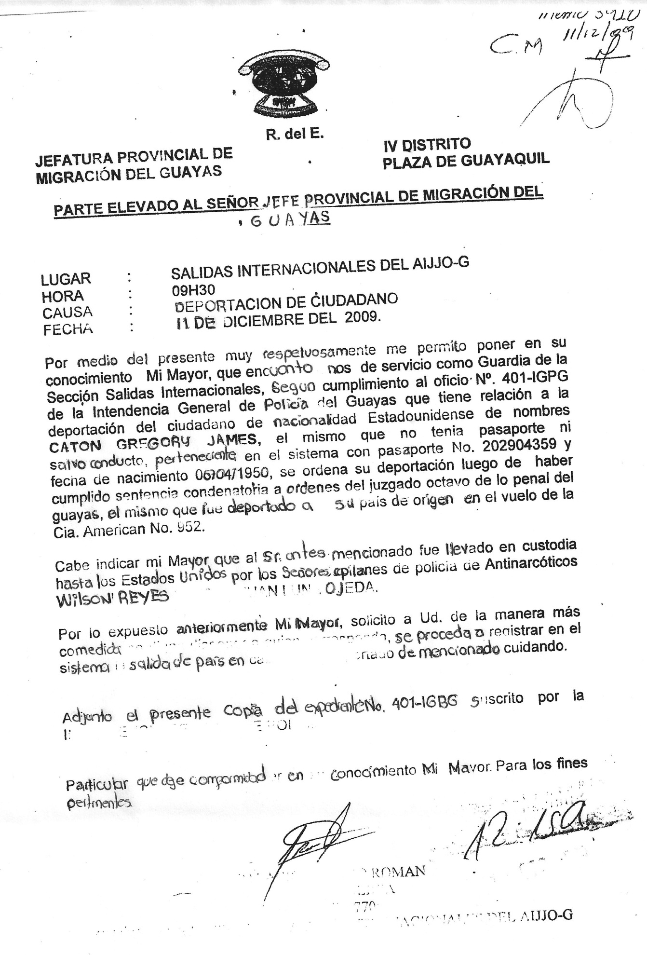

R. of E.
PROVINCIAL OFFICE OF IMMIGRATION OF GUAYAS IV DISTRICT
PLAZA OF GUAYAQUIL
REPORT SUBMITTED TO THE PROVINCIAL HEAD OF IMMIGRATION OF GUAYAS
PLACE: INTERNATIONAL DEPARTURE OF AIJJO-G
HOUR: 09H30
CAUSE: DEPORTATION OF THE CITIZEN
DATE: DECEMBER 11, 2009

Herein, respectfully, I am notifying you about my service as a Guard] in the International Departure Section in order to comply with the Official Action number 401-IGPG of the General Police Department of Guayas in relationship to the deportation of the American citizen named GREGORY JAMES CATON. This person did not have a passport or a safe-conduct, whose passport number is 202904359 and birth date is 06/04/1950 [sic: it’s 1956]. His deportation was ordered after the judgment where he was found guilty by the Eighth Judge of Criminal Law of Guayas. [sic] He was deported to his country of origin [Miami, USA] via Flight Number 952 of American (Airlines).

It is worth mentioning that the above named person was taken to the United States under the guard of the police officers of Anti-Narcotics, WILSON REYES and . . . (Illegible), OJEDA.
Considering the aforementioned, I kindly request . . . (illegible) proceed to register in the departure system of the country . . . (illegible) of the above mentioned citizen.
Herewith is the copy of the expedient number 401-IGBG subscribed by the . . . (illegible)
I hereby notify you of this fact for all legal purposes.

(Signature)

(illegible)

