Hearing Summary: Dec. 4, 2009

Background: A meeting inside a small government office in Guayaquil took place around Dec. 4, 2009 – one that would only latter be described to the Defendant as a court hearing – in which arguments were made concerning would only latter be described to the Defendant as a matter concerning deportation. During this hearing the Defendant was asked if he wanted to say anything, without any mention of desired content or context. This document is riddled with inaccuracies, noted in the English translation. (For example, the document opens by stating that the meeting took place on June 26, 2009 . . . an impossibility, since the kidnapping itself didn’t take place until Dec. 2, 2009).
A summary – something short of a transcript – was officially produced concerning this “hearing,” and its contents are included below.
A summons was issued which follows this document below; however, the Defendant never saw this document until nearly two years later.
These documents are posted below, drafted in Spanish, followed by their English translation.
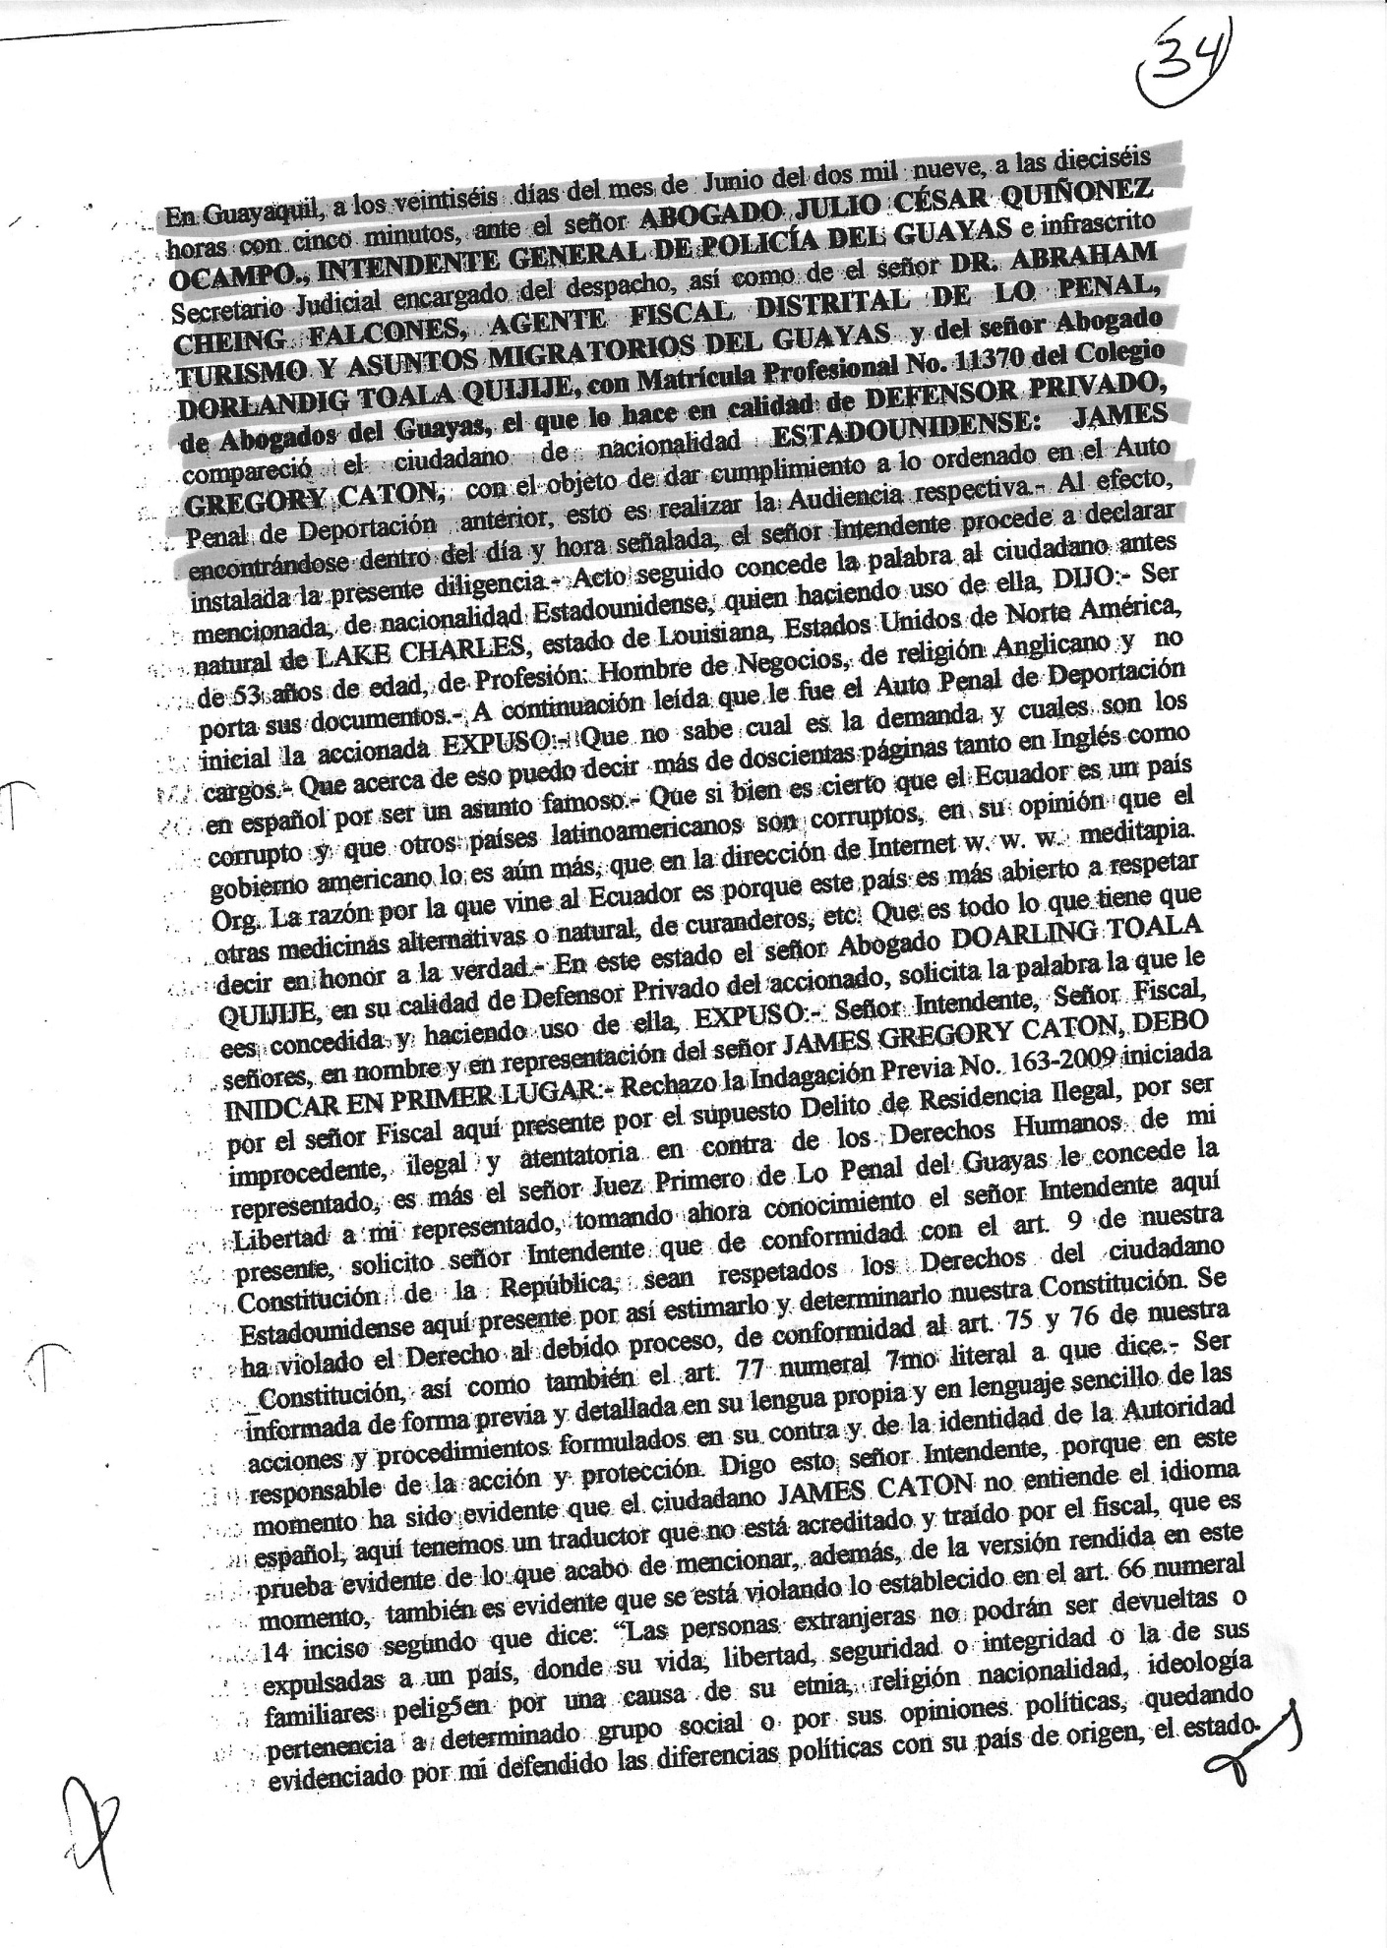
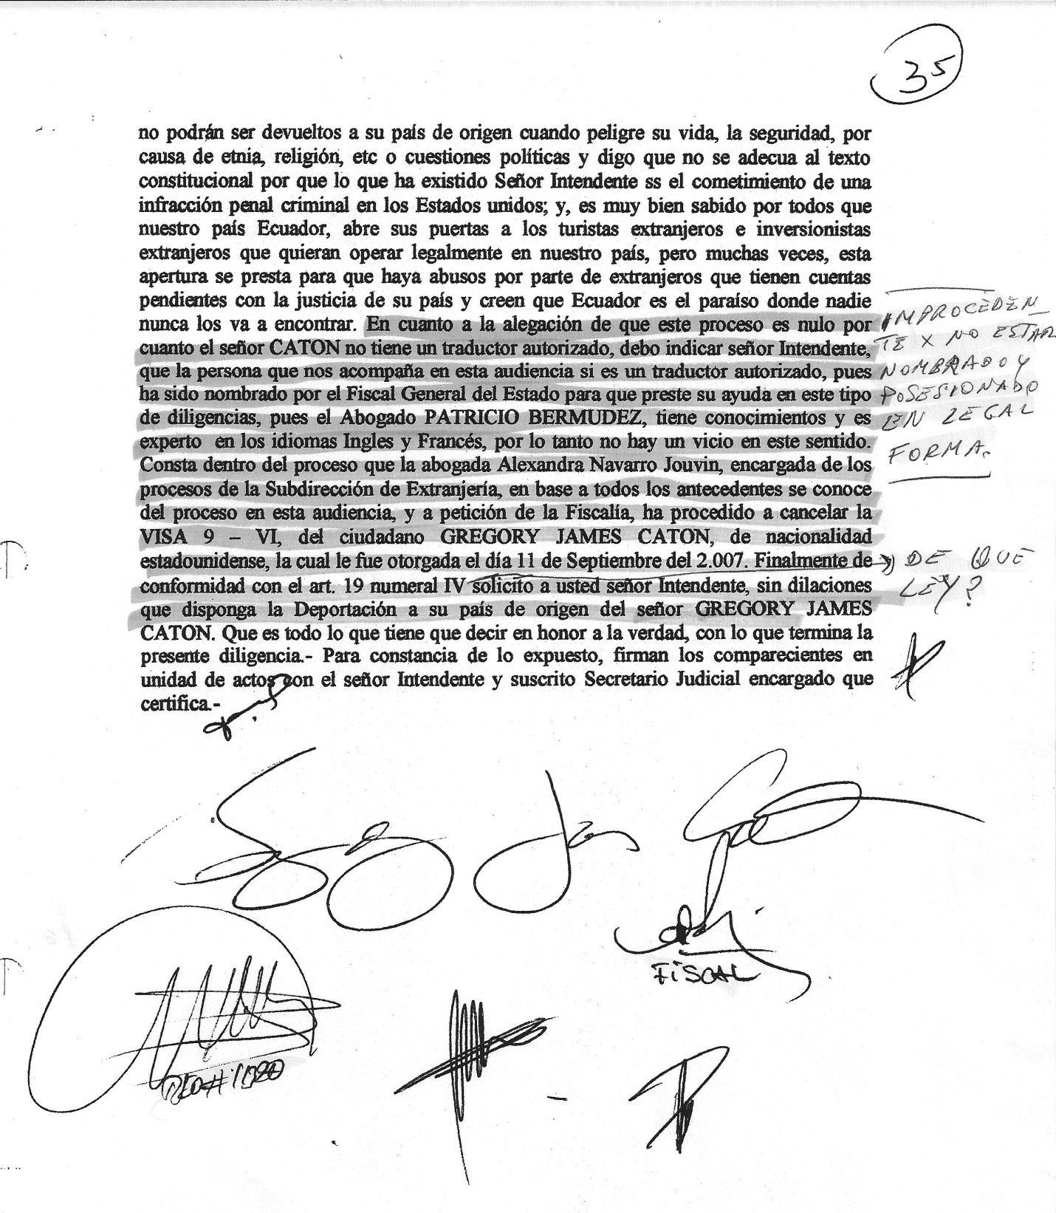

In Guayaquil, twenty six days of the month of June, two thousand nine, at sixteen hours and five minutes, [Editor’s Note: this meeting had to occur around December 4, 2009, so why the official record would say June 26, 2009, is a complete mystery. It is, however, completely consistent with the disregard for facts prevailing in this case] before ATTY. JULIO CESAR QUINONES, GENERAL MAYOR OF THEPOLICE DEPARTMENT OF GUAYAS and undersigned Judicial clerk as well as ATTY. ABRAHAM CHEING FALCONES, DISTRICT PROSECUTOR OF CRIMINAL, TOURISM AND IMMIGRATION AFFAIRS OF GUAYAS and Atty. DORLANDIG TOALA QUIJIJE, with professional registration no. 11370 of the Bar Association of Guayas, who is the private lawyer, appeared the North American citizen GREGORY JAMES CATON, with the object to comply with the prior Criminal Ruling of Deportation, having come together to have this respective Hearing. In this regard, being in the indicated day and hour, the Mayor proceeded to declare the present procedure open. Immediately thereafter, gave the floor to the aforesaid citizen of North American nationality, who used it and SAID: to be from LAKE CHARLES, State of Louisiana, United States of America, was 53 years old, with the profession of Businessman, with the religion of Anglican [Editor’s note: SIC – this was never stated, as Caton is not, nor never has been, an Anglican], as and does not bear his documents. [Editor’s note: at the time of arrest Caton had his driver’s license but not his cedula or other legal papers in his vehicle]. Immediately after being read the Criminal Ruling of Deportation, he STATED: That he does not know what the lawsuit is about and what the charges are. About that subject, he could have said more than two hundred pages in English and Spanish for being a well known topic. Although it is true that Ecuador is corrupt as well as other Latin American countries, in his opinion the American Government is even more. [sic . . . this statement is a revision of what Caton actually said: he stated that his reason for being in Ecuador, among other things, was that the U.S. Government had no right to characterize Ecuador as being corrupt, since the U.S. Government has become far more so.] On the web site www.meditapia .org. [sic. www.meditopia.org] The reason why I came to Ecuador is because this country is more open to respecting other types of alternative medicine, folk healers, etc. This is all that he can state in honor of the truth. At this moment, Atty. DOARLING TOALA QUIJIJE, in his capacity as the defendant’s lawyer, is given the floor and STATED: Mayor, Prosecutor, in the name and representation of Mr. GREGORY JAMES CATON, I must say in first place: I reject the Prior Investigation No. 163-2009 initiated by the Prosecutor present here for the alleged offense of Illegal Residence, for being wrongful, illegal and attempting against the Human Rights of my client. Moreover, the First Criminal Judge of Guayas released my client as the Intendente here present is informed. Intendente, in concordance with Article 9 of the Constitution of our Republic, I request the rights of this North American citizen to be respected. The right to a due process has been infringed according to Articles 75 and 76 of our Constitution as well as Article 77, numeral 7, subsection a) that states: “7. The right of all persons to defense includes: ( a ) To be informed, previously and in detail, in their own language and in simple words, about the claims and proceedings being filed against them and about the identity of the authority responsible for the claim or proceedings being filed.” Prosecutor, I state this because at this moment it is evident that the citizen GREGORY JAMES CATON does not understand Spanish. Here we have a translator that is not authorized and brought by the Prosecutor; this is evidence of what I just mentioned. As well as the version stated at this moment, it is evident that the very basis of Article 66, 14, second subsection has been infringed. “Foreigners cannot be returned or expelled to a country where their lives, liberty, safety or well-being or those of their families are in danger because of their ethnic belonging, religion, nationality, ideology, belonging to a given social group or political opinions.” This way it is put into evidence the political differences of my client with his country of origin. - The Constitution states that foreigners cannot be returned or expelled to a country where their lives, liberty, safety or well-being or those of their families are in danger because of their ethnic belonging, religion, nationality, ideology, belonging to a given social group or political opinions. Intendente, I say that this situation does not comply with the Constitutional text because a criminal offense has been committed in the United States and it is well known that our country opens its doors to foreign tourists and investors that wish to legally operate here, but many times this opening produces abuse from foreigners that have unattended accounts with the justice of their country and therefore think that Ecuador is the paradise where nobody will find them. About the claim that this process is void because Mr. CATON does not have an authorized translator, I should indicate, Intendente, that the person who is here in this Hearing is an authorized translator since he has been assigned by the General Mayor of State to help us in this type of procedures since Atty. PATRICIO BERMUDEZ has knowledge and is an expert in the languages of English and French. Therefore, there is no defect in this sense. It is also included in this process that Atty. Alexandra Navarro Jouvin, clerk of proceedings of the Sub-directorate of Immigration, based on all the precedents and by petition of the Prosecutor’s Office, has proceeded to cancel the 9-VI VISA of the citizen GREGORY JAMES CATON, with North American nationality that was issued on September 11, 2007. Finally, in compliance with Article 19, numeral IV, I request you, Mayor, without delays, to order the Deportation of GREGORY JAMES CATON to his country of origin. That this is all he states in honor of the truth, whereupon the present procedure was formalized. - As evidence of the stated, the appearing parties signed at the same time and in the same place with the Mayor and Judicial clerk who certified it.

(Illegible signatures)
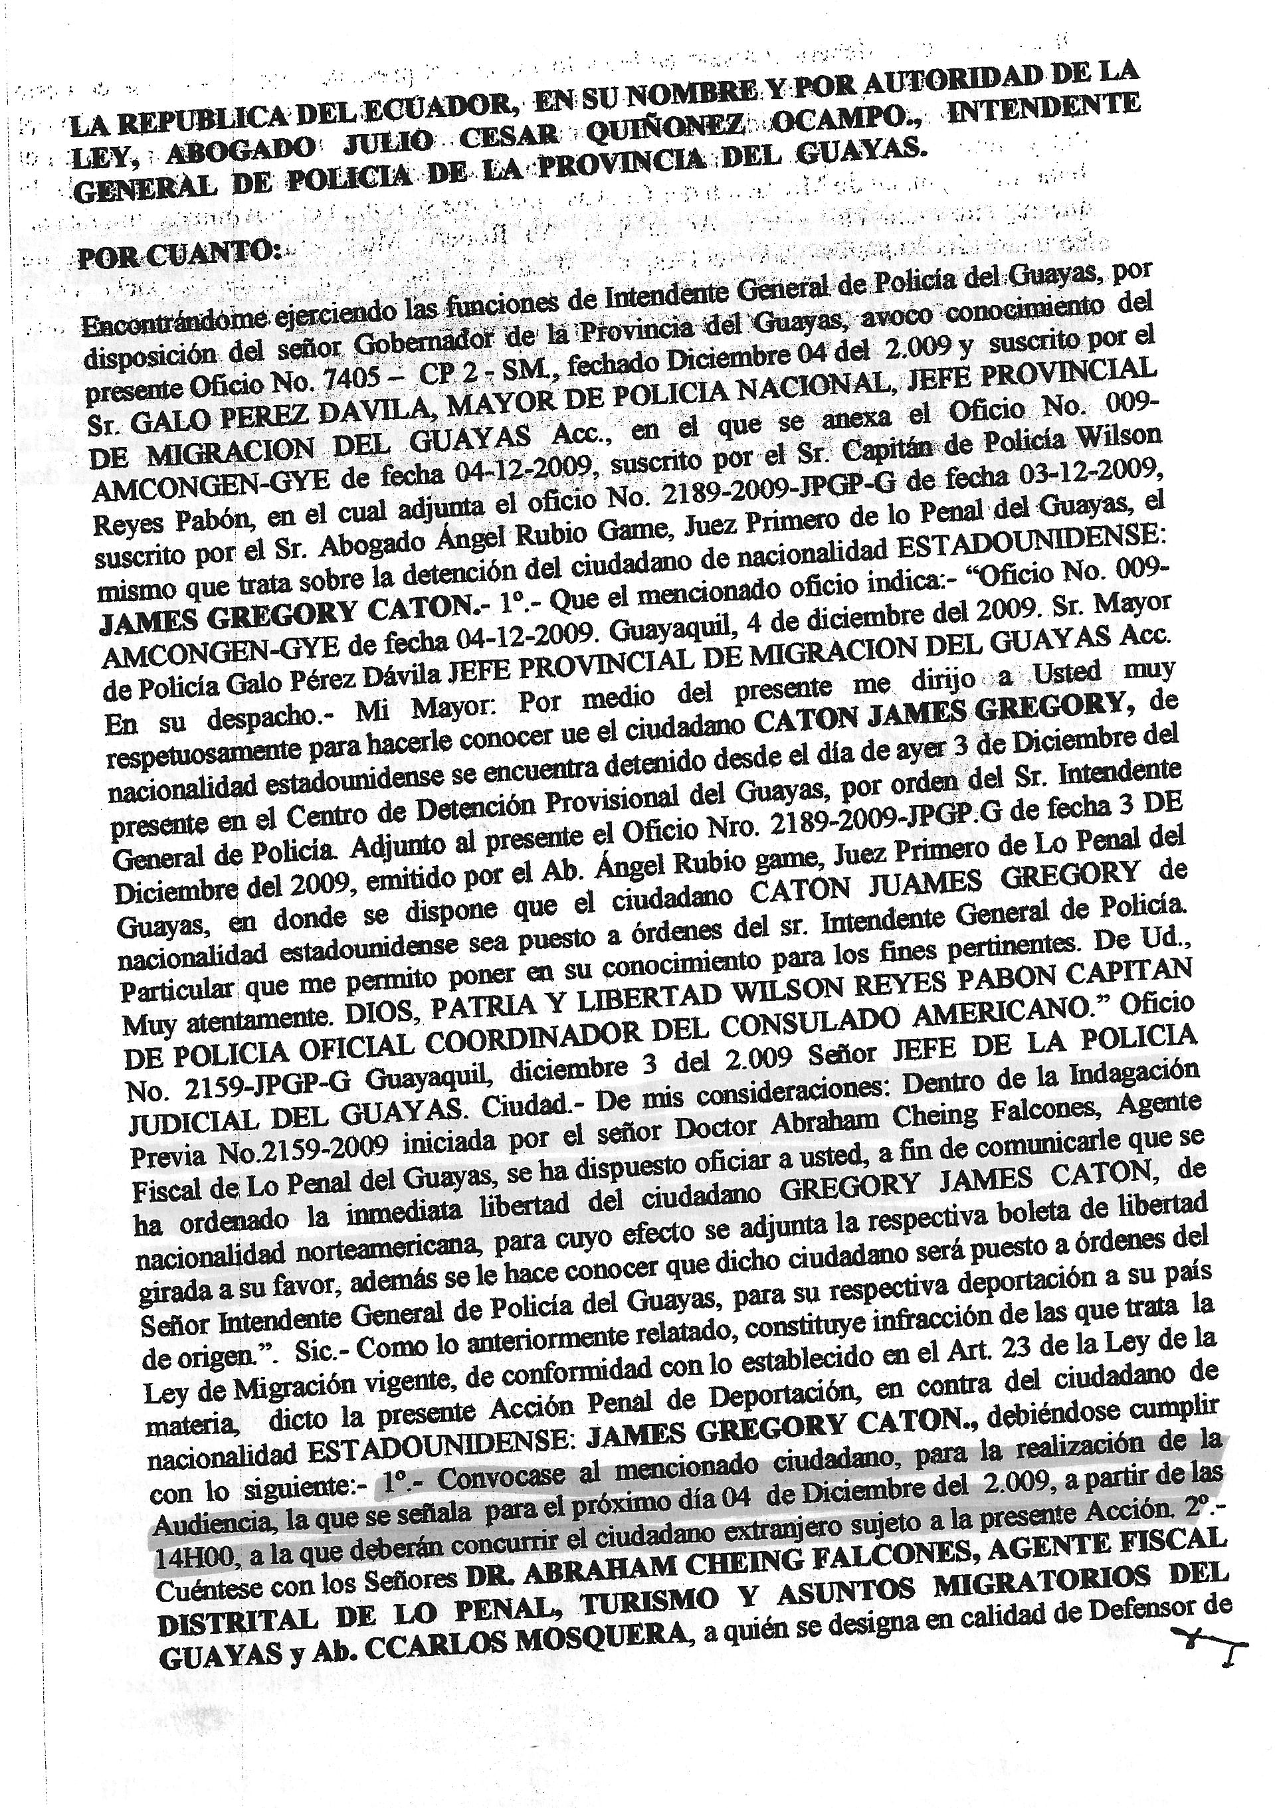
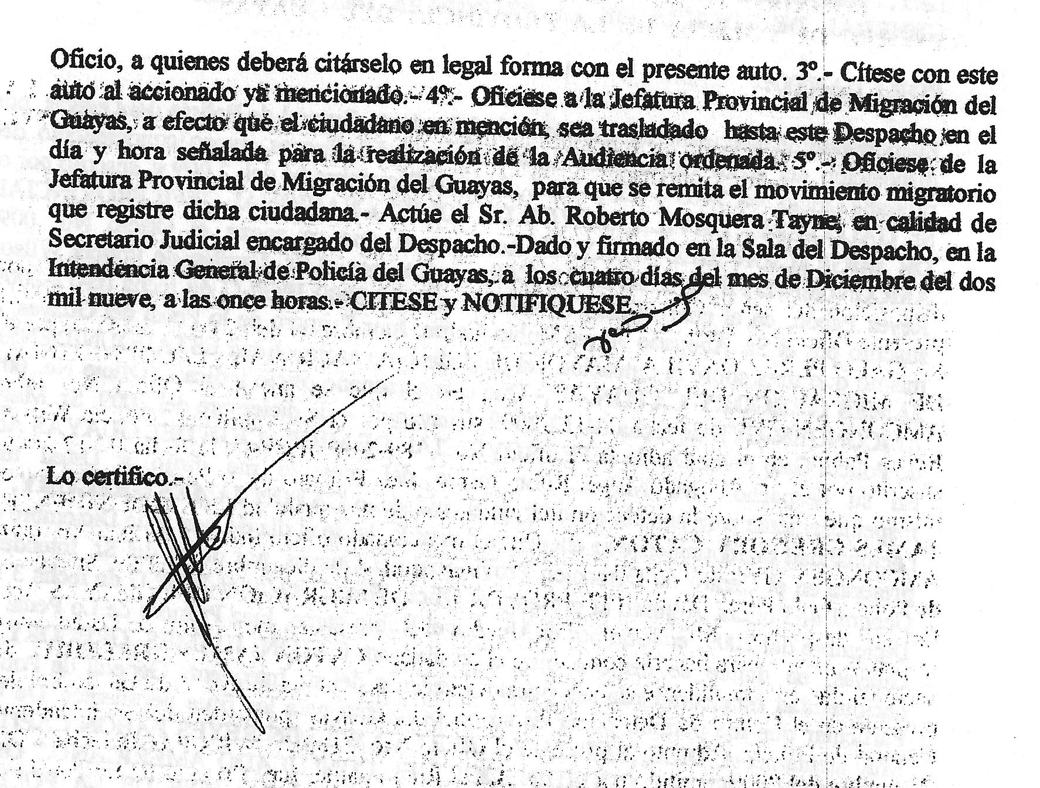

THE REPUBLIC OF ECUADOR, ON ITS BEHALF AND BY AUTHORITY OF LAW, ATTORNEY JULIO CESAR QUINONEZ OCAMPO, GENERAL MAYOR OF THE POLICE DEPARTMENT OF GUAYAS.
WHEREAS:
Acting in the capacity as General Mayor of the Police Department of Guayas, as ordered to me by the Governor of the Province of Guayas, I take over this present Official Action number 7405- CP 2 –SM of December 4, 2009 and undersigned by Mr. GALO PEREZ DAVILA, CHIEF OF THE NATIONAL POLICE, acting PROVINCIAL HEAD OF IMMIGRATION OF GUAYAS which is annexed by Official Action number 009-AMCONGEN-GYE of 04-12-2009, undersigned by Captain of Police Wilson Reyes Pabon that is attached by Official Action number 2189-2009-JPGP-G of 03-12-2009 undersigned by Attorney Angel Rubio Game, First Criminal Judge of Guayas, which is about the arrest of the NORTH AMERICAN citizen GREGORY JAMES CATON. 1. – That the mentioned Official Action number states: “Official Action number 009-AMCONGEN-GYE of 04-12-2009. Guayaquil, December 4, 2009. Chief of Police Galo Perez Davila, Acting PROVINCIAL HEAD OF IMMIGRATION OF GUAYAS. Hand delivered. My Chief: Hereby, by way of this letter, I respectfully inform you that the citizen GREGORY JAMES CATON of North American nationality was arrested in the Provisional Detention Center of Guayas yesterday, December 3rd, by order of the General Mayor of the Police Department. Annexed to this document is the Official Action number 2189-2009-JPGP-G of December 3, 2009 issued by Atty. Angel Rubio Game, First Judge of Criminal Guarantees of Guayas where it is stated that the citizen GREGORY JAMES CATON, of North American nationality be under orders of the General Mayor of the Police Department. This is what I hereby notify for all legal purposes. Sincerely, God, Fatherland and Liberty- (Illegible signature) WILSON REYES PABON, POLICE CAPTAIN, COORDINATOR OF THE AMERICAN CONSULATE”, “Official Action number 2159-JPGP-G Guayaquil, December 3, 2009. HEAD OF THE JUDICIAL POLICE OF GUAYAS- City– to Whom It May Concern- In the Prior Investigation No.2159-2009 initiated by Doctor Abraham Cheing Falcones, Prosecutor of Guayas, it is ordered to notify with the purpose of informing you that the immediate release of the North American citizen GREGORY JAMES CATON has been ordered. For that effect, the respective release order is annexed. Also, we inform you that such citizen will be put under orders of the General Mayor of the Police Department of Guayas for the respective deportation to his country of origin.” Sic. – As aforesaid, it is an infringement that the current Immigration Law states in accordance with Article 23 of the Law being discussed, I issue the present Criminal Prosecution of Deportation against the NORTH AMERICAN citizen JAMES GREGORY CATON. It must be complied with the following: - 1. – To summon the mentioned citizen in order to carry out the Hearing set for December 04, 2009 at 14H00, to which the foreign citizen must attend since he is subject to the present Prosecution. [emphasis added] 2. – It is ordered to count with the presence of DR. ABRAHAM CHEING FALCONES, DISTRICT PROSECUTOR OF CRIMINAL, TOURISM AND IMMIGRATION AFFAIRS OF GUAYAS and Atty. CARLOS MOSQUERA, in his capacity as a public defender. They must be summoned in a legal form with the present decision. 3. – It is ordered to summon the above mentioned defendant with this decision. – 4. – Officially notify the Provincial Office of Immigration of Guayas for the purpose of having the aforesaid citizen transferred to this Court on the appointed day and hour in order to carry out the ordered Hearing. 5. – Officially notify the Provincial Office of Immigration of Guayas so that the migratory movement registered by the mentioned citizen can be sent. – Atty. Roberto Mosquera Tayne must act in his capacity as the Judicial Clerk in charge of the Court. - Issued and signed at the Court of the General Mayor’s Office of the Police Department of Guayas on December four, two thousand nine, at eleven o’clock. It is ordered to summon and notify.
I certify –
(Illegible signature)

