Illegal Cancellation of Visa: Dec. 4, 2009

Background: Within hours of the arrest, the U.S. Passport of Gregory James Caton was cancelled, followed within 24 hours with the illegal cancellation of his Ecuadorean visa. Documents supporting these facts and the timeline are provided below.
All legal authorities that the Caton family subsequently discussed this case with indicated that this second action was completely illegal. It was executed without an investigation, without due process, and by an authority other than the one which is legally entrusted with this action: higher officials with the Ministry of Immigration.
The letters below provide the proof.
What follows firstly is an official announcement by the U.S. State Department that the Defendant’s U.S. Passport has been cancelled, dated Dec. 3rd, followed by official correspondence by the prosecutor’s office in Guayaquil requesting a cancellation of the Defendant’s Ecuadorean visa; followed by official correspondence on Dec. 4th between a clerk at a Sub-Directorate and the Prosecutor’s Office in Guayaquil that the Ecuadorean visa has been revoked, drafted in Spanish, followed by its English translation. Following that is correspondence from the same clerk to the Guayaquil Chief of Police – again, with the Spanish version followed by its English translation.

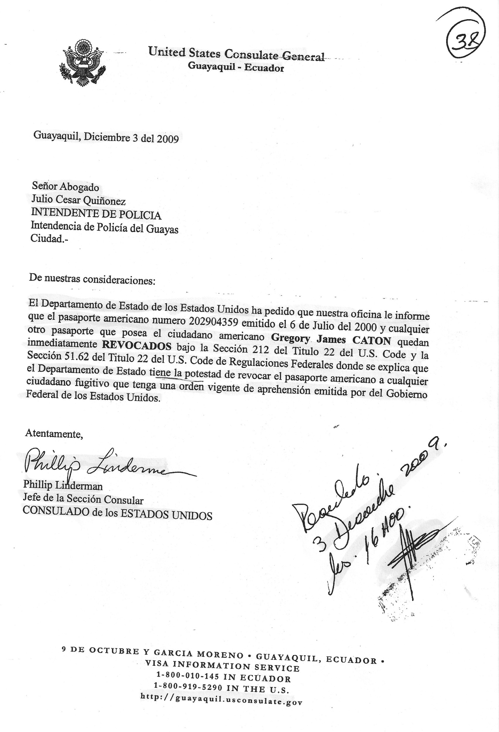
United States Consulate General
Guayaquil – Ecuador

Guayaquil, December 3, 2009

Atty.
Julio Cesar Quinones
POLICE MAYOR
Mayor’s Office of Guayas
City. -

To whom it may concern:

The Department of State of the United States has requested our office to inform that the American passport number 202904359 issued on July 6, 2000 and any other passport possessed by the American citizen Gregory James CATON are immediately REVOKED under Section 212 of Title 22 of the U.S. Code and Section 51.62 of Title 22 of the U.S. Code of Federal Regulations where it is explained that the Department of State has the authority to revoke the American passport to any fugitive citizen that has a current order of arrest issued by the Federal Government of the United States.

Sincerely,

(Illegible signature)
Philip Linderman
Head of the Consular Section
CONSULATE OF THE UNITED STATES

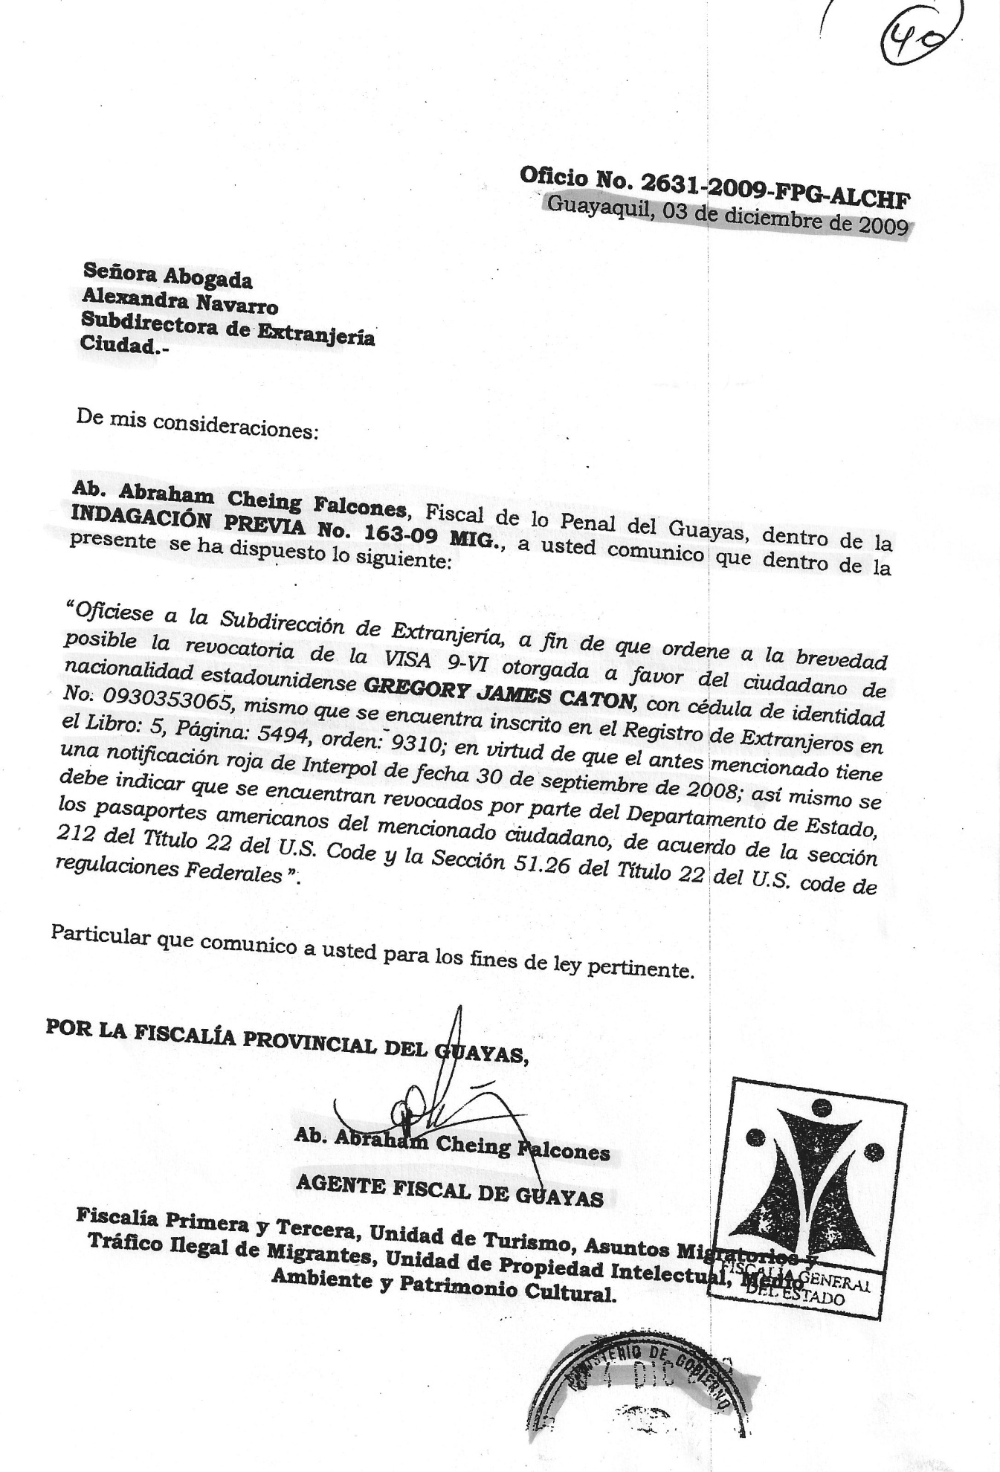
Av. 9 de Octubre y Pichincha,
Edificio del Registro Civil, sótano

Memo No.2631-2009-FPG-ALCHF
Guayaquil, December 03, 2009

Atty.
Alexandra Navarro
Sub-director of Immigration

To whom it may concern:

Atty. Abraham Cheing Falcones, Criminal Prosecutor of Guayas, in the PRIOR INVESTIGATION No. 163-09 MIG., inform you that the following has been established:

“Officially notify the Sub-directorate of Immigration as soon as possible to order the revocation of the 9-VI VISA issued in favor of the North American citizen GREGORY JAMES CATON, with ID No. 0930353065 that is registered in the Registry of Foreigners, Book 5, Page 5494, order 9310; by virtue whereof the above mentioned citizen has a red notice in the Interpol on September 30, 2008. Also, it must be stated that the American passports of this citizen are revoked by the Department of State, in concordance with Section 212 of Title 22 of the U.S. Code and Section 51.26 of Title 22 of the U.S. Code of Federal Regulations.”

This is what I hereby inform you for all legal purposes.

BY THE PROSECUTOR’S OFFICE OF THE PROVINCE OF GUAYAS

(Illegible signature)
Atty. Abraham Cheing Falcones
PROSECUTOR OF GUAYAS

First and Third Prosecutor’s Office, Unit of Tourism, Immigration Affairs and Illegal Traffic of Immigrants, Unit of Intellectual Property, Environment and Cultural Heritage.

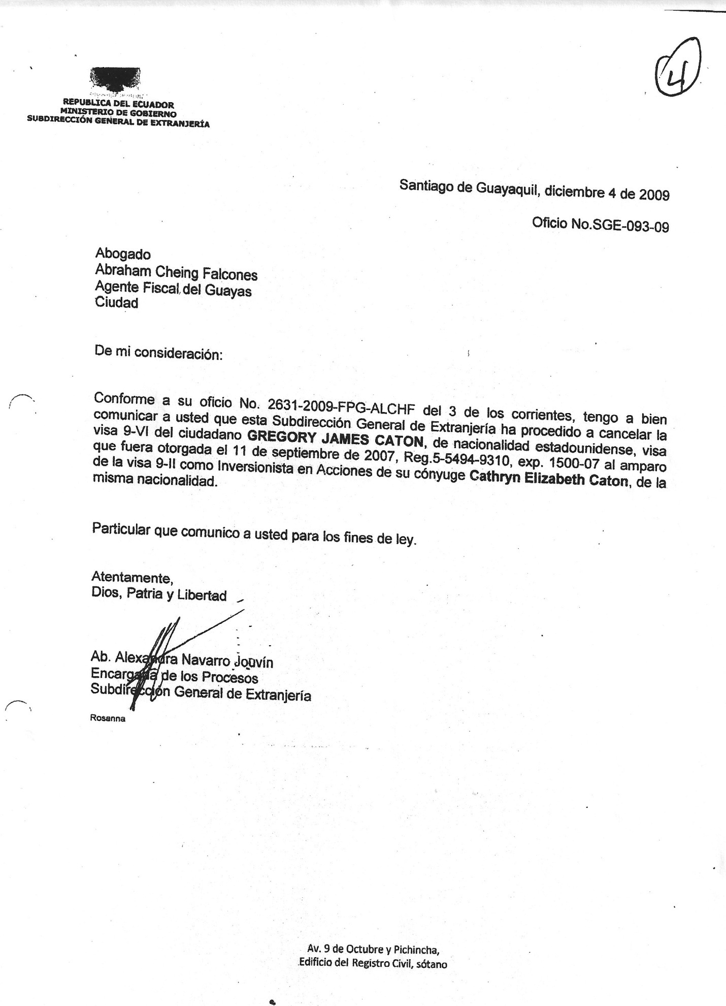

REPUBLIC OF ECUADOR
MINISTRY OF GOVERNMENT
GENERAL SUB-DIRECTORATE OF IMMIGRATION

Santiago of Guayaquil, December 4, 2009
Official Action number SGE-093-09
Attorney
Abraham Cheing Falcones
Prosecutor of Guayas

To whom it may concern:
In concordance with your Official Action number 2631-2009-FPG-ALCHF of December 3rd, I inform you that this General Sub-directorate of Immigration has proceeded to cancel the 9-VI Visa of GREGORY JAMES CATON of North American nationality, visa that was issued on September 11, 2007, Reg. 5-5494-9310, exp. 1500-07 in protection of the 9-II Visa as an Investor in Actions of his spouse Cathryn Elizabeth Caton of the same nationality.
This is what I hereby inform you for all legal purposes.
Sincerely,
God, Fatherland and Liberty
(Illegible signature)
Atty. Alexandra Navarro Jouvin
Clerk of Proceedings
General Sub-directorate of Immigration

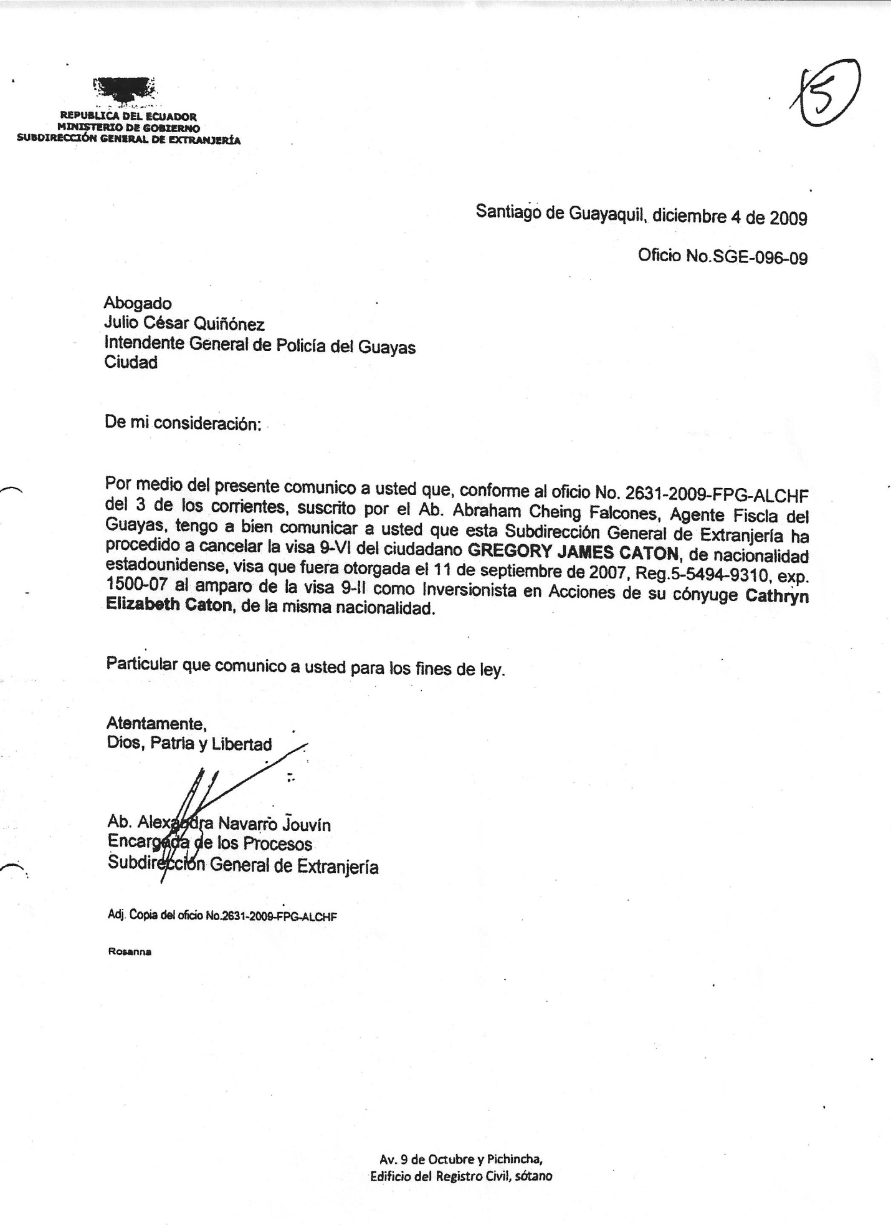

REPUBLIC OF ECUADOR
MINISTRY OF GOVERNMENT
GENERAL SUB-DIRECTORATE OF IMMIGRATION

Santiago of Guayaquil, December 4, 2009
Official Action number SGE-096-09
Attorney
Julio Cesar Quinonez
General Mayor of the Police Department of Guayas

To whom it may concern:
Hereby, by way of this letter, in concordance with Official Action number 2631-2009-FPG-ALCHF of December 3rd issued by Atty. Abraham Cheing Falcones, Prosecutor of Guayas I inform you that this General Sub-directorate of Immigration has proceeded to cancel the 9-VI Visa of GREGORY JAMES CATON of North American nationality, visa that was issued on September 11, 2007, Reg. 5-5494-9310, exp. 1500-07 under the 9-II Visa as an Investor in Actions of his spouse Cathryn Elizabeth Caton of the same nationality.
This is what I hereby inform you for all legal purposes.
Sincerely,
God, Fatherland and Liberty
(Illegible signature)
Atty. Alexandra Navarro Jouvin
Clerk of Proceedings
General Sub-directorate of Immigration

