EXTRAORDINARY MEETING OF ECUADOR’S
ADVISORY BOARD OF MIGRATION POLICY
Quito, Ecuador – April 17, 2012

On April 17th, 2012, the Advisory Board of Migration Policy for the Republic of Ecuador met to discuss the fate of the deportation against Gregory James Caton. When a deportation in Ecuador occurs under the color of law, it stands. You are not legally allowed to come back or remain in the country. From the beginning, it was the position of Caton’s legal counsel that the entire process that was used to “deport” their client on December 11, 2009 was completely illegal

The Ecuadorean Government now agrees.

Beginning on the next page, the original Spanish text of the minutes of the meeting are followed by their English translation.

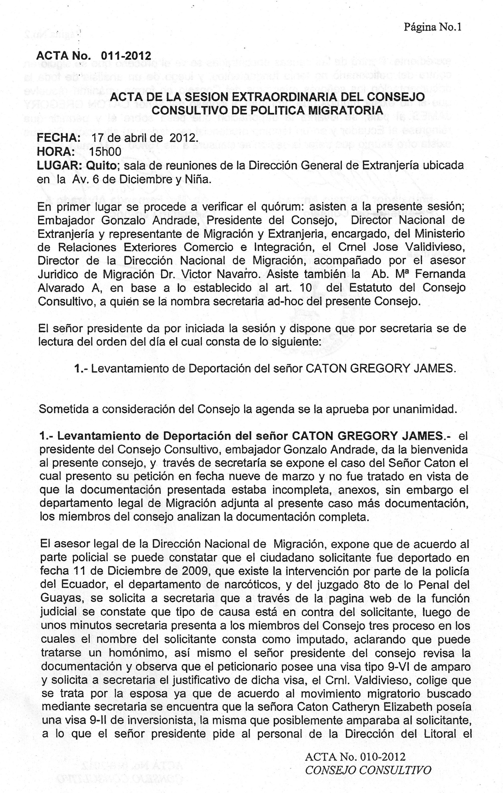
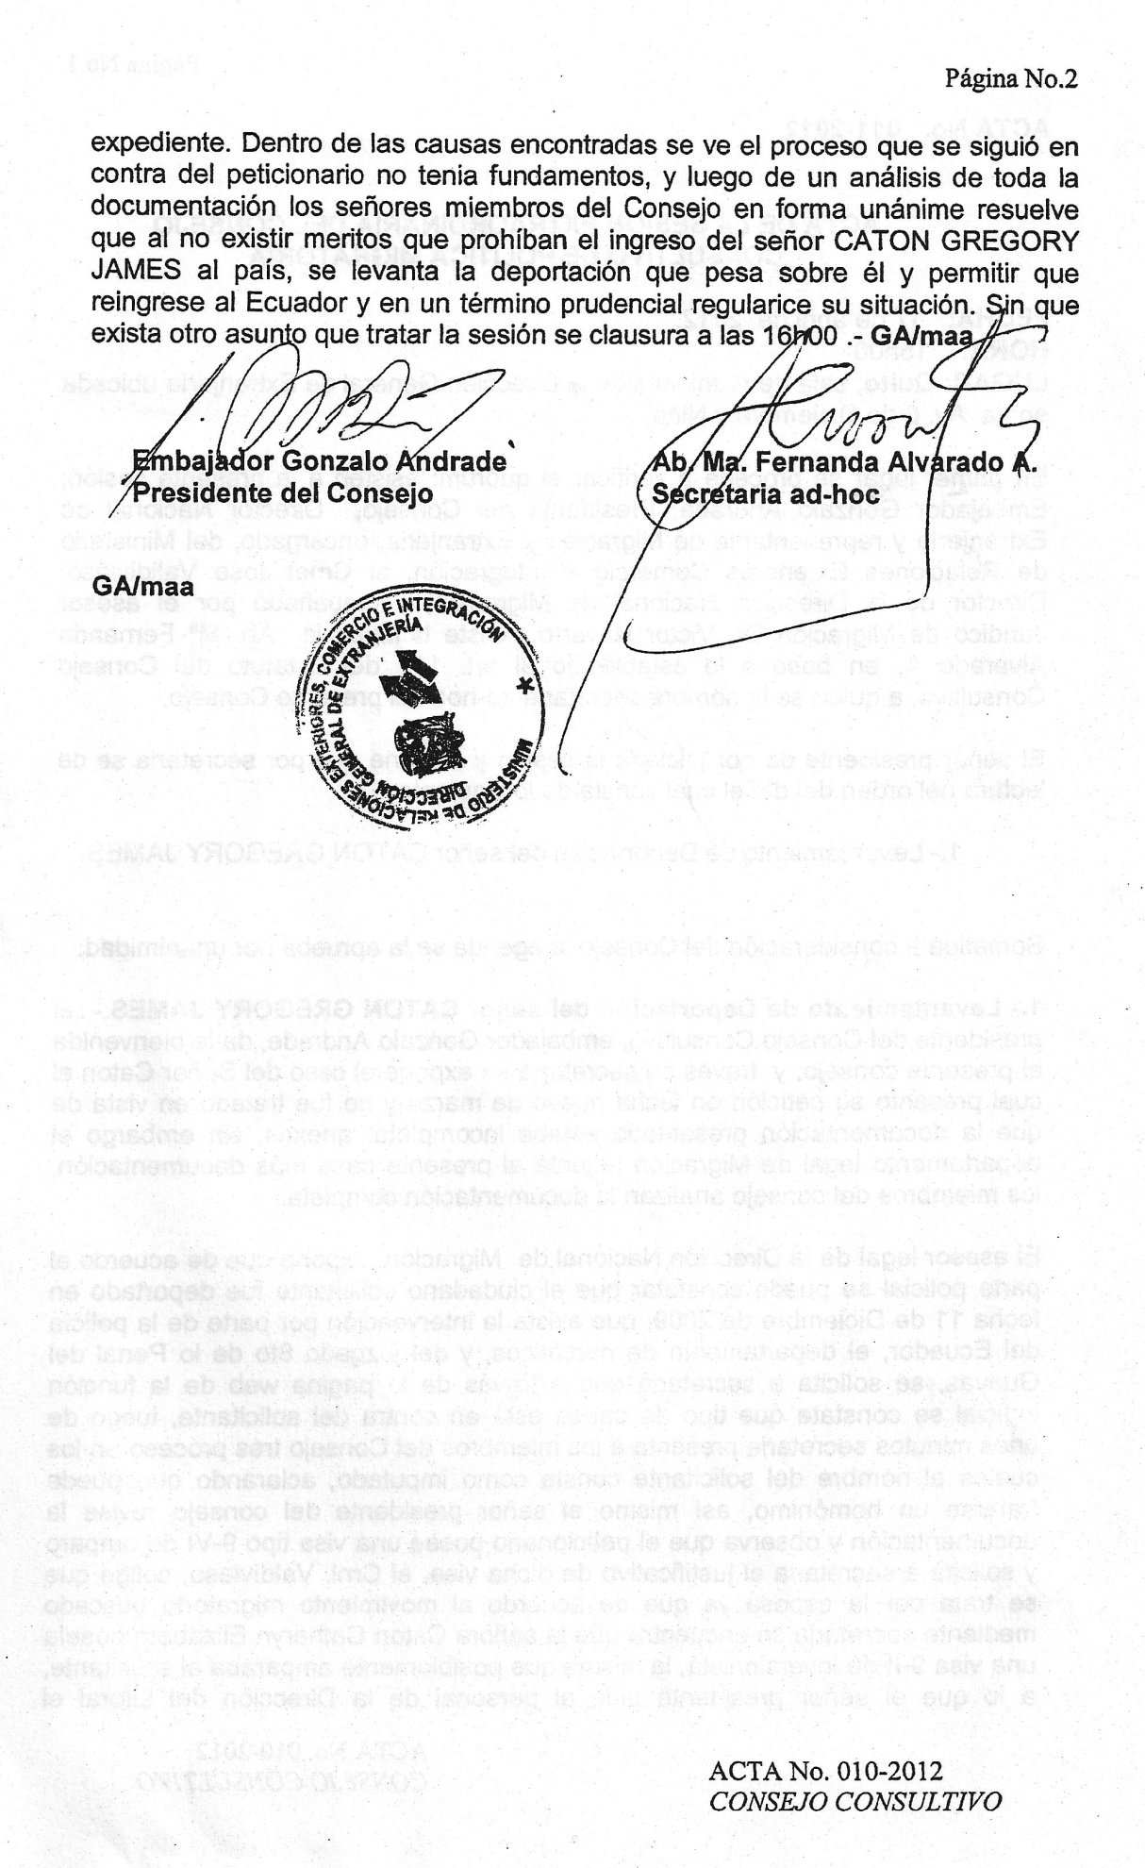
Page number 1
Minute Number 011-2012
MINUTES OF THE EXTRAORDINARY MEETING OF THE ADVISORY BOARD OF MIGRATION POLICY
DATE: April, 17th, 2012.
TIME: 15H00
PLACE: Quito, meeting hall of the General Directorate of Immigration located on Av. 6 de Diciembre and Niña Street.

In first place, it is proceeded to verify the quorum. The assistants of the present meeting are the Ambassador Gonzalo Andrade, President of the Board, National Director of Immigration and Representative of Immigration in charge of the Ministry of Foreign Affairs, Trade and Integration; Col. Jose Validivieso, Director of the National Directorate of Immigration accompanied by the Legal consultant of Immigration, Dr. Victor Navarro. The Atty. Ma Fernanda Alvarado A. also assists and based on Article 10 of the Statute of the Advisory Board, is named secretary ad-hoc of the present Board.
The president starts the meeting and orders the secretary to read the agenda where the following is contained:
- Deportation Revocation of Mister CATON GREGORY JAMES.
Under consideration of the Board, the agenda is approved by unanimity.
- Revoke of Deportation of Mister CATON GREGORY JAMES. - The president of the Advisory Board, Ambassador Gonzalo Andrade, welcomes the present board. Then, through the secretary, Mister Caton’s case is explained, who presented his petition on March 9th (2012), but was not processed since the documentation presented was incomplete. Nevertheless, the legal department of Immigration annexes more documents to the present case; the members of the board analyzed the complete documentation.

The legal consultant of the National Directorate of Immigration states that according to the police report, it can be confirmed that the applicant was deported on December 11th, 2009. There is an intervention by the Police of Ecuador, the Department of Narcotics and the Eighth Court of Criminal Guarantees of Guayas. Through the website of the Judicial Function, the secretary is requested to confirm the type of cause that is against the applicant. After a few minutes, the secretary presents the members of the Board three processes in which the name of the applicant is found as accused, clarifying that it could be another person with the same name. Likewise, the president of the Board examines the documentation and observes that the petitioner has a 9-VI Visa of protection and requests the secretary the justifying documents of such visa, the Col. Valdivieso, indicates that it is because of his wife and according to the immigration entries and exits researched by the secretary, it is found that Mrs. Caton Cathryn Elizabeth possessed a 9-II Visa of Investor, the same that possibly protected the applicant. Therefore, the president requests the expedient from the Directorate of the Littoral. In the causes that are found, it is evident that the process that was followed against the petitioner did not have fundamentals (i.e. a legitimate foundation), and after an analysis of all the documentation, the members of the Board, unanimously resolve that: since there are no merits that prohibit the entry of Mister CATON GREGORY JAMES to the country, the deportation is revoked and allow him to return to Ecuador and in a prudent period of time, resolve his situation. Without any other matter to solve, the meeting ends at 16h00. – GA/maa

(Signature) (Signature)
Ambassador Gonzalo Andrade Atty. Ma. Fernanda Alvarado A.
President of the Board Secretary ad-hoc

