Action of Protection: Dec. 10, 2009

Background: In the aftermath of a favorable ruling allowing for the release of defendant, Gregory James Caton, in his extradition hearing – which was completely ignored by authorities in Guayaquil; the illegal revocation of Caton’s visa; as well as numerous other violations of law and flagrant irregularities, Caton’s legal counsel filed the following “Action of Protection” on behalf of Caton on December 10, 2009.
The court accepted this Protective Action, which did nothing but annoy a lawless U.S. Consulate in Guayaquil, which was openly orchestrating events and manipulating Ecuadorean officials in plain view. The very next day, in order to abort the appellate process, Caton was illegally deported in defiance of a court order, again, at the behest of the U.S. Consulate.
The value of this document is that it further annunciates the complete disregard for law as it applied to this case.
What follows is the original petition, drafted in Spanish, followed by its English translation.

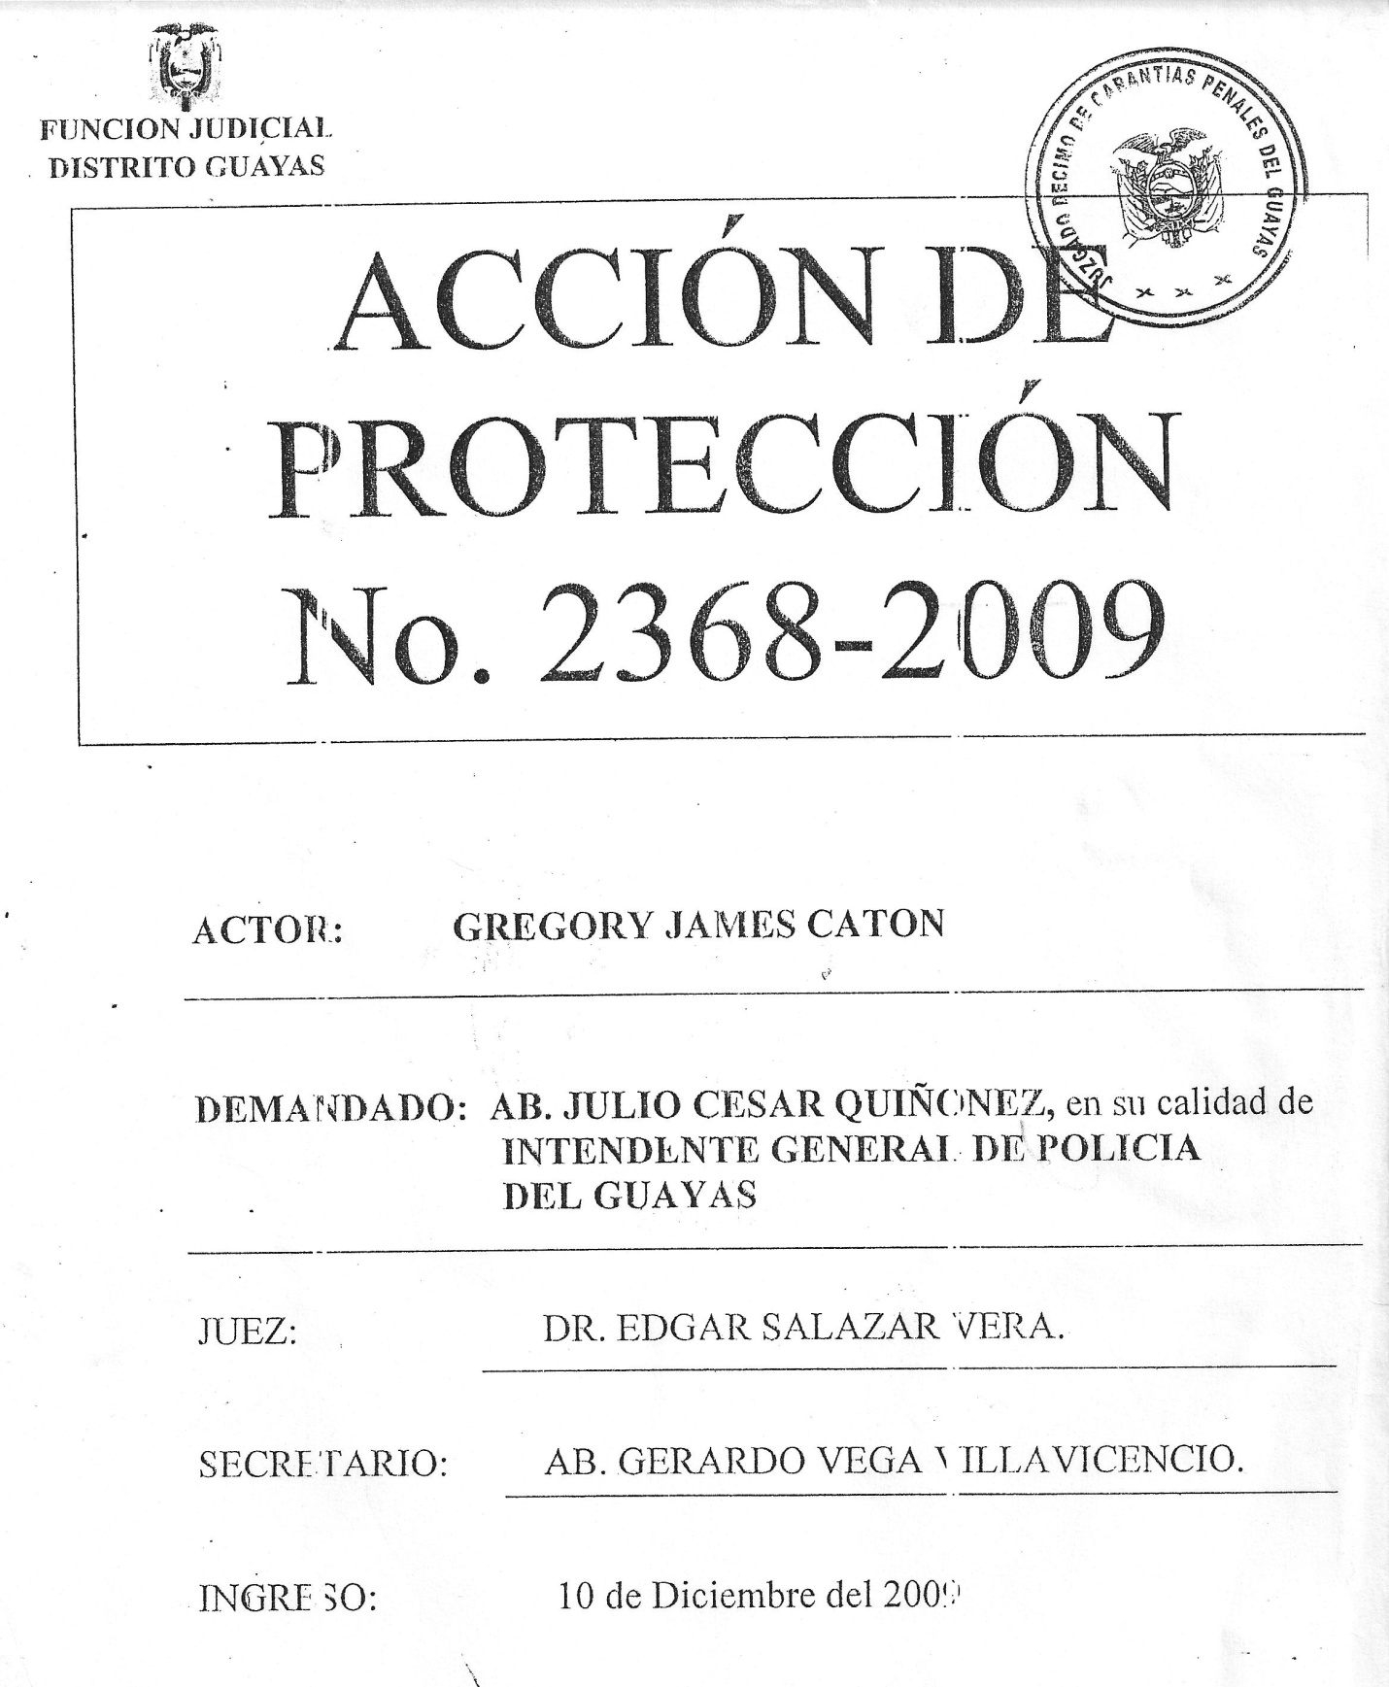

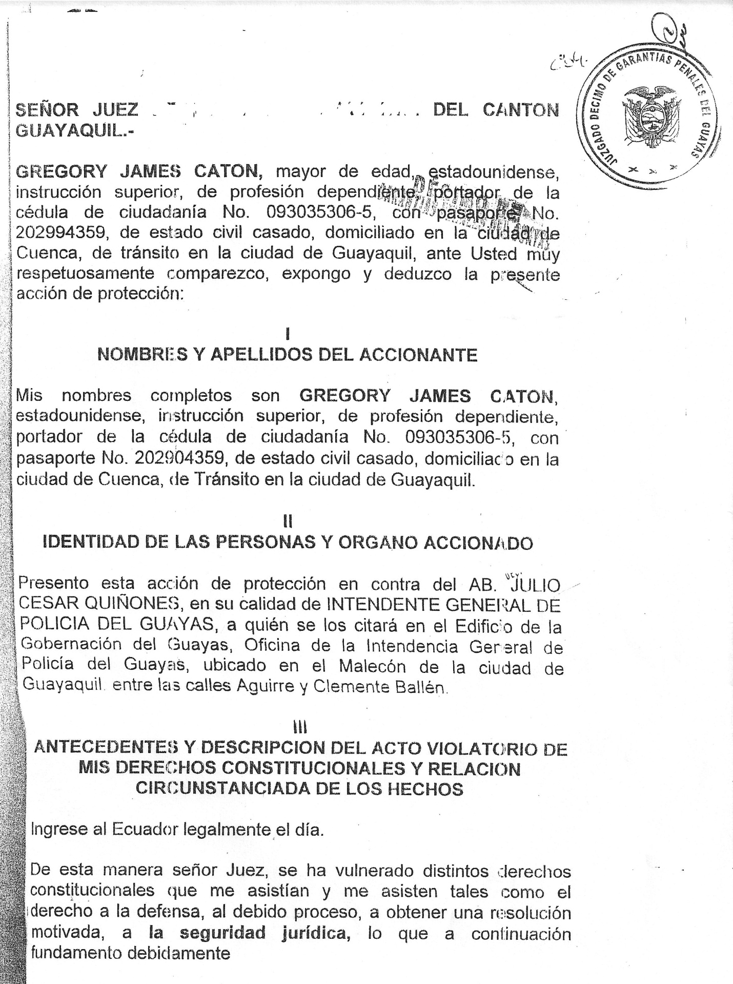
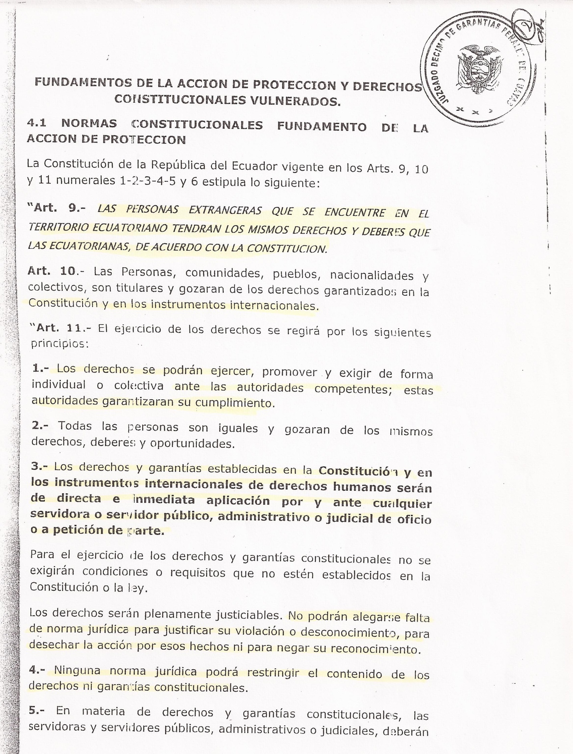
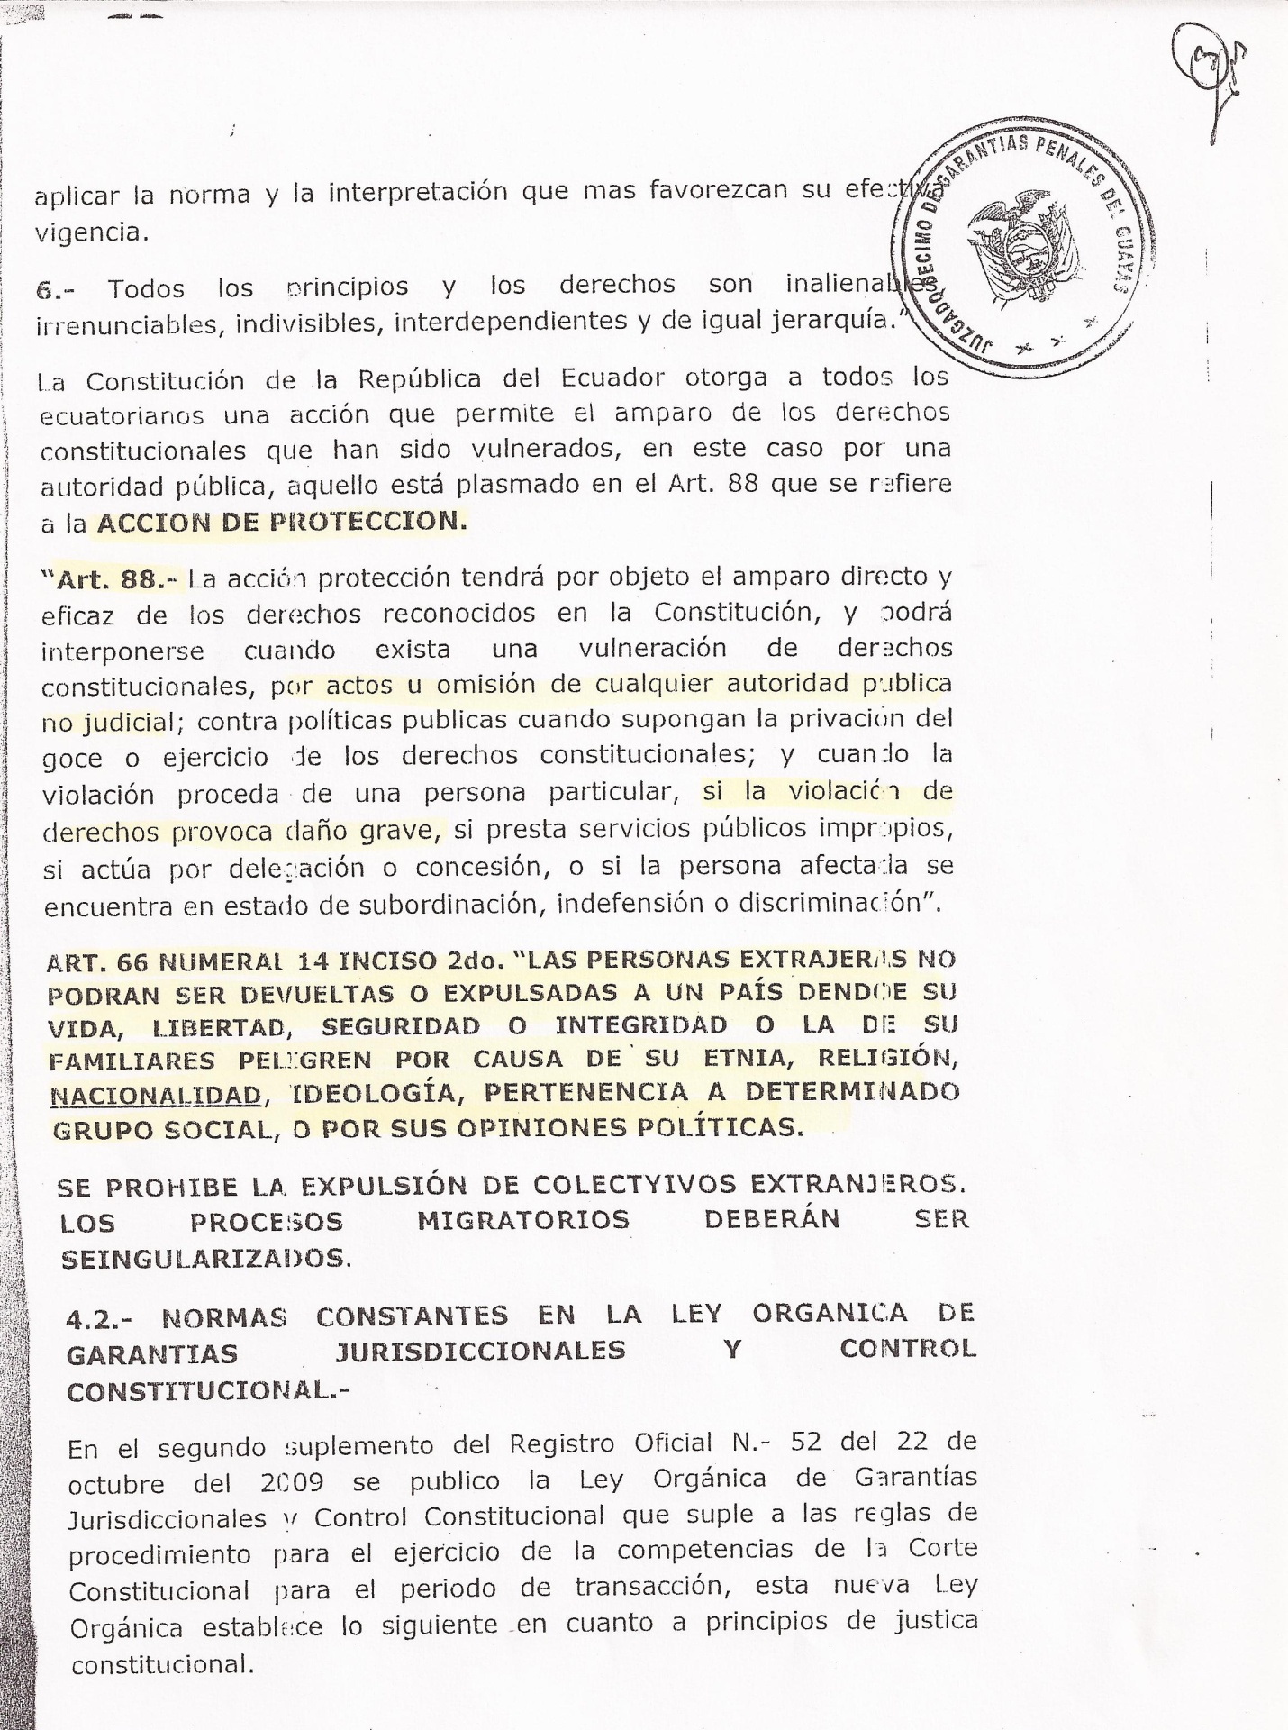
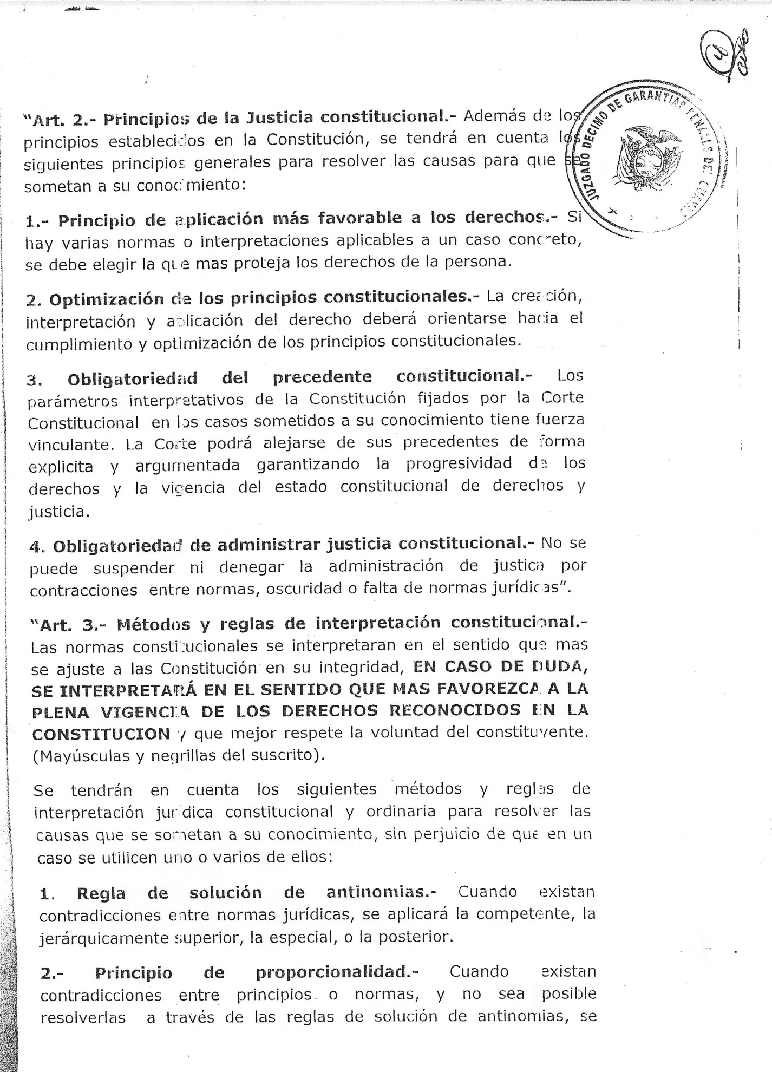
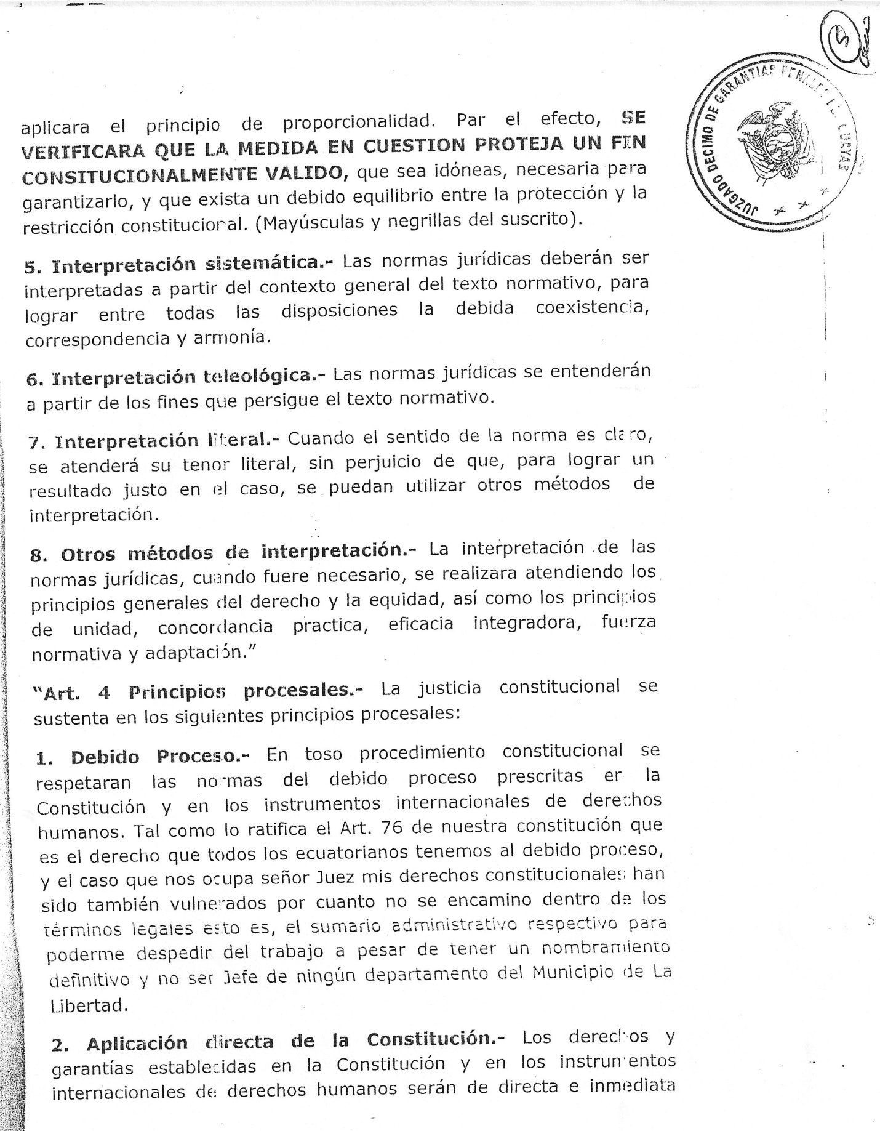

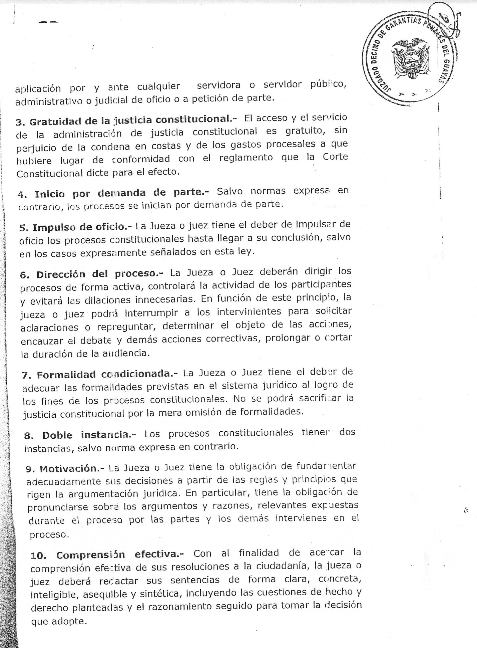
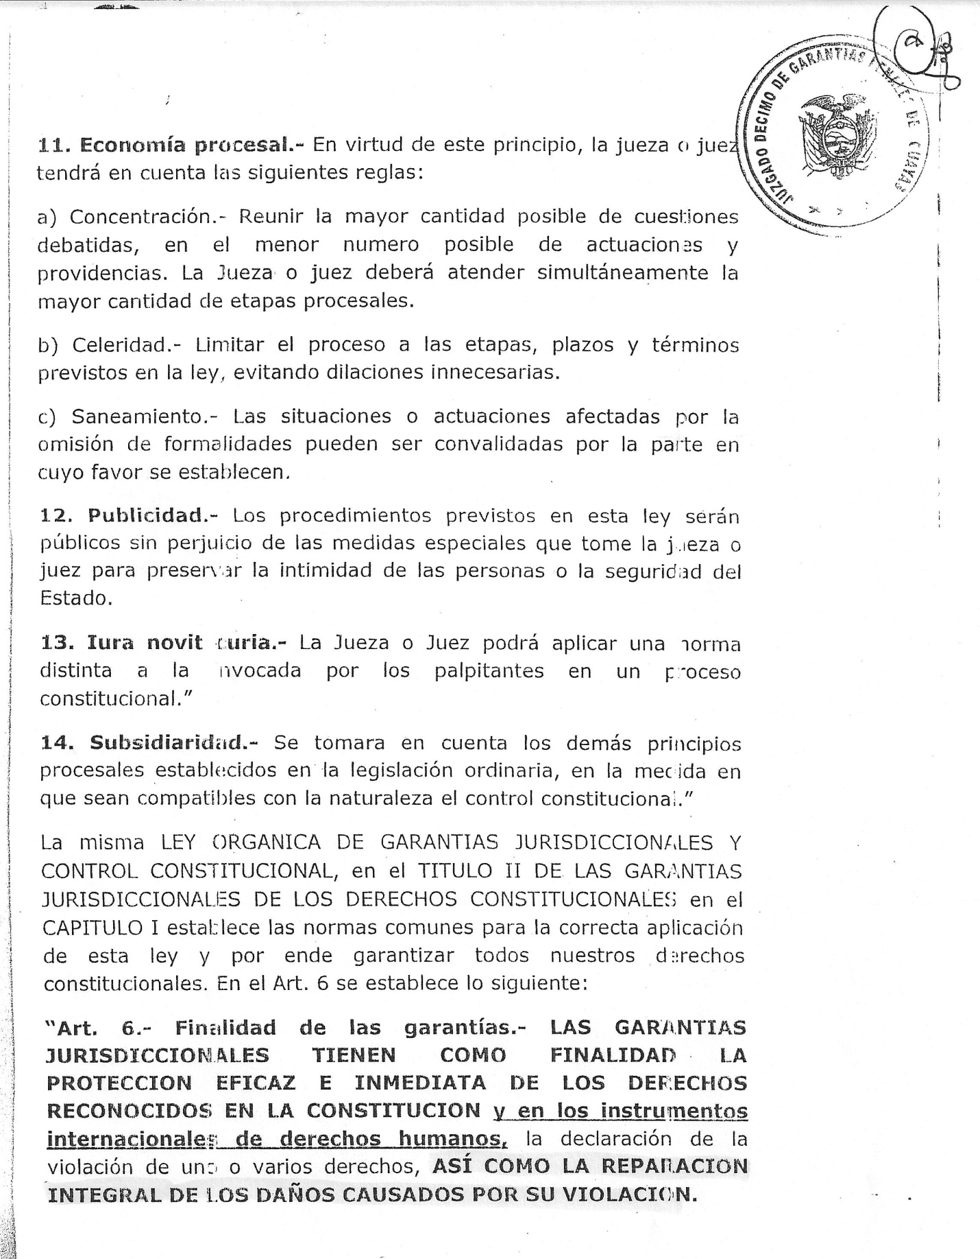

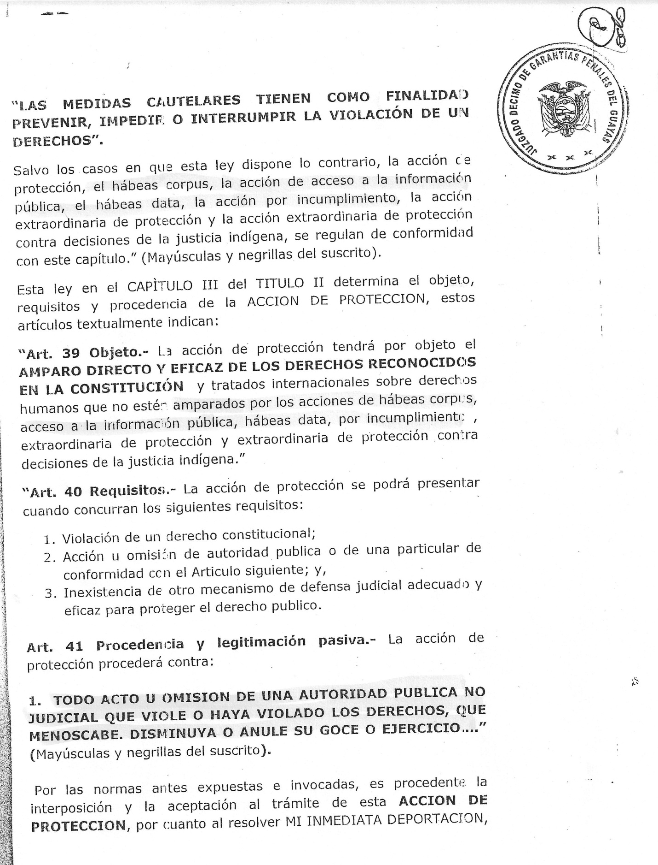

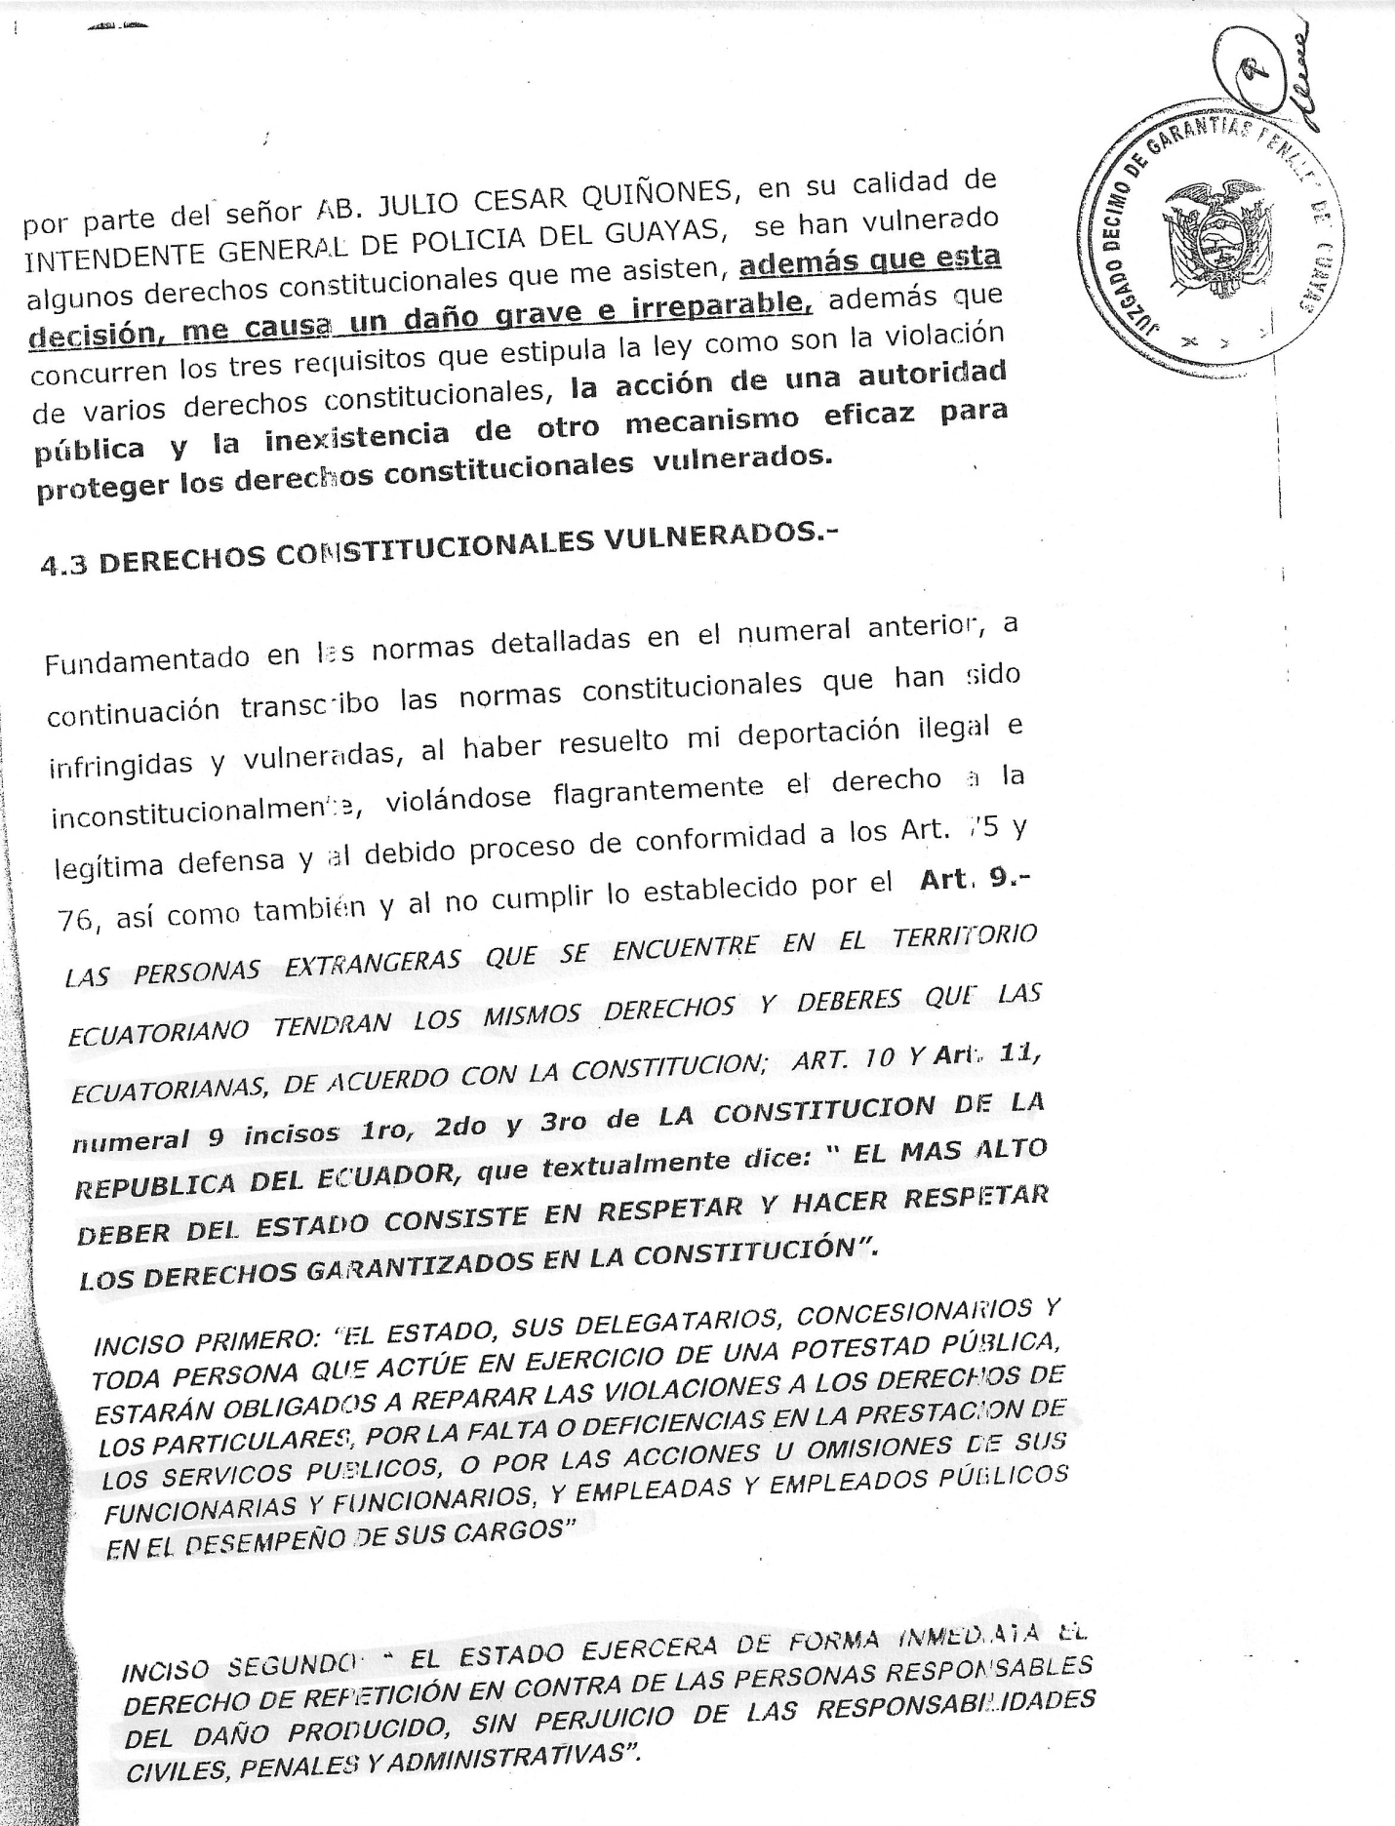

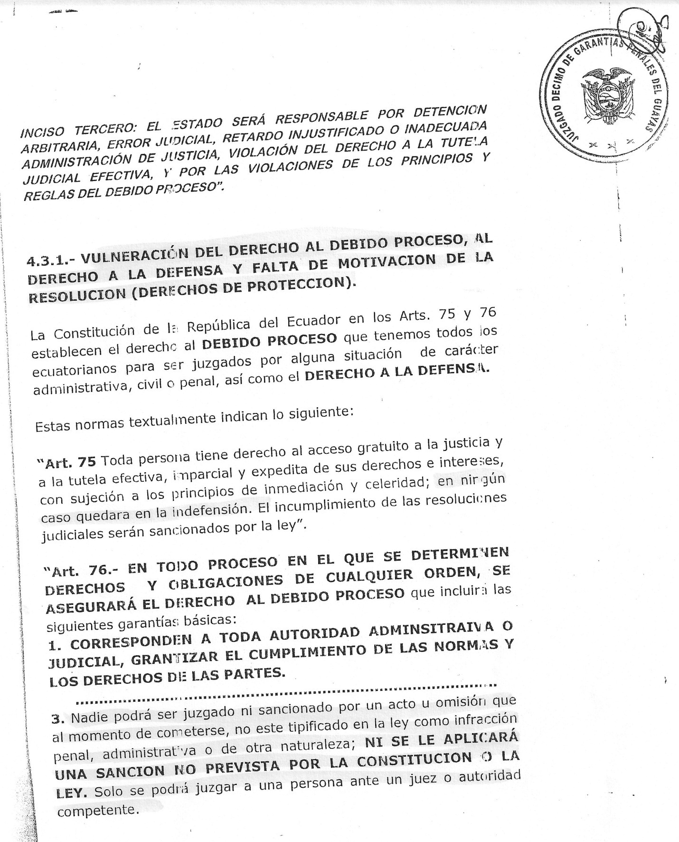

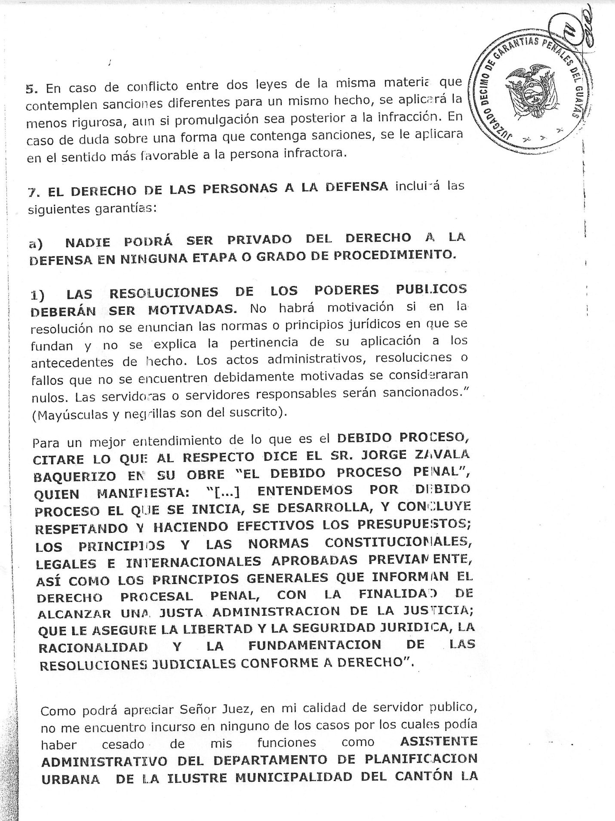
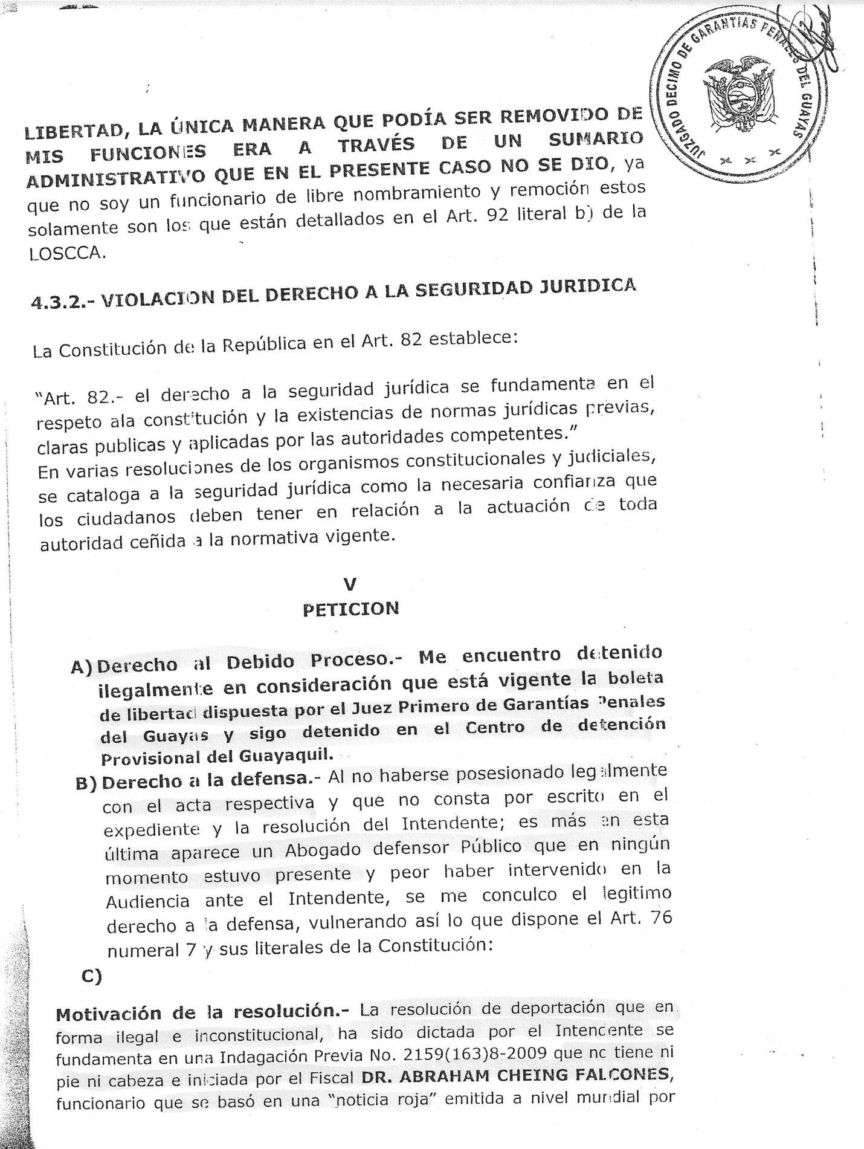
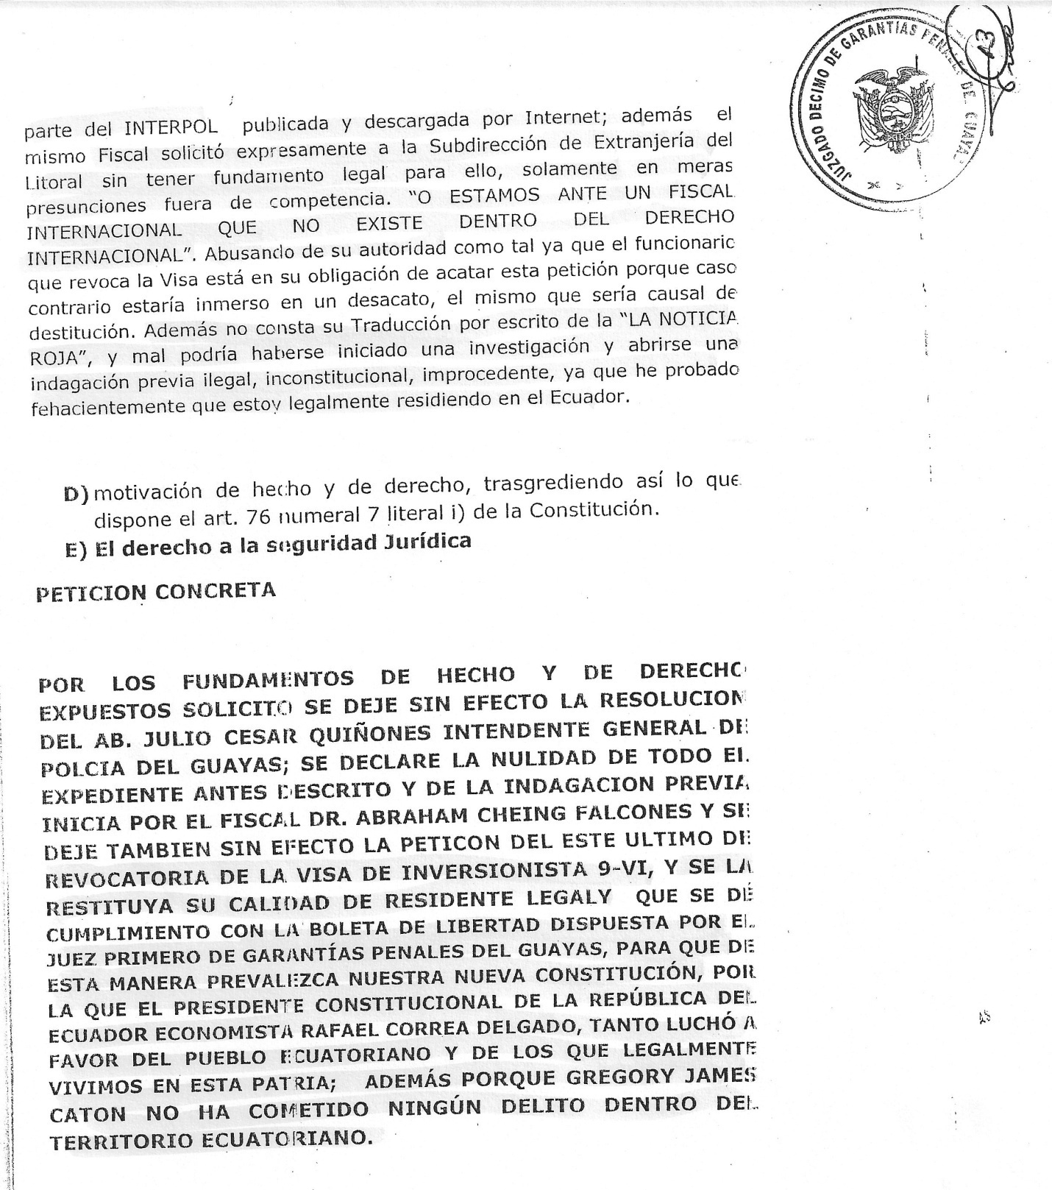

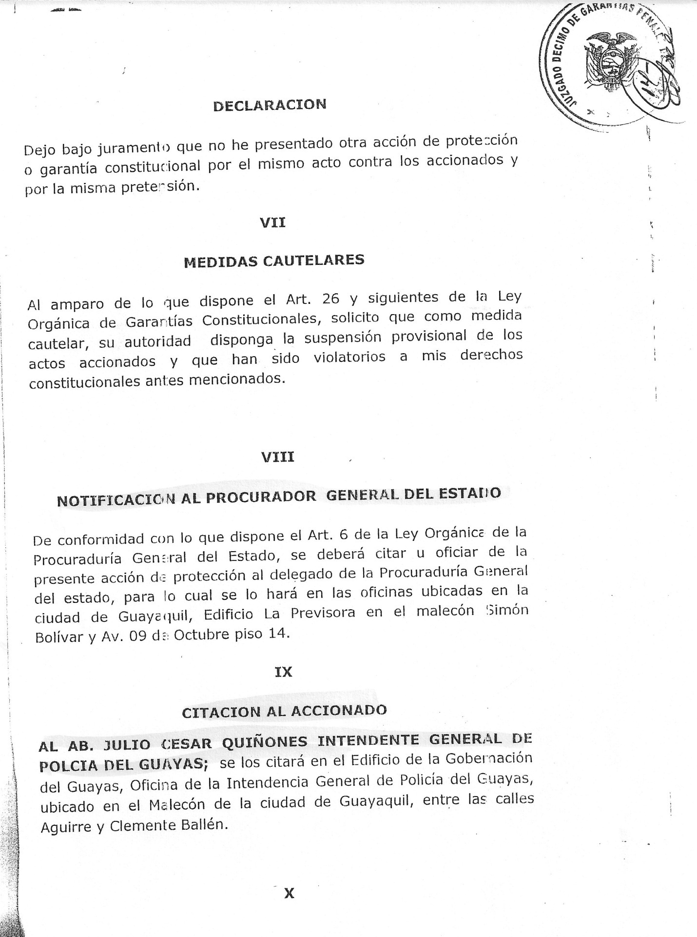
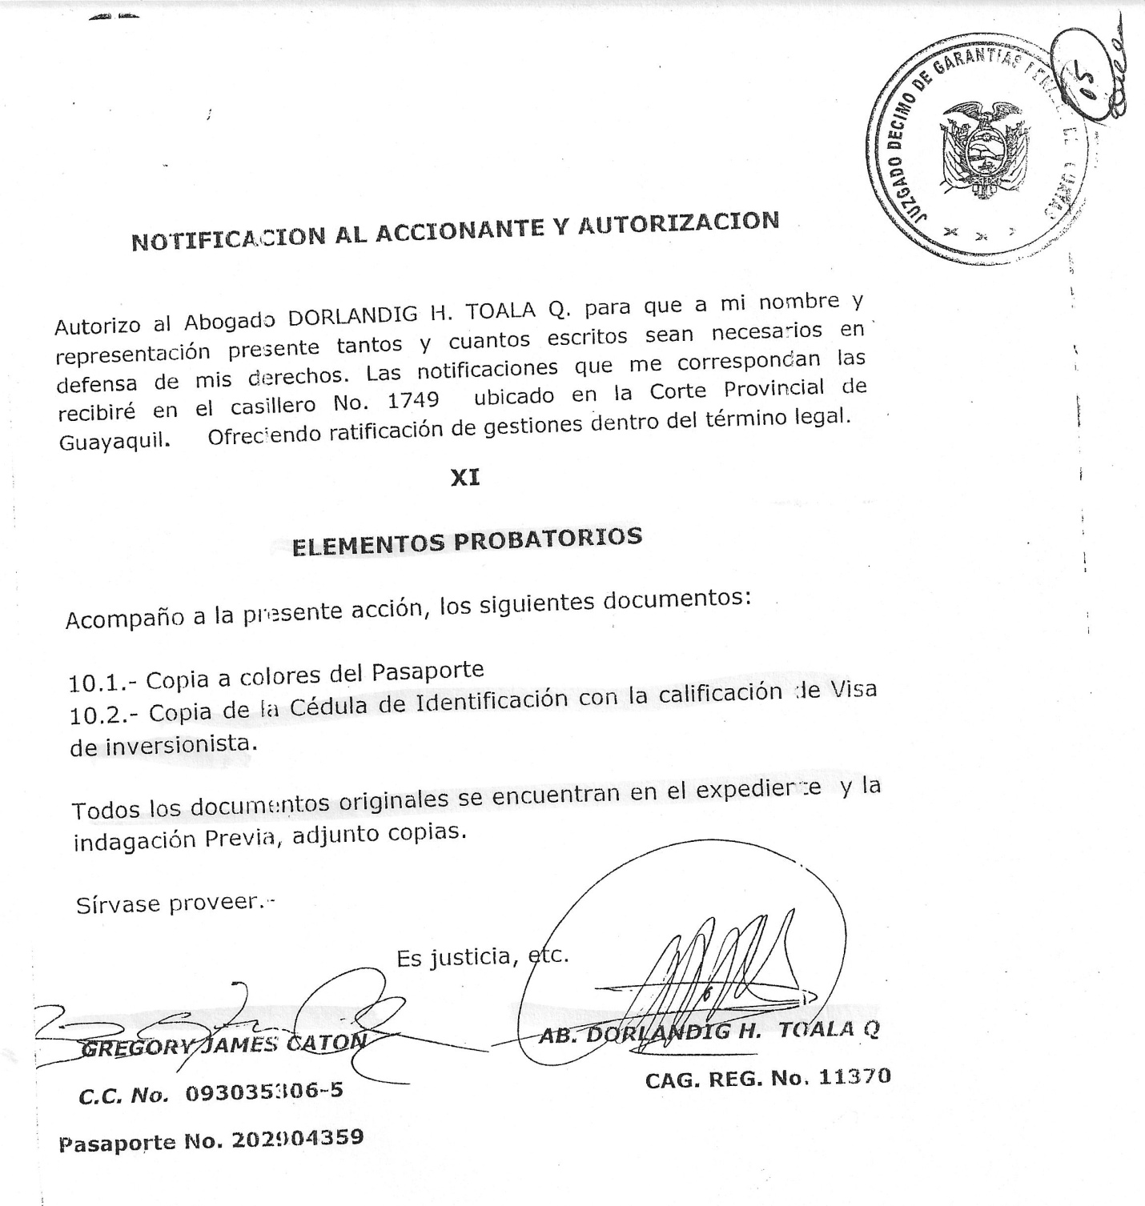

JUDICIAL FUNCTION
DISTRICT OF GUAYAS Round Stamp: Tenth Court of Criminal Guarantees of Guayas

PETITION OF
PROTECTION
No. 2368-2009

PETITIONER: GREGORY JAMES CATON
DEFENDANT: ATTY. JULIO CESAR QUINONEZ in his capacity as
GENERAL MAYOR OF POLICE OF GUAYAS
JUDGE: DR. EDGAR SALAZAR VERA
SECRETARY: ATTY. GERARDO VEGA VILLAVICENCIO
DATE ENTERED: December 10, 2009

JUDGE OF THE CANTON OF GUAYAQUIL
GREGORY JAMES CATON, adult, American, with superior-level academic instruction [editor’s note: this expression simply means that the petitioner has, put in the simplest terms, been to college], professionally independent, bearer of the identification card No. 093035306-5, with passport No. 202994359, married, residing in the city of Cuenca and in transit in Guayaquil, before You, with respect, I appear, state and file the present petition of protection:
I
NAMES AND LAST NAME OF THE PLAINTIFF
My complete name is GREGORY JAMES CATON, American, with superior-level academic instruction, professionally independent, bearer of the identification card No. 093035306-5, with passport No. 202904359, married, residing in the city of Cuenca and in transit in Guayaquil.
II
IDENTITY OF THE PEOPLE AND DEFENDANT BODY
I present this petition of protection against Atty. JULIO CESAR QUINONES, in his capacity as GENERAL MAYOR OF THE POLICE OF GUAYAS, who will be summoned at the “Edificio de la Gobernación del Guayas, Oficina de la Intendencia General de Policía del Guayas” located at the Malecon of Guayaquil between Aguirre and Clemente Ballen streets.
III
BACKGROUND AND DESCRIPTION OF THE INFRINGING ACT OF
MY CONSTITUTIONAL RIGHTS AND DETAILED RELATION OF THE FACTS

I legally reside in Ecuador this day.

This way, Judge, various constitutional rights that assisted and assist me have been infringed such as the right to defenses to a legal process, to obtain a resolution with grounding and to legal security. This is what I explain next.

GROUNDS OF THE PETITION OF PROTECTION AND INFRINGED CONSTITUTIONAL RIGHTS
4.1 CONSTITUTIONAL RULES THAT SUPPORT THE PETITION OF PROTECTION
The current Constitution of the Republic of Ecuador, in it Articles 9, 10 and 11, numerals 1-2-3-4-5 and 6 stipulates:
“Art. 9. – FOREIGN PERSONS IN ECUADORIAN TERRITORY SHALL HAVE THE SAME RIGHTS AND DUTIES AS THOSE OF ECUADORIANS, IN ACCORDANCE WITH THE CONSTITUTION.
Art. 10. – Persons, communities, peoples, nations and communities are bearers of rights and shall enjoy the rights guaranteed to them in the Constitution and in international instruments.
Art. 11. – The exercise of rights shall be governed by the following principles:
1. Rights can be exercised, promoted and enforced individually or collectively before competent authorities; these authorities shall guarantee their enforcement.
2. All persons are equal and shall enjoy the same rights, duties and opportunities.
3. The rights and guarantees set forth in the Constitution and in international human rights instruments shall be directly and immediately enforced by and before any civil, administrative or judicial servant, either by virtue of their office or at the request of the party.
For the exercise of rights and constitutional guarantees, no conditions or requirements shall be established other than those set forth in the Constitution or by law.
Rights shall be fully actionable. Absence of a legal regulatory framework cannot be alleged to justify their infringement or ignorance thereof, to dismiss proceedings filed as a result of these actions or to deny their recognition.
4. No legal regulation can restrict the contents of rights or constitutional guarantees.
5. In terms of rights and constitutional guarantees, public, administrative or judicial servants must abide by the most favorable interpretation of their effective force.
6. All principles and rights are unalienable, obligatory, indivisible, interdependent and of equal importance.
The Constitution of the Republic of Ecuador grants all the Ecuadorians a petition that allows the protection of the Constitutional rights that have been infringed, in this case by a public authority. That is stipulated in the Article 88 that refers to the PETITION OF PROTECTION.
“Article 88. Protection proceedings shall be aimed at ensuring the direct and efficient safeguard of the rights enshrined in the Constitution and can be filed whenever there is a breach of constitutional rights as a result of deeds or omissions by any non-judiciary public authority against public policies when they involve removing the enjoyment or exercise of constitutional rights; and when the violation proceeds from a particular person, if the violation of the right causes severe damage, if it provides improper public services, if it acts by delegation or concession, or if the affected person is in a status of subordination, defenselessness or discrimination.”
Art 66 NUMERAL 14, SECOND SUBSECTION: Foreigners cannot be returned or expelled to a country where their lives, liberty, safety or well-being or those of their families are in danger because of their ethnic belonging, religion, nationality, ideology, belonging to a given social group or political opinions.
The expulsion of groups of foreigners is forbidden. Migratory processes must be singled out.
4.2. – RULES INCLUDED IN THE ORGANIC LAW OF JURISDICTIONAL GUARANTEES AND CONSTITUTIONAL CONTROL.
In the second supplement of the Official Registry No. 52 of October 22, 2009, the Organic Law of Jurisdictional Guarantees and Constitutional Control was published. These substitute the rules of procedure for the practice of the Constitutional Court’s competences for the period of transaction. This new Organic Law establishes the following about principles of Constitutional Justice.
“Art. 2. – Principles of Constitutional Justice. – As well as the principles established in the Constitution, the following general principles will be taken into consideration in order to resolve the causes for them to be submitted to their acknowledgement:
- – Principle of most favorable application to the rights.- If there are various rules or interpretations applicable to a concrete case, the one that better protects the rights of a person will be applied.
- – The optimization of the Constitutional principles. - The creation, interpretation and application of the right will be oriented to the fulfillment and optimization of the Constitutional principles.
- – The compulsory nature of the Constitutional precedents. - The interpretation parameters of the Constitution determined by the Constitutional Court in the cases submitted to their acknowledgment, have binding force. The Court can recede from its precedents explicitly guaranteeing the progress of the rights and the validity of the Constitutional Order and Justice.
- – The compulsory nature of administrating Constitutional Justice.- The administration of justice cannot be suspended or denied by contradictions between rules, obscurity or lack of legal rules.”
“Art. 3. - Constitutional interpretation methods and rules. - The Constitutional rules are interpreted as to meaning in that they best suit the Constitution in its integrity, IN CASE OF DOUBT, THEY WILL BE INTERPRETED SO AS TO PROVIDE THE GREATEST DEGREE OF VALIDITY TO THOSE RIGHTS RECOGNIZED IN THE CONSTITUTION and best respect the will of the grantor.

The following Constitutional interpretation methods and rules will be taken into consideration to resolve the causes that will submit to their acknowledgement, without prejudice to use one or more in a case:

- Rule of solution of contradictions. - When there are contradictions between legal rules, the competent one will be applied, the one that is hierarchically superior, special or subsequent.
- Principle of proportionality. - When there are contradictions between principles and rules and it is not possible to solve them through rules of contradiction solution, the principle of proportionality will be applied. For that effect, THE MEASURE IN QUESTION WILL BE VERIFIED IN ORDER TO PROTECT A CONSTITUTIONALLY VALID PURPOSE, it has to be the most suitable one as well as necessary to guarantee and there has to be a balance between the protection and the Constitutional restriction.
- Systematic Interpretation. – The legal rules should be interpreted based on the general context of the regulatory text in order to achieve the legal coexistence, correspondence and harmony among all.
- Teleological Interpretation. – The legal rules will be understood based on the purposes that the regulatory text pursues.
- Literal Interpretation. – When the meaning of the rule is clear, it will literally read as follows in order to achieve a fair result in the case, without prejudice of using other interpretation methods.
- Other methods of interpretation. – The interpretation of legal rules, when necessary, will be made according to the general principles of law and equity as well as the principles of unity, practical concordance, integrated efficiency, regulatory and adaptation force.”

“Art. 4 Procedural Principles. – The Constitutional Justice is supported in the following procedural principles:

- Legal Process. – In every Constitutional procedure, the rules of the legal procedure prescribed in the Constitution and international instruments of human rights will be respected. As ratified in Article 76 of our Constitution which is the right of every Ecuadorian to have legal process and in my case, Judge, my Constitutional rights have been infringed because it was not processed in legitimate terms. This is a respective administrative investigation to be able to fire me despite having a definite appointment and not being Head of any department of the Municipality of La Libertad.
- Direct application of the Constitution. – The rights and guarantees established in the Constitution and in international instruments of human rights will have direct and immediate application by and before any public, administrative or legal server.
- Gratuity of the Constitutional Justice. – The access and service of the administration of Constitutional justice is gratuitous, without prejudice of court costs and attorney’s fees and procedural costs that could exist in accordance with the regulation that the Constitutional Court issues for such purpose.
- Begins by demand of a party. – Except for expressed opposite rules, the procedures will start by demand of a party.
- Ongoing process- The Judge has the obligation to protect Constitutional processes until they are followed to their conclusion, except for those cases expressly stipulated in this law.
- Direction of the process. – The Judge will actively direct the process, control the participants’ activities and avoid unnecessary delays. According to this principle, the Judge can interrupt the parties involved in order to request clarifications or to cross-examine, determine the objective of the petitions, guide the debate and other corrective actions, as well as extend or shorten the duration of the hearing.
- Conditioned Formality. – The Judge has the obligation to adapt the formalities provided in the legal system to the achievement of the purposes of the Constitutional procedures. Constitutional justice cannot be sacrificed by the omission of formalities.
- Double Instance. – The Constitutional procedures have two instances, unless there is a rule expressing the opposite.
- Reasoning. – The Judge has the obligation to adequately establish his or her decisions from the rules and principles that regulate the legal arguments. Particularly, he or she has the obligation to decide on the relevant arguments and reasons stated by the parties and the rest involved in the procedure.
- Effective comprehension. – With the purpose of having effective comprehension of the resolutions, the Judge must write his or her judgments in a clear, concrete, coherent, affordable and concise way, including the established questions of fact and law and followed by the reasoning to make the adopted decision.
- Procedural economy. – By virtue of this principle, the Judge will take into consideration the following rules:
- Concentration- Meet the highest possible amount of debated questions in the lowest possible numbers of proceedings and providences. The Judge must simultaneously deal with the highest amount of procedural stages.
- Promptness- Limit the process to the stages, periods and terms foreseen in the law, avoiding unnecessary delays.
- Warranty- The affected situations and proceedings by the omission of formalities can be recognized by the benefitted party.
- Notice. – The foreseen procedures in this law will be public without prejudice of the special measures that a Judge can take to preserve the privacy of the people and the security of the State.
- Iura novit uria. – The Judge can apply a different rule to the one cited in a Constitutional procedure.
- Subsidiarity. – The rest of the procedural principles established in the ordinary legislation will be taken into consideration in the measure that they are compatible with the nature of the Constitutional control.”
The same ORGANIC LAW OF JURISDICTIONAL GUARANTEES AND CONSTITUTIONAL CONTROL, in the II TITLE OF THE JURISDICTIONAL GUARANTEES OF CONSTITUTIONAL RIGHTS in CHAPTER I establishes the common rules for the correct application of this law, and therefore guarantee all of our Constitutional rights. Article 6 establishes the following:
“Art. 6. – Purpose of the guarantees. – THE JURISDICTIONAL GUARANTEES HAVE THE PURPOSE OF EFFECTIVELY AND IMMEDIATELY PROTECTING THE RIGHTS RECOGNIZED IN THE CONSTITUTION and in the international instruments of human rights, the declaration of the infringement of one or various rights, AS WELL AS THE TOTAL REPAIR OF THE DAMAGES CAUSED BY ITS/THEIR INFRINGEMENT.”

“THE CAUTIONARY MEASURES HAVE THE PURPOSE OF PREVENTING AND INTERRUPTING THE INFRINGEMENT OF A RIGHT.”

Except for the cases that this law oppositely establishes, the petition of protection, the habeas corpus, the petition of access to public information, the habeas data, the petition for breach, the extraordinary petition of protection and the extraordinary petition of protection against decisions of indigenous justice, will regulate in concordance with this chapter.”

This law, in CHAPTER III OF TITLE II, determines the object, requirements and origin of the PETITION OF PROTECTION, theses articles textually indicate:

“Art. 39 Object. – The petition of protection will have the object of DIRECT AND EFFECTIVE PROTECTION OF THE RIGHTS RECOGNIZED IN THE CONSTITUTION and international treaties about human rights that are not protected by the petition of habeas corpus, access to public information, habeas data, for breach, extraordinary petition of protection and extraordinary petition of protection against decisions of indigenous justice.”

“Art. 40 Requirements. – The petition of protection can be presented when the following requirements are met:

- Infringement of Constitutional rights;
- Petition or omission of a public authority or of a private individual in accordance with the following Article; and,
- Inexistence of another mechanism of legal defense adequate and effective to protect the public right.
Art. 41 Defendant’s origin and standing. - The petition of protection will proceed against:
- EVERY ACT OR OMISSION OF A NON-JUDICIAL PUBLIC AUTHORITY THAT INFRINGES OR HAD INFRINGED RIGHTS, WHICH DIMINISHES, DECREASES OR CANCELS IT’S BENEFIT OR PRACTICE…”

By the foreseen and cited rules, it is proper to file and accept the procedure of this PETITION OF PROTECTION, in order to solve MY IMMEDIATE DEPORTATION ordered by Atty. JULIO CESAR QUINONES, in his capacity as GENERAL MAYOR OF THE POLICE DEPARTMENT OF GUAYAS. Some Constitutional rights that assist me have been infringed; also, this decision causes me serious and irreparable damage. In addition, three requirements stipulated by the law concur in this case, these are the infringement of various Constitutional rights, the action of a public authority and the inexistence of another effective mechanism to protect the infringed Constitutional rights.

4.3 INFRINGED CONSTITUTIONAL RIGHTS
As established in the rules detailed above, I transcribe the Constitutional rules that have been infringed when my illegal and unconstitutional deportation was ordered, flagrantly breaking the right to a legitimate defense and the legal process in concordance with Articles 75 and 76 as well as not complying with what is established in Article 9. – FOREIGN PERSONS IN ECUADORIAN TERRITORY SHALL HAVE THE SAME RIGHTS AND DUTIES AS THOSE OF ECUADORIANS, IN ACCORDANCE WITH THE CONSTITUTION IN ARTICLES 10 AND 11, numeral 9, subsection 1st, 2nd, 3rd of the CONSTITUTION OF THE REPUBLIC OF ECUADOR, that textually establishes: “The State’s supreme duty consists of respecting and enforcing respect for the rights guaranteed in the Constitution.”
FIRST SUBSECTION: “The State, its delegates, concession holders and all persons acting in the exercise of public authority, shall be obligated to redress infringements of the rights of individuals for negligence or inadequacies in the provision of public services or for the deeds or omissions of their public officials and employees in the performance of their duties.”
SECOND SUBSECTION: “The State shall immediately exercise the right to file a claim for restoration against those persons responsible for the damage produced, without detriment to civil, criminal and administrative liabilities.”
THIRD SUBSECTION: “The State shall be held liable for arbitrary arrest and detention, miscarriage of justice, unjustified delay or inadequate administration of justice, violation of the right to effective protection of the court, and any violations of the principles and rules of due process of law.”
4.3.1. – INFRINGEMENT OF THE RIGHT TO A DUE PROCESS, TO THE RIGHT TO DEFENSE AND LACK OF REASONING OF THE RESOLUTION (RIGHTS OF PROTECTION).
The Constitution of the Republic of Ecuador in its Articles 75 and 76 establishes the right to a DUE PROCESS that Ecuadorians have in order to be judged for any administrative, civil or criminal situation as well as the RIGHT TO DEFENSE.
These rules textually establish the following:
Article 75: “Every person has the right to free access to justice and the effective, impartial and expeditious protection of their rights and interests, subject to the principles of immediate and swift enforcement; in no case shall there be lack of proper defense. Failure to abide by legal rulings shall be punishable by law.”
Article 76: “In all processes where rights and obligations of any kind are set forth, the right to due process of law shall be ensured, including the following basic guarantees:
1. All administrative or judiciary authorities are responsible for guaranteeing enforcement of the standards and rights of the parties.
3. No one shall be judged or punished for a deed or omission which, at the time of its perpetration, is not legally classified by law as a criminal, administrative or other offense; nor shall a punishment not provided for by the Constitution or law be applied. A person can only be judged by a competent judge or authority and in keeping with the procedures corresponding to each proceeding.
5. In the case of conflict between two laws on the same subject envisaging different punishments for a single action, the less severe of the two punishments shall be imposed, even when its enactment is subsequent to the offense. In the event of any doubt on a regulation providing for punishments, the regulation shall abide by the most favorable interpretation of its effective force for the benefit of the offender.
7. The right of persons to defense shall include the following guarantees:
a) No one shall be deprived of the right to defense at any stage or level of the proceedings.
1) THE RESOLUTIONS OF PUBLIC BRANCHES MUST BE REASONED. There will be no reasoning if in the resolution the supporting legal rules or principles are not stated and if the relevant application to the precedents of fact is not explained. The administrative acts, resolutions or judgments that are not duly reasoned are considered void. The responsible servers will be penalized.”
For a better understanding of what is a DUE PROCESS, I WILL MENTION WHAT MR. JORGE ZAVALA BAQUERIZO SAYS TO ITS RESPECT IN HIS BOOK “THE DUE CRIMINAL PROCESS”, HE INDICATES: “(…) WE WILL UNDERSTAND FOR DUE PROCESS THE ONE THAT STARTS, DEVELOPS AND CONCLUDES RESPECTING AND ENFORCING THE RULES, CONSTITUTIONAL LEGAL AND INTERNATIONAL PRINCIPLES AND RULES AS WELL AS GENERAL PRINCIPLES THAT INFORM CRIMINAL PROCEDURAL LAW WITH THE PURPOSE OF ACHIEVING A JUST ADMINISTRATION OF JUSTICE THAT ENFORCES LEGAL LIBERTY AND SECURITY, RATIONALIZATION AND A LEGAL BASIS FOR JUDICIAL RESOLUTIONS ACCORDING TO LAW.
As you can see Judge, in my capacity as a public server, I am not included in any case for which I would have left my functions as ADMINSTRATIVE ASSISTANT OF THE URBAN PLANIFICATION OF THE HONORABLE MUNICIPALITY OF LA LIBERTAD, THE ONLY WAY THAT I COULD HAVE BEEN REMOVED FROM MY FUNCTIONS WAS BY AN ADMINISTRATIVE SUMMARY THAT WAS NOT APPLIED IN THE PRESENT CASE, since I am not a freely appointed and removed official. These are detailed in Article 92, literal b of the LOSCCA.
4.3.2. - INFRINGEMENT OF THE RIGHT TO LEGAL SECURITY
The Constitution of the Republic in its Article 82 establishes:
“Article 82: – The right to legal security is based on respect for the Constitution and the existence of prior legal regulations that are clear, public and applied by the competent authorities.”
In various resolutions of the Constitutional and legal organisms, legal security is catalogued as the necessary confidence that citizens should have in relation with the acts of every authority limited to the current regulation.
V
PETITION
- Right to a Due Process. – I am being illegally held since the release order issued by the First Judge of Criminal Guarantees of Guayas is still in force. I am still detained in the Provisional Detention Center of Guayaquil.
- Right to defense. –Not appearing with the respective act and not being written in the expedient and resolution of the Mayor, as well as in that last one there is a public defense attorney that was never present or participated in the Hearing before the Mayor; my legitimate right to defense was infringed, impinging on the Constitution’s Article 76, numeral 7 and its literals.
- Reasoning of the resolution. – The deportation resolution that was illegally and unconstitutionally issued by the Mayor based on Prior Investigation No. 2159(163)8-2009 that makes no sense and was initiated by the Prosecutor DR. ABRAHAM CHEING FALCONES, who based his decision on a “red notice” issued by INTERPOL, published and downloaded from the internet. OR ARE WE BEFORE AN INTERNATIONAL MAYOR THAT DOES NOT EXIST IN INTERNATIONAL LAW? Abusing his capacity as an authority, he requested the Department of Immigration of the Littoral to revoke a visa without having legal grounds but only based on mere presumptions without competence. The Immigration officer had the obligation to obey this petition, if not, he would have been engaging in disobedience and this would have caused his destitution. Also, the translation of such “RED NOTICE” was not included and therefore an illegal, unconstitutional and wrongful investigation could not have been initiated since I have irrefutably proved that I am legally residing in Ecuador.
- Reasoning of fact and law, infringing the Constitution’s Article 76, numeral 7, literal i.
- The right to Legal Security.

CONCRETE PETITION

ACCORDING TO THE STATED GROUNDS OF FACT AND LAW, I REQUEST TO RENDER THE RESOLUTION OF ATTY. JULIO CESAR QUINONES, GENERAL MAYOR OF THE POLICE OF GUAYAS INEFFECTIVE; TO DECLARE THE ANNULMENT OF ALL THE ABOVE MENTIONED EXPEDIENT AND PRIOR INVESTIGATION INITIATED BY PROSECUTOR DR. ABRAHAM CHEING FALCONES. ALSO TO RENDER HIS PETITION TO REVOKE AN INVESTMENT VISA 9-VI INNEFECTIVE AND TO RETURN THE POSITION OF A LEGAL RESIDENT AND TO COMPLY WITH THE RELEASE ORDER ISSUED BY THE FIRST JUDGE OF CRIMINAL GUARANTEES OF GUAYAS SO THAT OUR NEW CONSTITUTION CAN BE RESPECTED, THE CONSTITUTION THAT THE PRESIDENT OF ECUADOR, ECONOMIST RAFAEL CORREA DELGADO FOUGHT SO MUCH FOR IN FAVOR OF THE ECUADORIAN PEOPLE AS WELL AS OF THE ONES THAT LEGALLY LIVE IN THIS COUNTRY; ALSO BECAUSE GREGORY JAMES CATON HAD NOT COMMITTED ANY CRIME IN ECUADORIAN TERRITORY.

DECLARATION
Under oath I state that I have not presented another petition of protection or Constitutional guarantee for the same circumstances.

VII
PRECAUTIONARY MEASURES
In protection of the established in Article 26 and the Organic Law of Constitutional Guarantees, I request as a precautionary measure to order the provisional suspension of the authorities involved that have infringed my aforesaid Constitutional rights.

VIII
NOTIFICATION TO THE ATTORNEY GENERAL OF STATE

In accordance with Article 6 of the Organic Law of the Attorney General’s office, the present petition of protection must be notified to the officer at the Attorney General’s office. This will be held in the offices of Guayaquil, Edificio La Previsora, 14th floor, on Malecon Simon Bolivar and Av. 9 de Octubre.

IX
SUMMONS TO THE DEFENDANT
ATTY JULIIO CESAR QUINONES, GENERAL MAYOR OF THE POLICE OF GUAYAS will be summoned at the building of the Government of Guayas, in the office of the General Mayor of Police of Guayas, located on Malecon between Aguirre and Clemente Ballen.

X
NOTIFICATON TO THE PLAINTIFF AND AUTHORIZATION

I authorize Atty. DORLANDIG H. TOALA Q. to represent me in all the necessary documents in defense of my rights. The notifications that correspond to me, I will receive in the judicial box No. 1749 located at the Provincial Court of Guayaquil.

XI
ELEMENTS OF EVIDENCE

I annex the following documents to this petition:

10.1 – Color copy of the passport
10.2 – Copy of the Identification Card with the investor’s visa.

All of the original documents can be found in the expedient and the prior investigation. Herewith are copies.

Please issue a ruling.

(Illegible signature) (Illegible signature)
GREGORY JAMES CATON ATTY. DORLANDIG H. TOALA Q.
CC. No. 093035306-5 BAR ASSOCIATION No. 11370
Passport No. 202904359

