Arrest Reports & Correspondence
by Wilson Reyes: Dec. 3, 2009

Background: Without the arrest reports posted below, a casual reader might find the notion of the U.S. Consolate’s orchestration of the entire kidnapping and illegal deportation of Gregory James Caton . . . well . . . conspiratorial. Caton’s counsel obtained these reports by sheer surrendipity, and their release is most decidedly unwelcome to the perpetrators.
Throughout the entire legal process, Capt. Wilson Reyes – whose allegiance supposedly rests with the Republic of Ecuador, its laws and courts – was present with another U.S. Consulate representative who refused to give his name, even when asked by Caton at the time he was presented paperwork stating that his U.S. passport had been revoked. The fact that the documents below were issued only hours after Caton was transported to Guayaquil from Cuenca indicates the high degree of involvement of U.S. government operatives. It also indicates that Reyes – who has his own office inside the Consulate – has a clear conflict of interest.
Note that the second document clearly indicates that there is NO evidence of a crime against the Defendant. What it is indicated is that apprehension – which mimics the language of the original arrest warrant – is based on an “investigation.”
The statement is completely fraudulent. There never was, nor was there subsequently, any investigation. This was such a cover.
Note also that the second document indicates that the Defendant was attended to by a physician. This, too, is completely fabricated. It never happened.
Lastly, also on Dec. 3, 2009, are included below two additional letters to colleagues, announcing the success of the arrest of the Defendant “for the criminal charge of investigation.” You can’t make this up.
What follows are the reports and correspondence, drafted in Spanish, followed by its English translation.
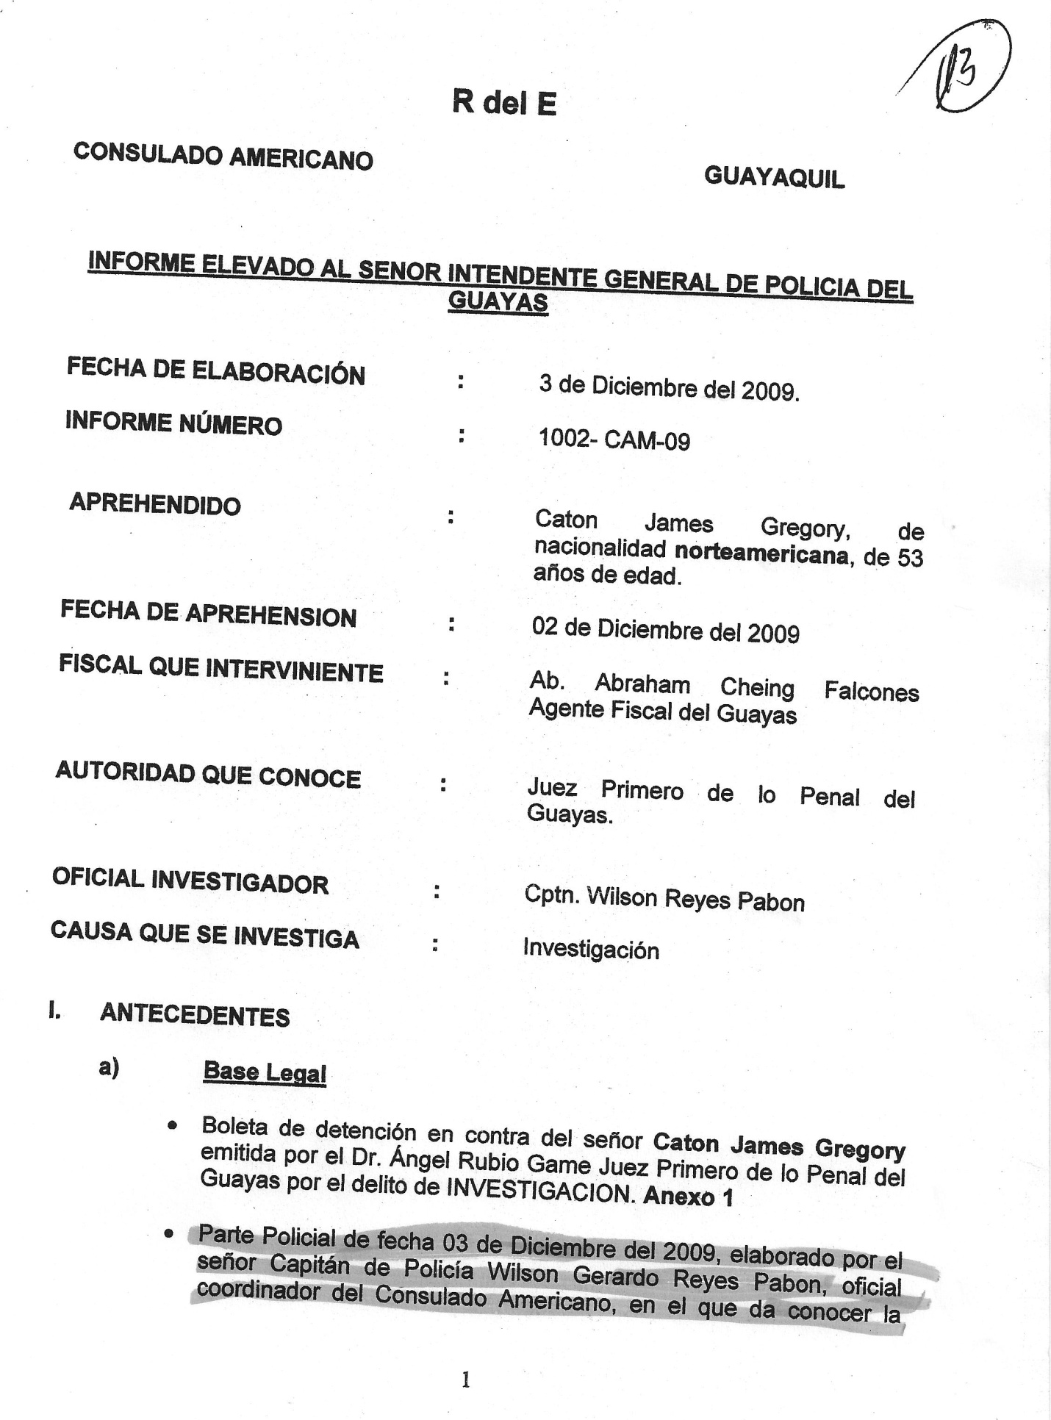
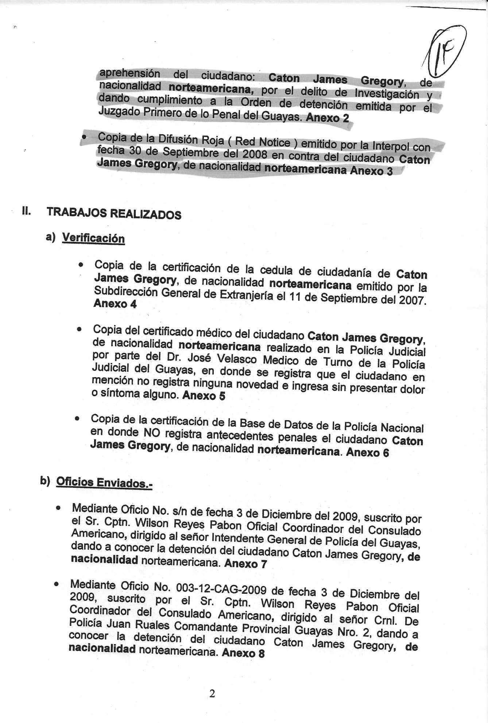
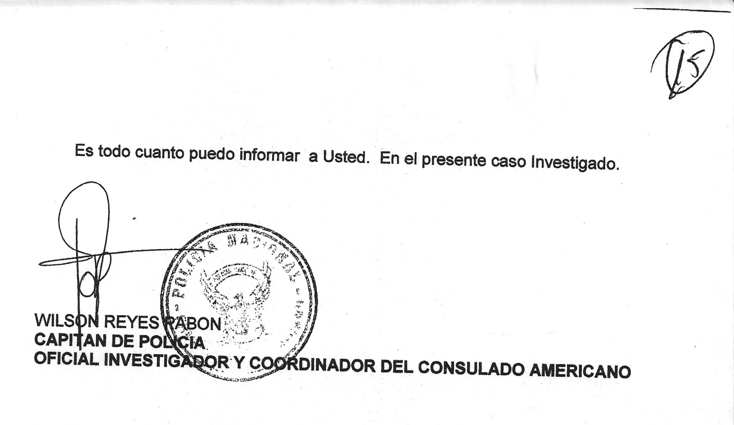

R of E
AMERICAN CONSULATE , GUAYAQUIL
REPORT TRANSFERRED TO THE GENERAL MAYOR OF THE POLICE DEPARTMENT OF GUAYAS
DATE OF ISSUANCE: December 3, 2009.
REPORT NUMBER: 1002-CAM-09
APPREHENDED: Caton James Gregory,
North American, 53 years old.
DATE OF APPREHENSION: December 2, 2009
MAYOR THAT PARTICIPATED: Atty. Abraham Cheing Falcones
Prosecutor of Guayas
AUTHORITY THAT KNOWS: First Judge of Criminal Guarantees
of Guayas
INVESTIGATING OFFICER: Captain Wilson Reyes Pabon
CAUSE INVESTIGATED: Investigation

- PRECEDENTS
- Legal Base
- Arrest order against Mr. Caton James Gregory issued by Dr. Angel Rubio Game, First Judge of Criminal Guarantees of Guayas for the crime of INVESTIGATION. Annex 1
- Police Report of December 3, 2009 issued by Captain Wilson Gerardo Reyes Pabon, coordination officer of the American Consulate where it is informed of the apprehension of Gregory James Caton, North American for the crime of Investigation and complying with the Arrest Order issued by the First Judge of Criminal Guarantees of Guayas. Annex 2
- Copy of the Red Notice issued by the Interpol of September 30, 2008 against Caton James Gregory with North American nationality. Annex 3

- ACTIVITIES DONE
- Verification
- Copy of the certification of the identification card of Gregory James Caton, with North American nationality issued by the General Sub directorate of Immigration on September 11, 2007. Annex 4
- Copy of the medical certificate of Caton James Gregory, North American issued by Dr. Jose Velasco, physician of the Judicial Police of Guayas where it is registered that the aforesaid person does not have any observations and enters without presenting any type of pain or symptoms. Annex 5
- Copy of the certification of the Data Base of the National Police where it is stated that Caton James Gregory, North American, does not register criminal records. Annex 6
- Reports issued
- By Report without reference dated December 3, 2009, issued by Captain Wilson Reyes Pabon, Coordination Officer of the American Consulate, directed to the General Mayor of the Police Department of Guayas, concerning the arrest of Gregory James Caton, North American. Annex 7
- By Report No. 003-12-CAG-2009 of December 3, 2009, issued by Captain Wilson Reyes Pabon, Coordination Officer of the American Consulate, directed to Police Col. Juan Ruales, Number 2 Provincial Commander of Guayas, concerning the arrest of Gregory James Caton, North American. Annex 8

This is all I have to report on the present case.

(Illegible signature)
WILSON REYES PABON
CAPTAIN OF POLICE
INVESTIGATION AND COORDINATION OFFICER OF THE AMERICAN CONSULATE

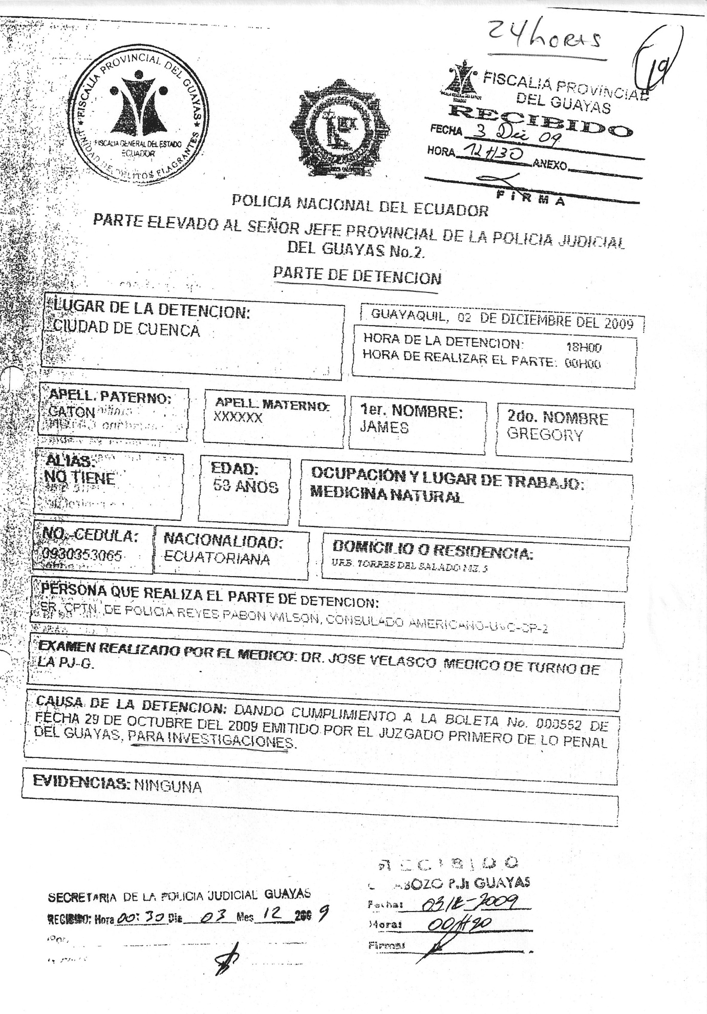
24 hours
PROVINCIAL PROSECUTOR’S OFFICE OF GUAYAS
DATE: Dec. 3/09
HOUR: 12H30 ANNEX
(Signature)
SIGNATURE

NATIONAL POLICE OF ECUADOR
REPORT TRANSFERRED TO THE PROVINCIAL HEAD OF THE
JUDICIAL POLICE OF GUAYAS No. 2
ARREST REPORT

PLACE OF ARREST:  CITY OF CUENCA |  |  | GUAYAQUIL, DECEMBER 2, 2009
TIME OF ARREST: 18H00
TIME OF MAKING THE REPORT: 00H00
PATERNAL SURNAME:  CATON | MATERNAL SURNAME XXXX |  | FIRST NAME:  JAMES |  | MIDDLE NAME:  GREGORY
ALIAS: NONE |  | AGE: 58 |  | OCCUPATION AND WORK PLACE: NATURAL MEDICINE
ID. No. 0930353065 |  | NATIONALITY: ECUADORIAN |  | ADDRESS: URB. TORRES DEL SALADO
PERSON THAT MAKES THE ARREST REPORT: POLICE CAPTAIN REYES PABON WILSON, AMERICAN CONSULATE
MEDICAL EXAMINATION MADE BY DR. JOSE VELASCO. DOCTOR IN TURN AT THE PJ-G (JUDICIAL POLICE OF GUAYAS)
CAUSE OF ARREST: COMPLYING WITH THE ORDER No. 000552 OF OCTOBER 29, 2009 ISSUED BY THE FIRST COURT OF CRIMINAL GUARANTEES OF GUAYAS, FOR INVESTIGATION
EVIDENCE: NONE

CLERK OF THE JUDICIAL POLICE OF GUAYAS
RECEIVED: HOUR 00:30 DAY 03 MONTH 12, 2009

Signature

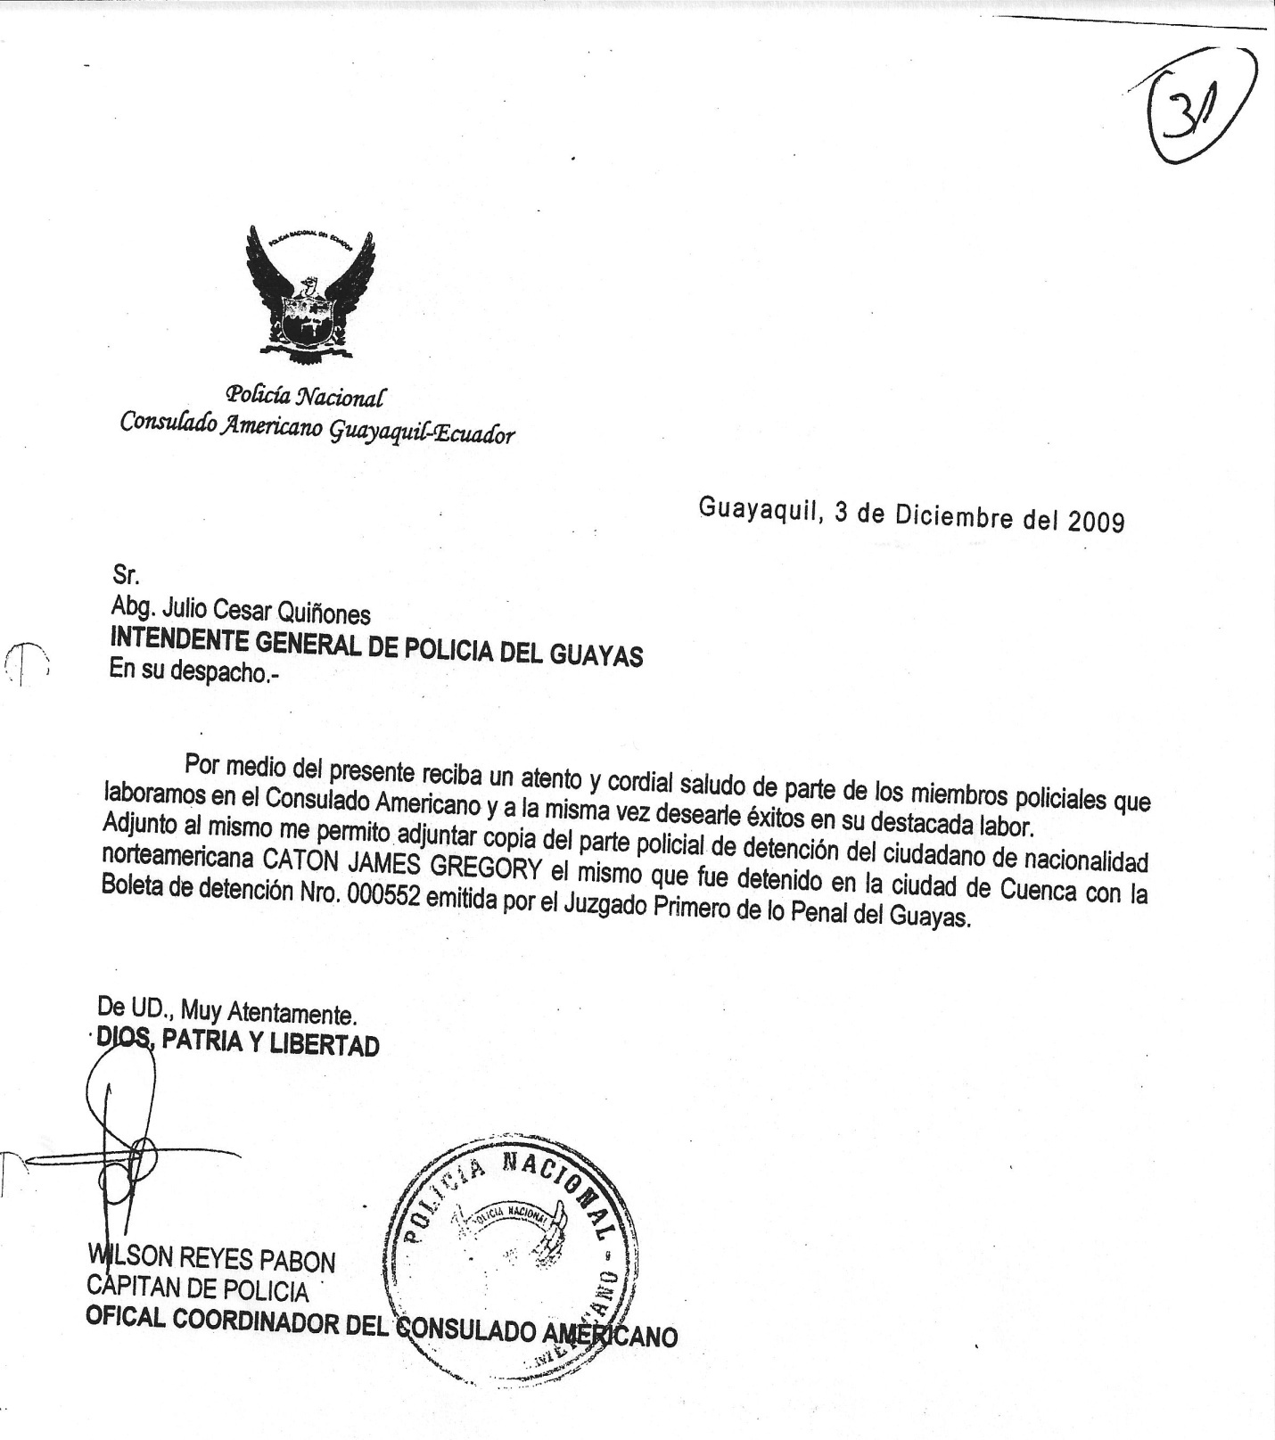

National Police
American Consulate Guayaquil-Ecuador

Guayaquil, December 3, 2009

Atty. Julio Cesar Quinones
GENERAL MAYOR OF THE POLICE DEPARTMENT OF GUAYAS
Hand delivered.

Hereby, by way of this letter, receive an attentive and cordial greeting from the Police officers that work at the American Consulate and at the same time wish you success in your outstanding labor.
Annexed to this document is the copy of the arrest report of the North American citizen CATON JAMES GREGORY who was arrested in the city of Cuenca with Arrest Order No. 000552 issued by the Criminal Court No. 1 of Guayas.
Sincerely,
God, Fatherland and Liberty
(Illegible signature)
WILSON REYES PABON
POLICE CAPTAIN
COORDINATION OFFICER OF THE AMERICAN CONSULATE

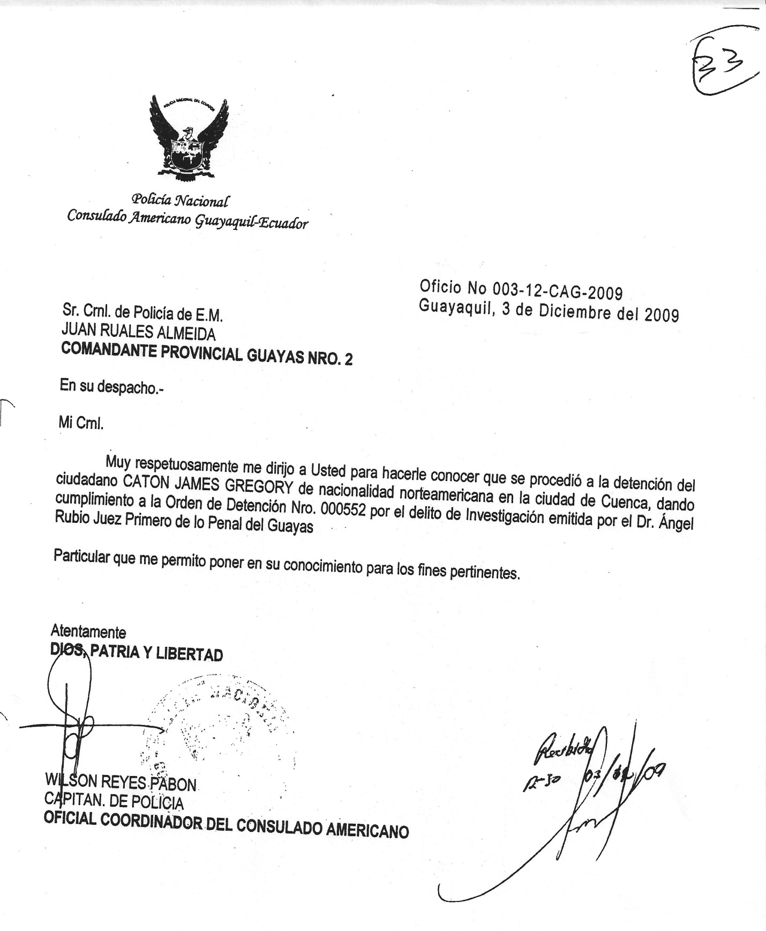

National Police
American Consulate Guayaquil-Ecuador
Official Action number 003-12-CAG-2009
Guayaquil, December 3, 2009
Col. of Police
JUAN RUALES ALMEIDA
PROVINCIAL COMMANDER (No. 2) OF GUAYAS
Hand delivered.

Commander:

With much respect I am writing to inform you that it proceeded to the arrest of the citizen CATON JAMES GREGORY of North American nationality in the city of Cuenca in compliance with the Arrest Order No. 000552 for the offence of Investigation issued by Atty. Angel Rubio, First Criminal Judge of Guayas.

Information that you are hereby notified for all legal purposes.

Sincerely,
God, Fatherland and Liberty

(Illegible signature)
WILSON REYES PABON
POLICE CAPTAIN
COORDINATION OFFICER OF THE AMERICAN CONSULATE

