Criminal Background Check: Dec. 2, 2009

Background: Capt. Wilson Reyes and police officers around him indicated that they needed to apprehend Gregory James Caton because he needed to be “investigated” – as if all orders weren’t being directed by the U.S. Consulate in Guayaquil, and any notion there was a violation of Ecuadorian law was a smokescreen.
This document proves it.
Issued on December 2, 2009 by the Ecuadorian National Police, the report clearly indicates that there is NO CRIMINAL RECORD ON FILE.
What follows is the original document, drafted in Spanish, followed by its English translation.
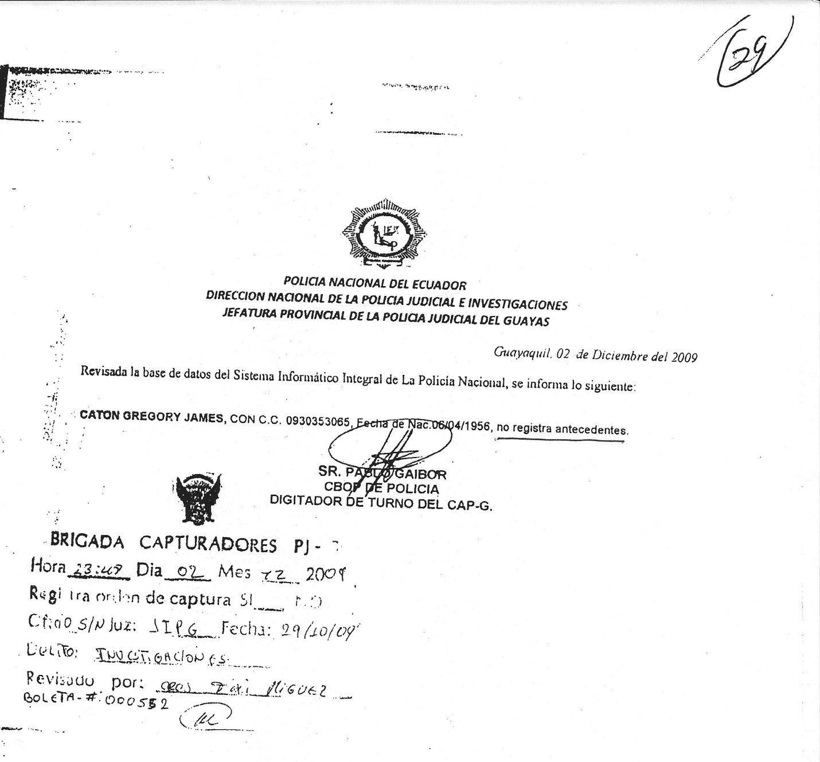

NATIONAL POLICE OF ECUADOR
NATIONAL DIRECTORATE OF THE JUDICIAL POLICE DEPARTMENT AND INVESTIGATIONS
PROVINCIAL HEAD OF THE JUDICIAL POLICE OF GUAYAS

Guayaquil, December 2, 2009
After examining the data base of the National Police, the following is informed:
CATON GREGORY JAMES, WITH ID No. 0930353065, Date of Birth: 06/04/1956, has no criminal record on file.

(Illegible signature)
MR. PABLO GAIBOR
FIRST CORPORAL
DATA ENTRY CLERK

(Stamp: not totally legible)

