Defendant’s Post-Release Petition: Dec. 4, 2009

Background: After it became apparent, following a victorious extradition hearing in which defendant Gregory James Caton was ordered released, that local police officials – acting on behalf of the corrupt U.S. Consulate in Guayaquil – were not going to follow the judge’s order, the following petition was filed by Caton’s counsel. It also questions the illegal revocation of Caton’s visa.
Quite incredibly, this petition requests that the legal procedures of the previous two days be altered so that the law can begin to be applied.
What follows is the original petition, drafted in Spanish, followed by its English translation.

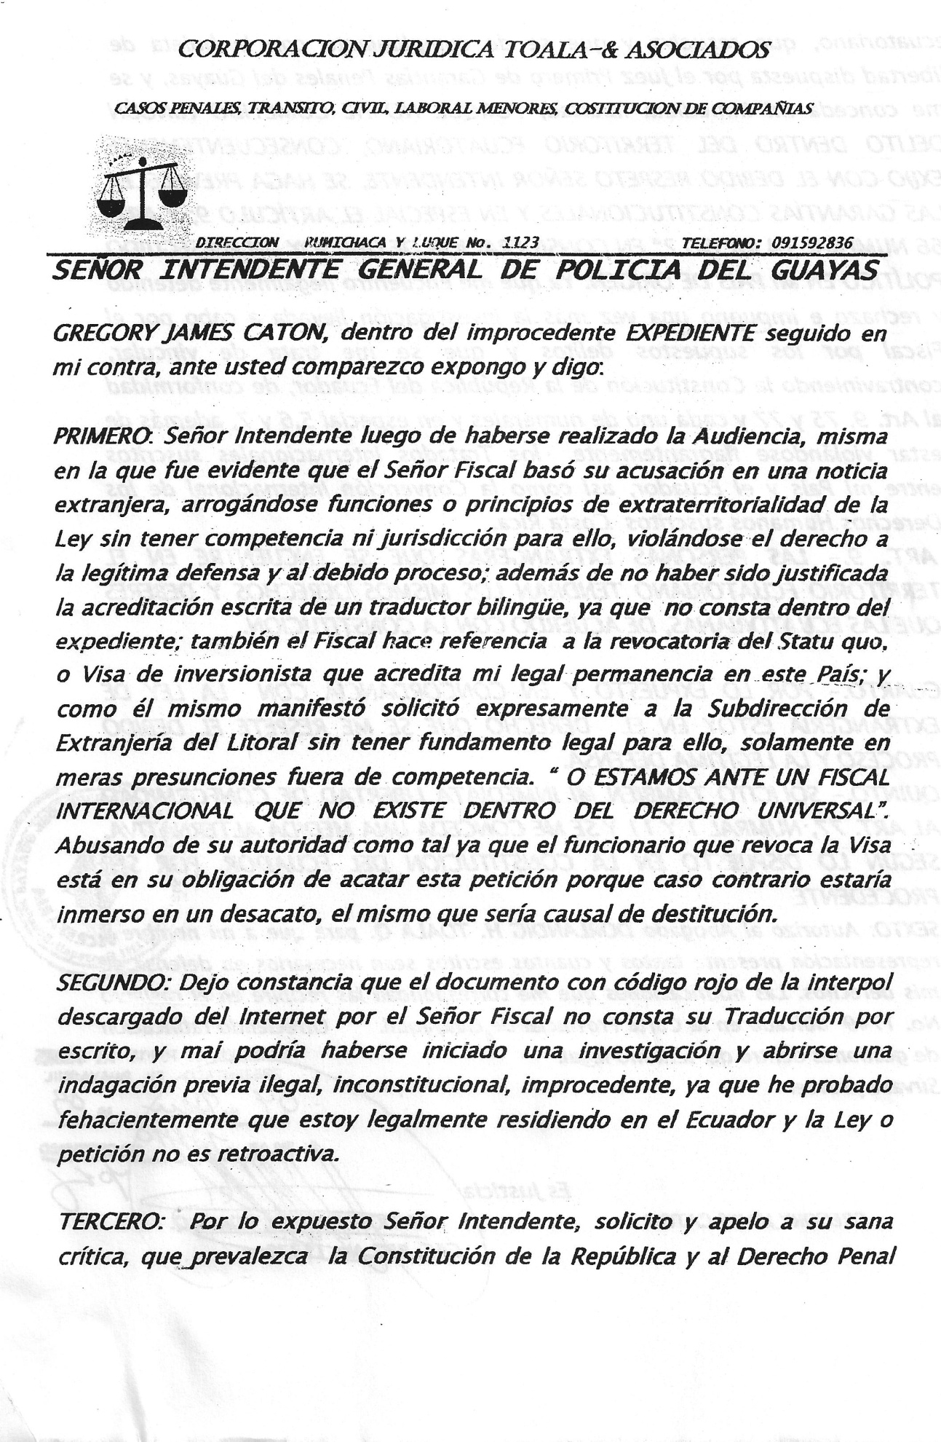
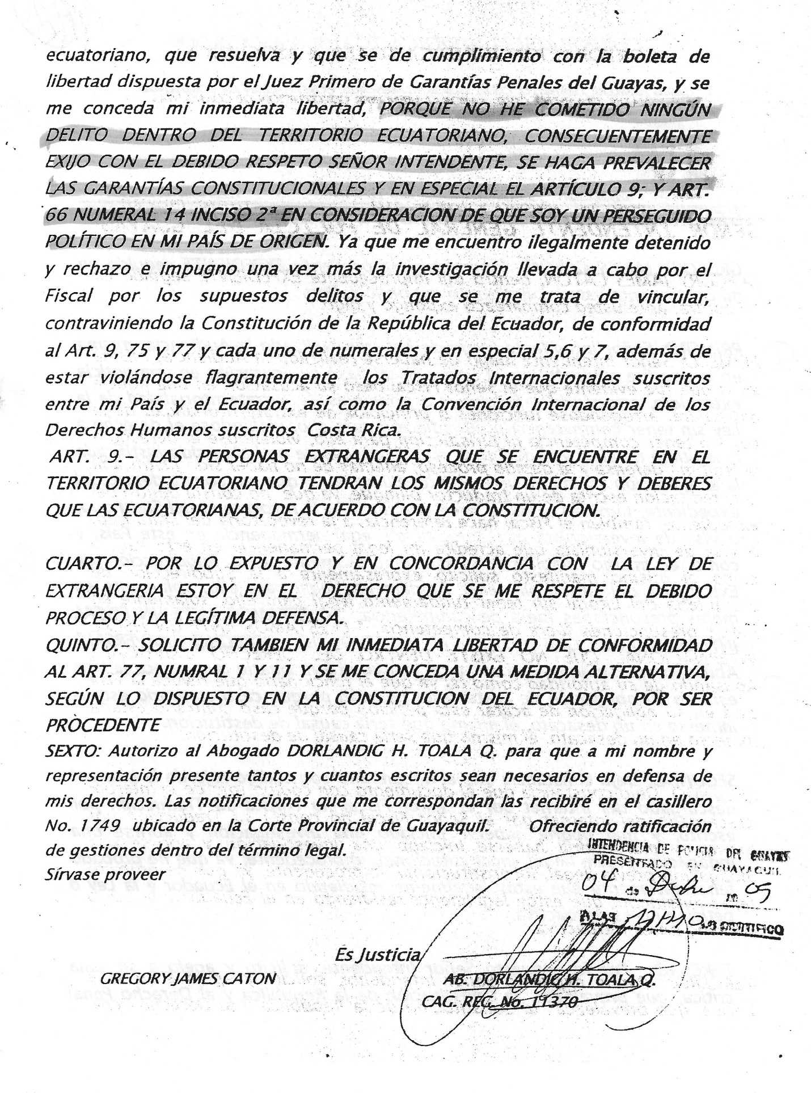
TOALA & ASSOCIATES LEGAL CORPORATION
CRIMINAL CASES, TRANSIT, CIVIL, LABOR, MINORS, CONSTITUTION OF COMPANIES
ADDRESS: PUMICHACA Y LUQUE No. 1123 TELEPHONE: 091592836
DEAR GENERAL MAYOR OF THE POLICE DEPARTMENT OF GUAYAS
GREGORY JAMES CATON, in the wrongful EXPEDIENT followed against me, before you I appear and state:
FIRST: Dear Mayor, after the hearing was held, it became evident that the Prosecutor based his accusation on foreign news, expounding extraterritorial principals of Law without having competence for them, infringing the right to a legitimate defense and due process, as well as not having (an English) translation since it is not present in the expedient. The Prosecutor also refers to the revocation of the Statu quo or investor’s visa that authorizes my legal permanence in this country and as he stated, he requested the Department of Immigration of the Littoral to revoke a visa without having legal grounds, based only on mere presumptions without competence. OR ARE WE BEFORE AN INTERNATIONAL MAYOR THAT DOES NOT EXIST IN INTERNATIONAL LAW? He abused his capacity as an authority, therefore the Immigration officer had the obligation to obey this petition, if not, he would have been engaging in disobedience and this would have caused his destitution.
SECOND: I hereby declare that the document of red code downloaded from the Interpol by the Prosecutor does not have a translation; therefore, an illegal, unconstitutional and wrongful investigation could not have been initiated since I have irrefutably proved that I am legally residing in Ecuador and the Law is not retroactive.
THIRD: Considering the aforesaid dear Mayor, I request and appeal to your judgment to enforce the Constitution of the Republic and Criminal Law of Ecuador, to resolve and to comply with the release order issued by the First Judge of Criminal Guarantees of Guayas and to grant my immediate freedom BECAUSE I HAVE NOT COMMITTED ANY CRIME IN ECUADORIAN TERRITORY, CONSEQUENTLY I RESPECTFULLY REQUEST YOU MAYOR TO ENFORCE THE CONSTITUTIONAL GUARANTEES AND ESPECIALLY ARTICLE 9, ARTICLE 66 NUMERAL 14 SUBSECTION 2 SINCE I AM A POLITICALLY PERSECUTED PERSON IN MY COUNTRY OF ORIGIN. And I am illegally arrested and once more I reject the wrongful investigation carried out by the Prosecutor for the crimes that I am supposedly involved with, infringing the Constitution of the Republic of Ecuador in its Articles 9, 75 and 77, each numeral and especially numerals 5, 6 and 7 and additionally infringing the International Treaties subscribed between my country and Ecuador as well as the International Convention of Human Rights subscribed in Costa Rica.
ARTICLE 9. - Foreign persons in Ecuadorian territory shall have the same rights and duties as those of Ecuadorians, in accordance with the Constitution.
FOURTH: BY virtue of the aforesaid and in compliance with the Immigration Law, I have the right to a legitimate defense and to due process.
FIFTH: I ALSO REQUEST MY IMMEDIATE RELEASE IN ACCORDANCE WITH ARTICLE 77, NUMERALS 1 AND 11 AND TO GRANT ME AN ALTERNATIVE MEASURE SINCE IT IS PROPER IN ACCORDANCE WITH THE CONSTITUTION OF ECUADOR.
SIXTH: I authorize Atty. DORLANDIG H. TOALA Q. to represent me in all the necessary documents in defense of my rights. The notifications that correspond to me, I will receive in the judicial box No. 1749 located at the Provincial Court of Guayaquil.
Please issue a ruling.
(Illegible signature)
GREGORY JAMES CATON ATTY DORLANDIG H. TOALA Q.

