Defendant’s Petition: Dec. 7, 2009

Background: This second petition was filed by Gregory James Caton’s legal counsel on December 7, 2009 – five days after the initial arrest and well after the First Judge of Constitutional Guarantees decreed that it would not be legal under Ecuadorian law to have the Defendant deported.
The original petition, drafted in Spanish, is provided, followed by its English translation.
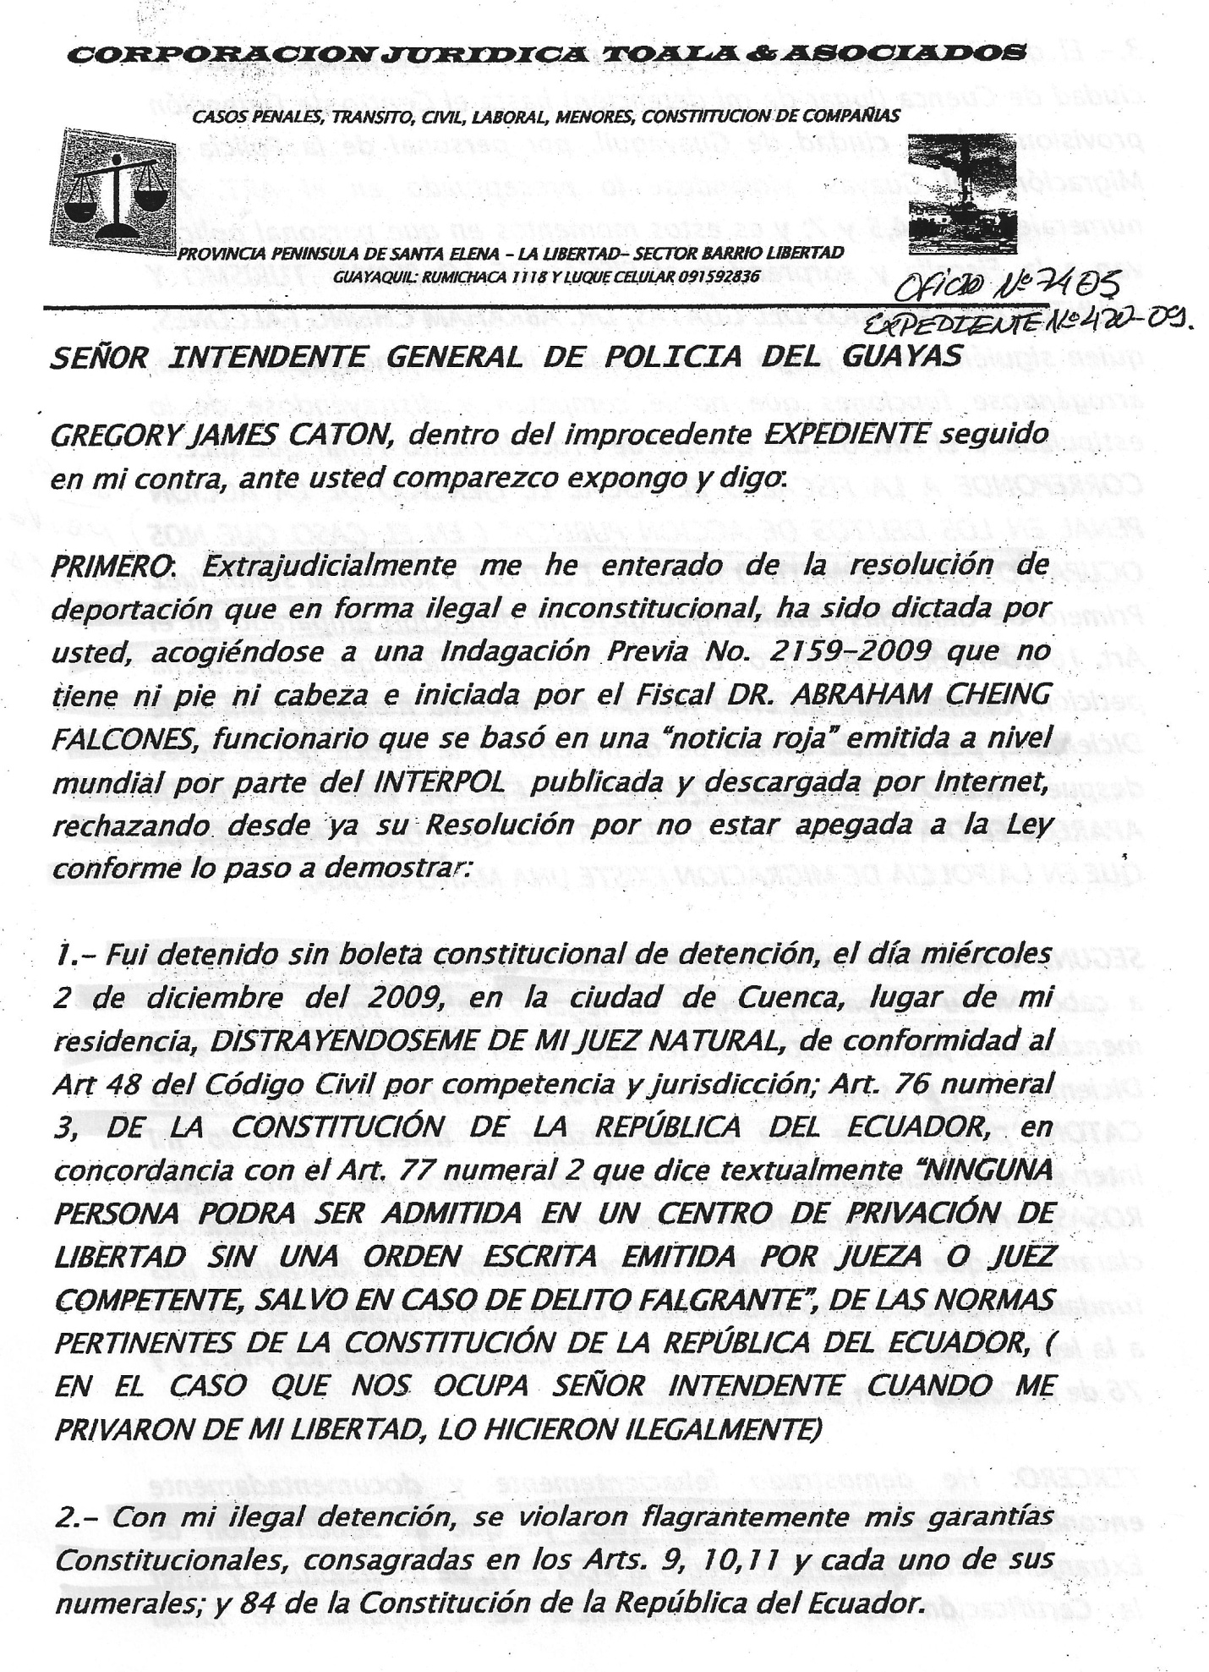
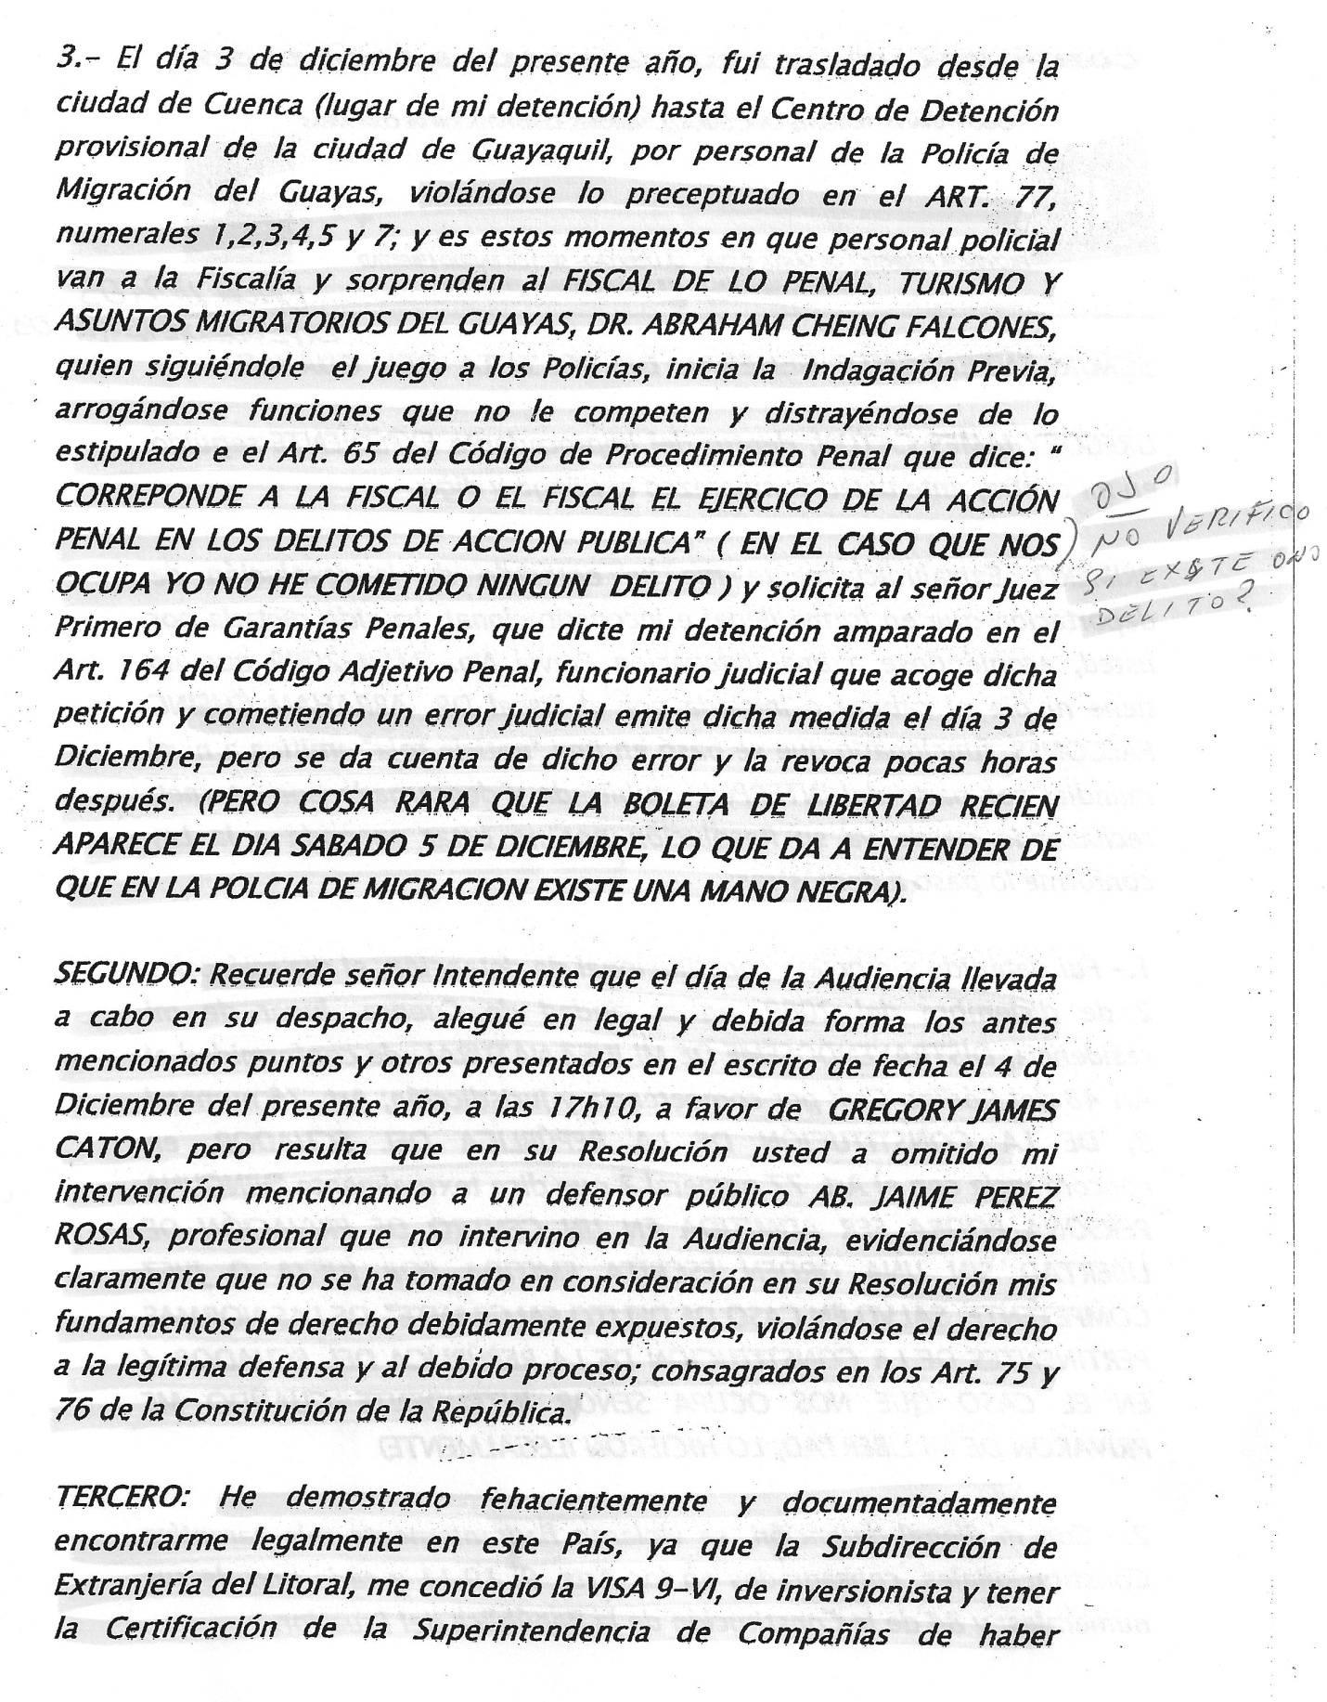

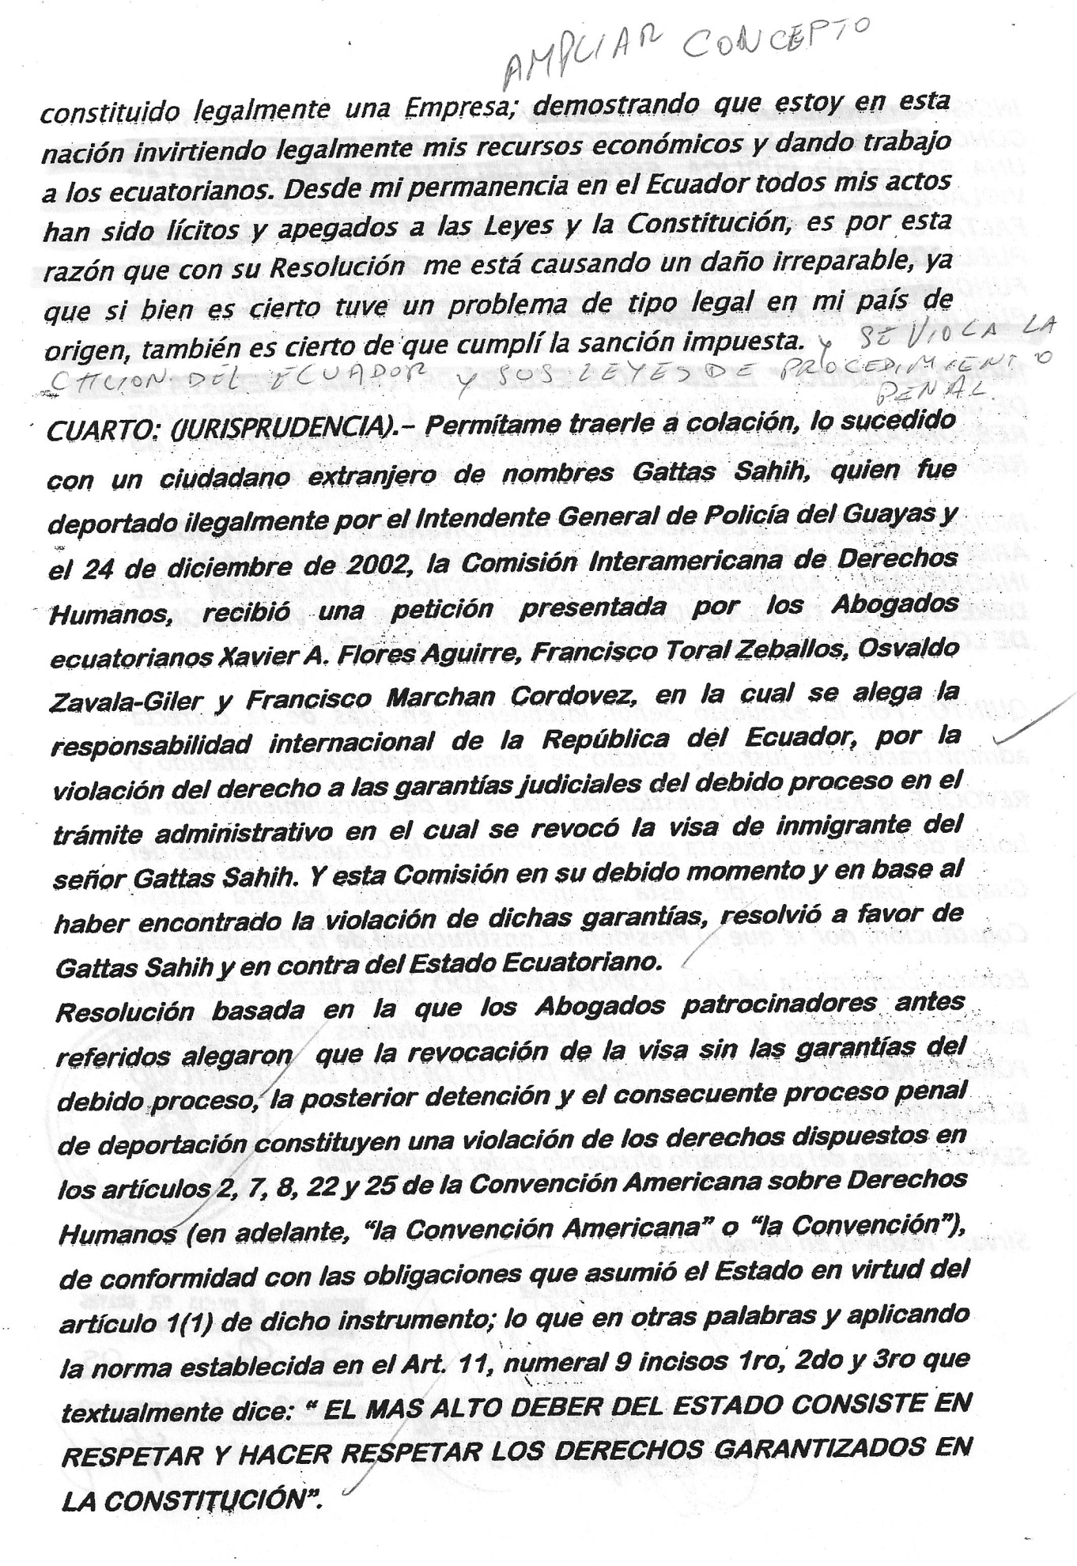
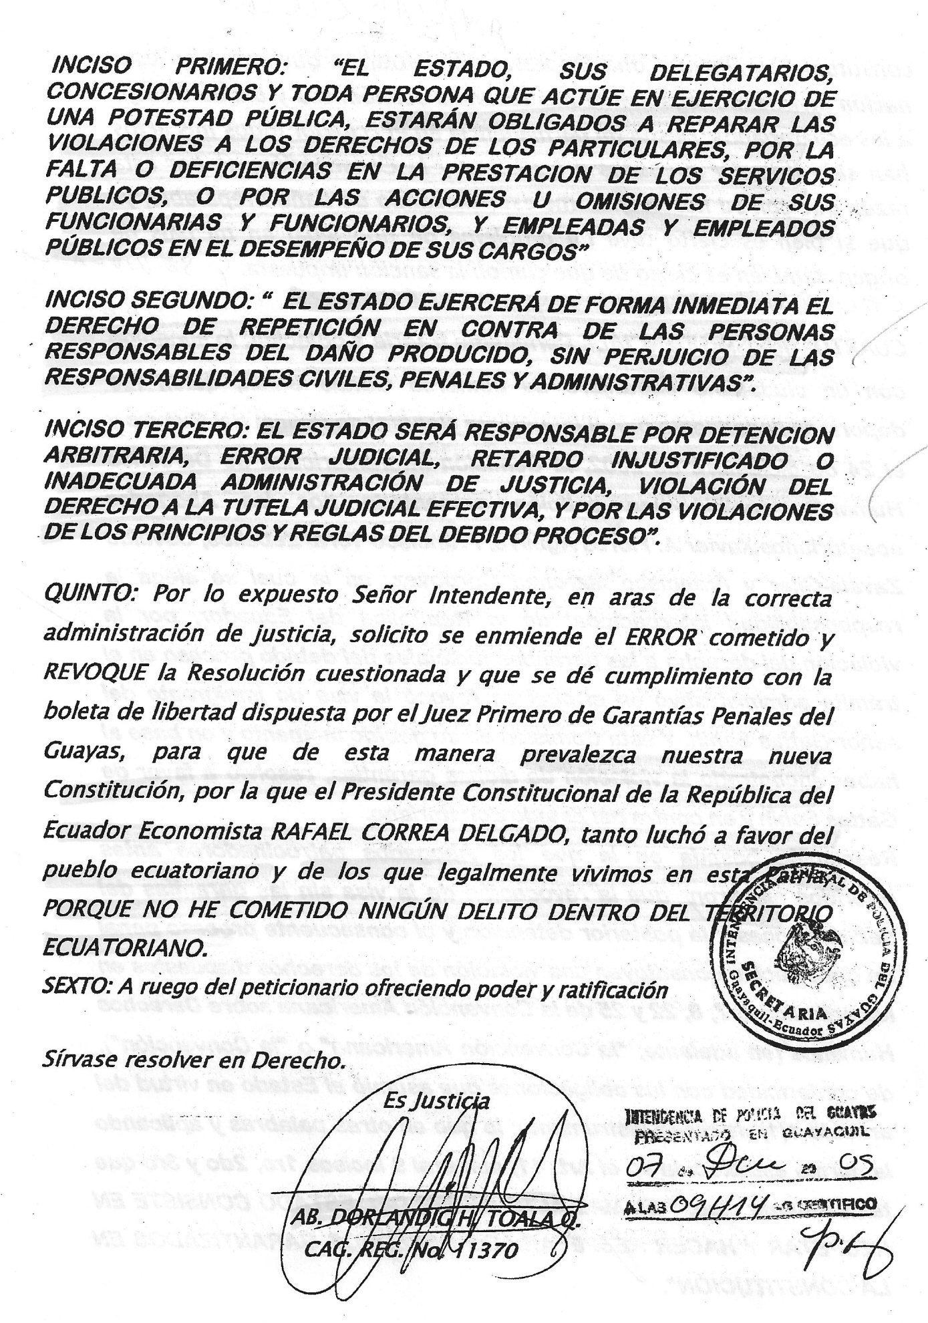
TOALA & ASSOCIATES LEGAL CORPORATION
CRIMINAL CASES, TRANSIT, CIVIL, LABOR, MINORS, CONSTITUTION OF COMPANIES
PROVINCIA PENINSULA DE SANTA ELENA – LA LIBERTAD – SECTOR BARRIIO LIBERTAD
GUAYAQUIL: RUMICHACA 1118 Y LUQUE CELULAR: 091592836
DEAR GENERAL MAYOR OF THE POLICE DEPARTMENT OF GUAYAS
GREGORY JAMES CATON, in the wrongful EXPEDIENT followed against me, before you I appear and state:
FIRST: In an extrajudicial manner, I have been informed of the resolution of deportation that in an illegal and unconstitutional way has been issued by you based on Prior Investigation No. 2159-2009 that makes no sense and initiated by the Prosecutor, DR. ABRAHAM CHEING FALCONES, that was based on a worldwide “Red Alert” issued by INTERPOL , published online, and downloaded from the Internet, rejecting your Resolution because it is not based on the Law as I will demonstrate in the following:
- I was arrested without a Constitutional arrest order on Wednesday, December 2, 2009 in the city of Cuenca, city of my residence, DIVERTING ATTENTION AWAY FROM MY NATURAL JUDGE in concordance with Article 48 of the Civil Code by competence and jurisdiction; Article 76, numeral 3 of the CONSTITUTION OF THE REPUBLIC OF ECUADOR in concordance with Article 77, numeral 2 that textually states: “No person shall be admitted to a detention center without a written warrant issued by a competent judge, except in the case of felonies” FOLLOWING THE RELEVANT RULES OF THE CONSTITUTION OF THE REPUBLIC OF ECUADOR. IN THE CASE at hand, mayor, when i was arrested, they did it illegally.
- With my illegal arrest, my Constitutional guarantees established on Articles 9, 10, 11 with all their numerals as well as Article 84 were infringed.
- On December 3rd of the current year, I was transferred from the city of Cuenca (place of my arrest) to the Provision Detention Center of Guayaquil by personnel of the Immigration Police of Guayas, infringing upon Article 77, numerals 1, 2, 3, 4, 5 and 7. And at those moments, Police personnel went to the Prosecutor’s Office and surprised DR. ABRAHAM CHEING FALCONES, DISTRICT PROSECUTOR OF CRIMINAL, TOURISM AND IMMIGRATION AFFAIRS OF GUAYAS, who following the police officers’ game, started the Prior Investigation, assuming functions that are not competent to him and diverting attention from principlies established in Article 65 of the Criminal Procedural Code that states: “IT CORRESPONDS TO THE PROSECUTOR THE PRACTICE OF THE CRIMINAL PROSECUTION IN CRIMES OF PUBLIC ACTION” (IN THE CASE AT HAND, I HAVE NOT COMMITTED ANY CRIME) and requested the First Judge of Criminal Guarantees to order my arrest under Article 164 of the Criminal Procedural Code. The judicial officer accepted such petition and making a judicial error, issued such measure on December 3rd, but realizing his mistake, revoked it a few hours later. (BUT THE STRANGE THING IS THAT THE RELEASE ORDER ONLY APPEARED UNTIL SATURDAY, DECEMBER THE 5TH, THIS EXPLAINS THAT THERE IS A BLACK HAND IN THE IMMIGRATION POLICE).

SECOND: Mayor, please remember that on the Hearing carried out in your office, I alleged in a legal way the aforesaid points and others presented in the document of December 4 of the current year at 17H10 in favor of GREGORY JAMES CATON, but it results that in your Resolution, you omitted my participation and mentioned a public defender named ATTY. JAIME PREZ ROSAS, professional who did not participate in the Hearing. This clearly evidences that my legal grounds were not taken into consideration in your Resolution, infringing the right to a legitimate defense and a due process established on Articles 75 and 76 of the Constitution of the Republic.

THIRD: I have irrefutably demonstrated with documents that I am legally residing in this country since the Sub-directorate of Immigration of the Littoral granted me a 9-VI INVESTOR’S VISA, and I provide a certification of the Superintendence of Companies indicating that I have a legally established company. [Editor’s note: this is Herbologics, S.A. – an Ecuadorean corporation incorporated in Guayaquil in 2008.] This demonstrates that I am legally investing my financial resources and providing jobs to Ecuadorians. During my permanent residence in Ecuador, all my acts have been legal. This is the reason why your Resolution is causing me irreparable damage. Although it is true that I had a legal problem in my country, it is also true that I complied with the sanction imposed.

FOURTH (CASE LAW): Please allow me to bring up the situation occurred to a foreign citizen named Gattas Sahih who was illegally deported by the General Mayor of the Police Department of Guayas on December 24th, 2002. The Inter American Commission of Human Rights received a petition presented by Ecuadorian attorneys Xavier A. Flores Aguirre, Francisco Toral Zeballos, Oswaldo Zavala-Giler and Francisco Marchan Cordovez, in which the international responsibility of the Republic of Ecuador is alleged for the violation of the right to judicial guarantees of the due process in the administrative procedure that revoked the visa of the immigrant Gattas Sahih. And this Commission, based on the violation of such guarantees, decided in favor of Gattas Sahih and against the Ecuadorian State.

This decision was based on the fact that the aforesaid Attorneys alleged that the revocation of the visa without guarantees of a due process, the subsequent arrest and the consequent criminal process of deportation constitute a violation to the rights established on Articles 2, 7, 8, 22 and 25 of the American Convention on Human Rights (hereinafter, “the American Convention” or “the Convention”), in accordance with the obligations that the State assumes in virtue of Article 1(1) of such instrument; which in other words and applying to the established rule on Article 11, numeral 9, first, second and third subsections that textually state: “The State’s supreme duty consists of respecting and enforcing respect for the rights guaranteed in the Constitution.”
FIRST SUBSECTION: “The State, its delegates, concession holders and all persons acting in the exercise of public authority, shall be obligated to redress infringements of the rights of individuals for negligence or inadequacies in the provision of public services or for the deeds or omissions of their public officials and employees in the performance of their duties.”

SECOND SUBSECTION: “The State shall immediately exercise the right to file a claim for restoration against those persons responsible for the damage produced, without detriment to civil, criminal and administrative liabilities.”

THIRD SUBSECION: “The State shall be held liable for arbitrary arrest and detention, miscarriage of justice, unjustified delay or inadequate administration of justice, violation of the right to effective protection of the court, and any violations of the principles and rules of due process of law.”

FIFTH: Mayor, considering the aforesaid, for the sake of the correct administration of justice, I request to amend the ERROR made and to REVOKE the challenged Resolution and to comply with the release order issued by the First Judge of Criminal Guarantees of Guayas in order to respect our new Constitution that the Constitutional President Economist RAFAEL CORREA DELGADO fought so much for in favor of the Ecuadorian people and of the ones who legally live here, BECAUSE I HAVE NOT COMMITTED ANY CRIME IN ECUADORIAN TERRITORY.

SIXTH: Upon request of the petitioner, offering power and ratification.

Please decide by Law.
Let justice be done

(Illegible Signature)
ATT. DORLANDIG H. TOALA Q.
BAR ASSOCIATION OF GUAYAS REGISTRY NUMBER: 11370

