Notification of Judge Angel Rubio’s Ruling: Dec. 3, 2009

Background: Judge Rubio’s ruling is an exercise in contradiction and it was one of the most shocking documents later examined by legal experts who were hired by Cathryn Caton to study the case.
Essentially, the ruling – issued just hours after Caton was taken to Guayaquil in the late hours of December 2, 2009 – indicates that since that there is no evidence against the Defendant to justify further criminal prosecution, still . . . put him in the hands of the local police authorities – (who directly report to the U.S. Consulate) – for “deportation” to his country of origin. In other words, we have no legal basis to “extradict” him, but we can “deport” him, thus turning the entire extradiction process on its head.
What follows is the Judge’s letter to the local police, announcing his ruling, followed by its English translation. Since this particular document was a difficult-to-read COPY of the original, obtained by Cathryn Caton’s legal team following the illegal deportation, the original Spanish has been re-typed and appears at the end of this document.

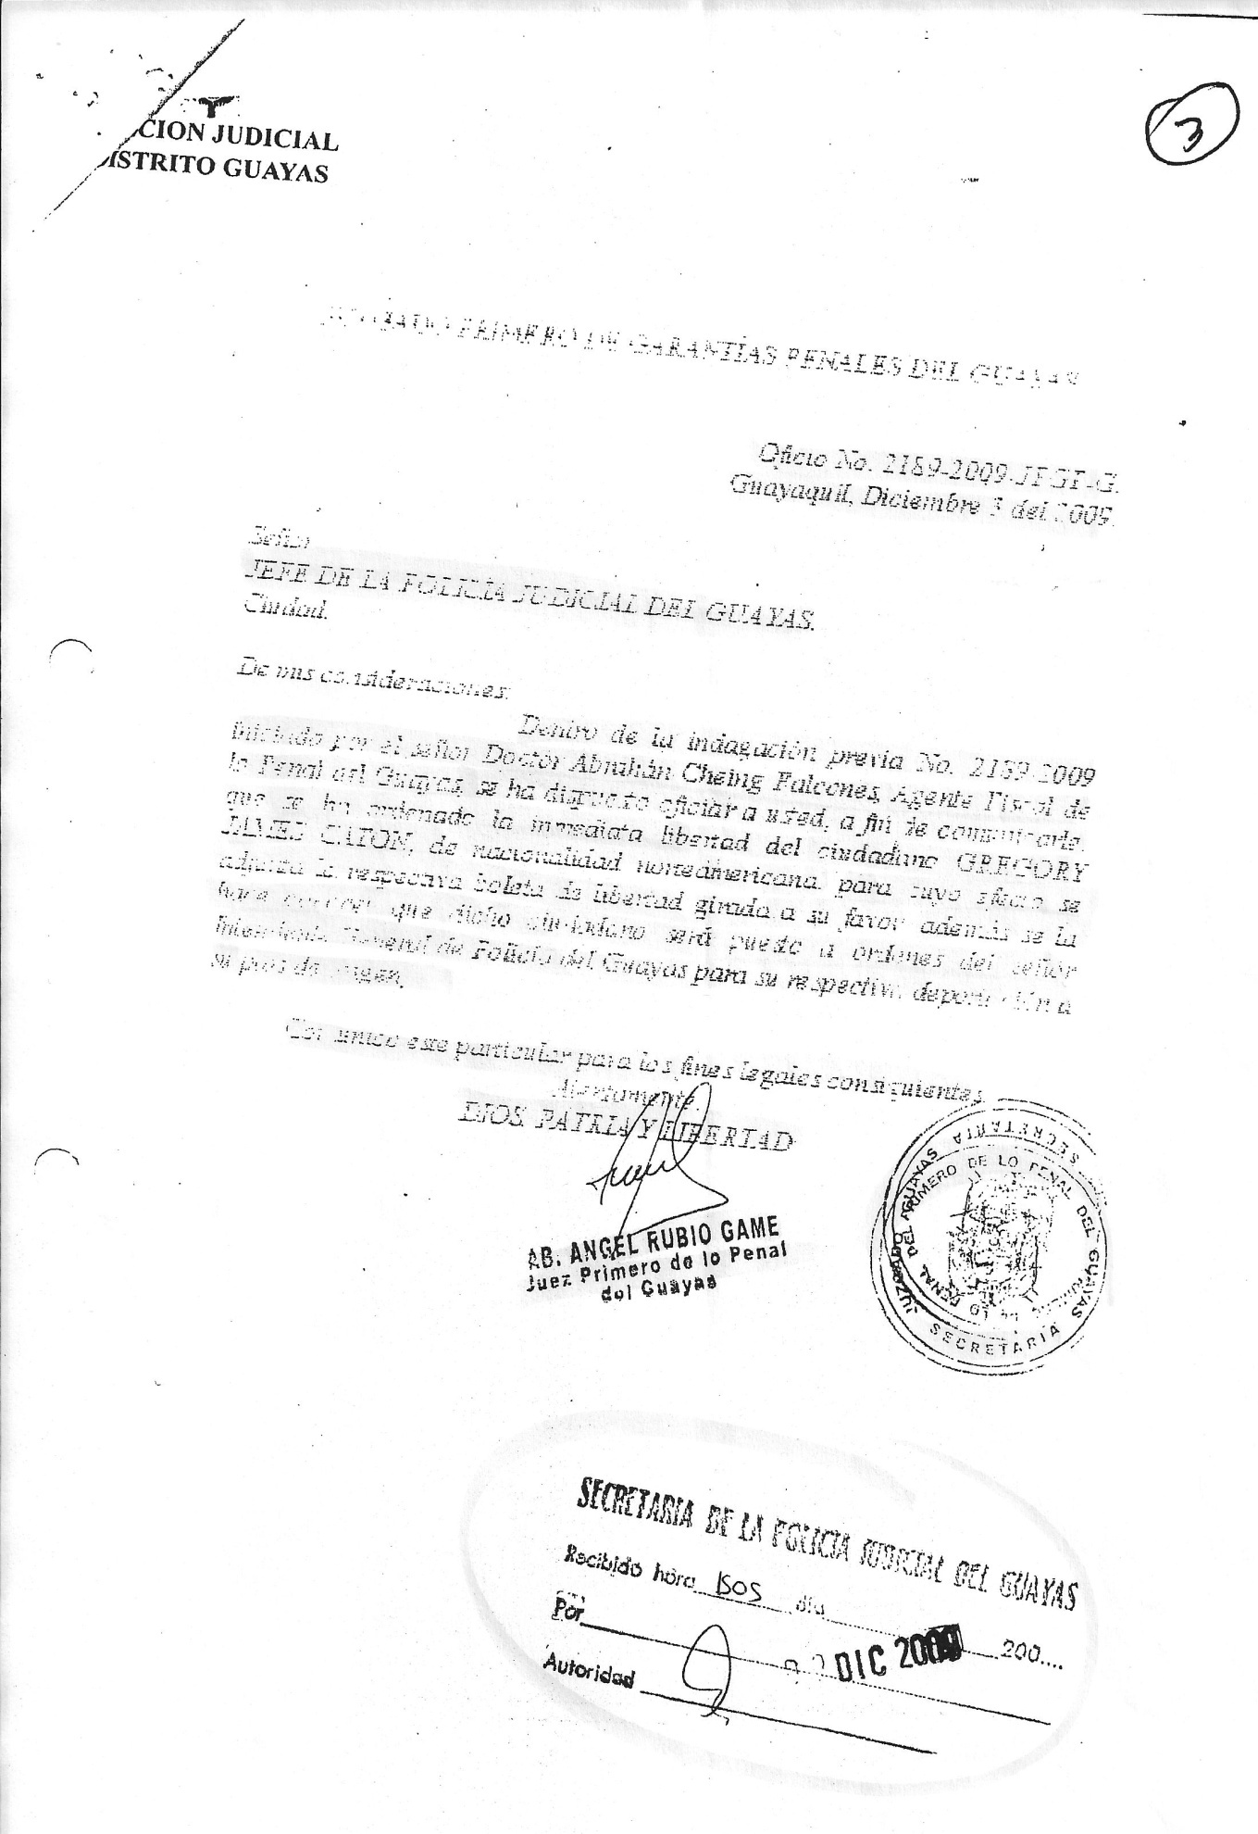
First Criminal Court of Guarantees, Guayas

Official Number 2189-2009-[rest illegible]
Guayaquil, December 3, 2009

First criminal trial guarantees of Guayas
Head of the judicial police of Guayas

Of my considerations . . .
Within the previous inquiry number 2189-2009 given by Mr. Abraham Chein Falcones, prosecuting agent of the criminal court of Guayas, it is officially communicated to you that it has been ordered the immediate release of the citizen Gregory James Caton, being a U.S. citizen for which purpose is attached the respective notification of release issued in his favor. Also this lets you know that the citizen will be placed under the orders of the mayor federal police of Guayas for his respective deportation to his country of origin.
I communicate this matter for legal purposes,
Sincerely,

Attorney Angel Rubio Game
God, Homeland & Freedom
Chief Judge of the Criminal Court of Guayas

Rendering in Spanish:
Juzgado primero de garantías penales del guayas
Jefe de la policía judicial del guayas

De mis consideraciones

Dentro de la indagación previa numero 2189-2009 dictado por el señor dr. Abraham Chein Palcone agente fiscal de la penal del guayas se ha dispuesto oficiar a usted a fin de comunicarle que se ha ordenado la inmediata libertad del ciudadano GREGORY JAMES CATON, de nacionalidad norteamericana para cuyo efecto se adjunta la boleta de libertad girada a su favor además de le hace conocer que dicho ciudadano será puesto a ordenes del señor intendente federal de policía del guayas para su respectiva deportación a su país de origen.

Comunico este particular para los fines legales consiguientes.

ATT

Abogado Angel Rubio Game
Dios patria y libertad
Juez primero de la penal del guayas

