Formal “Denuncia” by the late Dr. Neville G. Solomon
Concerning the Attempted Kidnapping of Greg Caton
On November 19, 2008

Background: This document was first made public in an online newsletter called the Ashwin that Alpha Omega Labs used to put out. It was written by Cathryn Caton. (See http://www.altcancer.net/ashwin/ashw0209.htm; January/February 2009 edition). It details Dr. Solomon’s remarkable story of how he was mistaken for Greg Caton, arrested with his 15 year old son, Michael; taken into custody by Immigration and then were questioned by Ecuadorian police who were acting under orders from U.S. Consulate officials there present. (The license plate of the vehicle cited, “RYA003,” was later found to belong to the U.S. State Department – an additional indicator that ALL the Ecuadorian police present during the detainment described were acting under direct orders of this U.S. agency.)
A “denuncia” – for those who don’t know – is a formal document in Ecuador, an affidavit detailing events to which the affiant is swearing as truthful, that any citizen can file with the local police or in the local courts. “Denuncias” are often the starting point for civil litigation, or they can initiate the process that will culminate in a criminal investigation. In Neville Solomon’s case, his denuncia was destined to go nowhere, because the recipients in authority in Guayaquil were the very same people who would be implicated if his charges went anywhere.
What follows is the Dr. Solomon’s “denuncia” – as submitted to authorities in Guayaquil – followed by its English translation. Note that “paragraphing” has been added to aid its reading, along with clarifying notes, as made apparent.

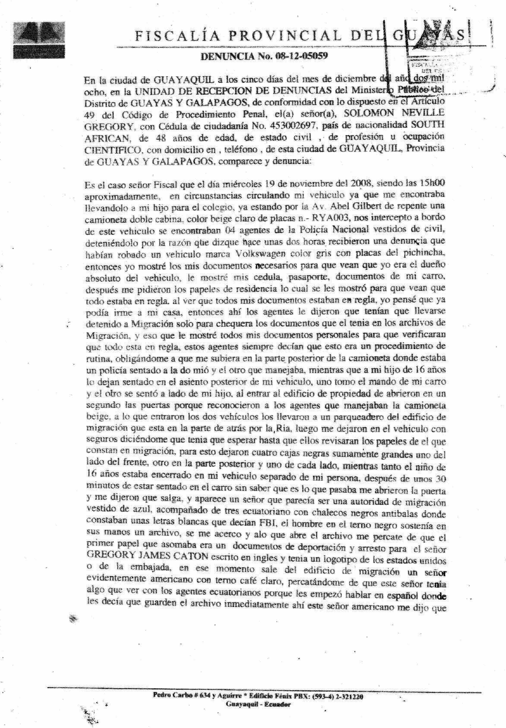
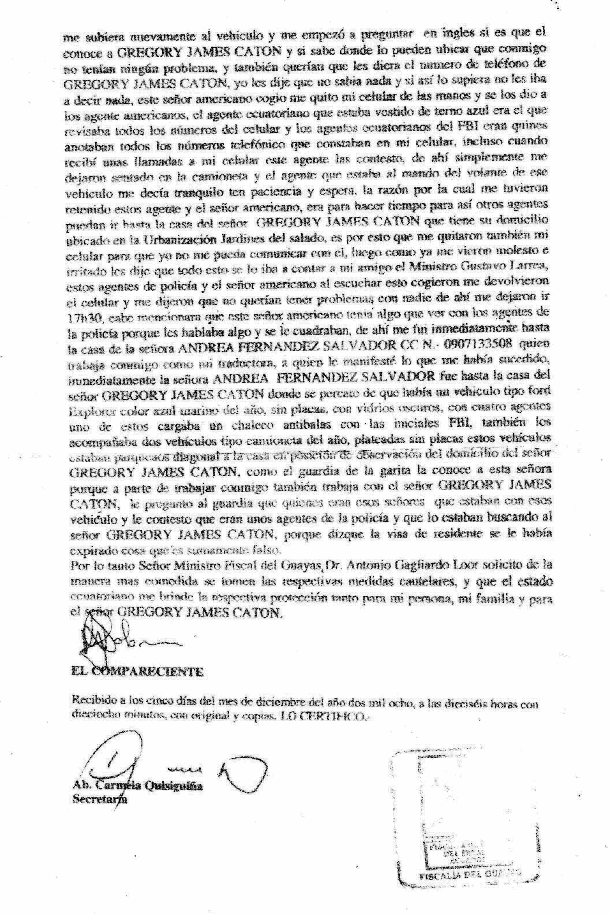
Prosecutor’s Office for the Province of Guayas
REPORT NUMBER 08-12-05059

In the city of GUAYAQUIL, on the 5th day of December, 2008, in the UNIT OF REPORT RECEPTION of the Public Ministry of the District of GUAYAS AND GALAPAGOS, in accordance with Article 49 of the Code of Criminal Procedure. Mister NEVILLE GREGORY SOLOMON, with Identification [Cedula] card number 453002697, with the nationality of SOUTH AFRICAN, with the age of 48, with the profession or occupation of SCIENTIST, residing in this city of GUAYAQUIL, Provinces of Guayas and Galapagos, appeared and reported:

Prosecutor, it is the case that on Wednesday, the 19th of November, 2008, at approximately 15H00 (i.e. 3:00 pm), while driving my car down Avenida Abel Gilbert, taking my 16 year old son to school, I was suddenly intercepted by a pickup truck – double cabin, light beige, with license plate number – RYA003. On board the vehicle there were 4 agents of the National Police, dressed in civilian clothes. They told me they had received a report of a stolen gray volkswagon with Pichincha license plates. I showed them the necessary documents which confirmed that I was the absolute owner of the car. I showed them my ID (i.e. cedula), passport, and car documents.
After that, they asked for my residency papers, which I showed, and they saw that all was in order.
Seeing that all my documents were in order, I thought I could go home. That’s when they told me I had to be detained to go to Migration so they could check and compare my document with theirs, even though I had presented all documents, and all were clear and up to date. These agents always said (this is) “routine procedure,” obliging me to sit in the back of their pickup truck, where one agent sat with me while another one drove. Meanwhile, they put my son, (Michael), into the back seat of my car; one agent sat with him in the back and another one drove.
When we entered the Migration property, the doors were opened in a second to allow the vehicle to enter. The Migration Police immediately seemed to recognize the agents’ faces. Once the two vehicles entered, we drove to the back side of the building, through the parking lot, and parked there. They left me inside the vehicle, with the doors locked, telling me I had to wait until they compared my documents with Migration’s documents. They then placed four heavy black boxes in front, on the sides, and at the back of the car – on the ground. Meanwhile, my 16 year old son was locked up in my car, separated from me. Thirty minutes later, after sitting inside the car without knowing what was happening, they opened the door and told me to get out. A man approached who looked like some kind of authority of Migration, dressed in a blue suit, accompanied by three Ecuadorians, wearing black bulletproof vests with “FBI” written on them in white letters.
The man in the suit was holding a folder and approached me. He opened the file, and when he did that I noticed the first page was a document, with a U.S. Consulate or Embassy emblem heading, written in English. I could see that they were documents of deportation and arrest for Gregory James Caton. At that moment a man evidently American, came out of the Migration building, wearing a light brown suit. I realized that this guy had something to do with the Ecuadorian agents, as he spoke to them in Spanish, and ordered them to immediately put that folder away.
Immediately after that, the American ordered me to go back to the vehicle, asked me in English if I knew Greg(ory) James Caton, and if I knew where to locate him. He said he didn’t have a problem with me and to give them his phone number. I told them I knew nothing, and that even if I did, I would not tell them. This American (then) grabbed my cellphone from my hands and gave it to the Ecuadorian agent that was dressed in a blue suit. He checked all the numbers that were on my cellphone while the other took note of them. I was getting calls on my cellphone and this guy was answering them. They kept me once again inside the vehicle, and the agent who had been at the driving wheel kept on saying, “Be patient, be patient . . . and wait.” The reason why they did that was to give time for other agents to get to Greg James Caton’s home in the Torres del Salado community. That is why they took my cellphone from me, so that I could not communicate with Greg. After they saw that I was irritated, I told them that all of this was going direct to the Minister of National and International Security, Gustavo Larrea, a friend of mine. When they heard this, these police agents and the American gave me back my cell and said they didn’t want any problems from anyone.
They let me go at 17H30 (i.e. 5:30 pm). I will add that the Ecuadorian agents seemed quite familiar with the American, as they promptly demonstrated that his wish was their command.
After this I immediately called Andrea Fernandez-Salvador, who works with me as a translator. I told her what happened. Immediately, she went to Caton’s residence where she saw a brand new Ford Explorer car, dark blue, no license plates, black-tinted windows, with four agents, one of them wearing “FBI” white letters. Two other brand new silver pickups, double cabin, no license plates, dark windows, and four agents inside, joined them, and parked in an observation position outside of Greg James Caton’s home.
The guard at the entrance to the community said the agents were there to look for Greg Caton because his visa had expired, which is false because all his documents are in order.
Therefore, Ministro Fiscal del Guayas, Dr. Antonio Gagliardo Loor, I respectfully request you to take the respective cautionary measures and have the Ecuadorian State provide with the respective protection for me, my family and Mister GREGORY JAMES CATON.
[ Signature of Dr. Neville Solomon]
Received on the fifth day of the month of December, two thousand eight, at sixteen hourse and eighteen minutes, with original and copies. I CERTIFY.
[ Clerk’s signature]

Atty. Carmela Quisiguina
Clerk

