Release Order Countermanded: Dec. 4, 2009

Background: The initial court ruling ordering the release of Defendant, Gregory James Caton, was not found favorable in the eyes of the U.S. Consulate or those on their payroll in the police establishment in Guayaquil. What follows is a statement from police authorities in Guayaquil ordering the IMMEDIATE deportation of the Defendant anyway – in direct conflict with the favorable court ruling.
This document was hand delivered by a courier to Greg Caton in prison on the evening of Dec. 10, 2009 – just hours before he would be forcibly deported the next morning. Not understanding the Spanish, he was never able to discuss its content with his attorney.
What follows is the original document, drafted in Spanish, followed by its English translation.

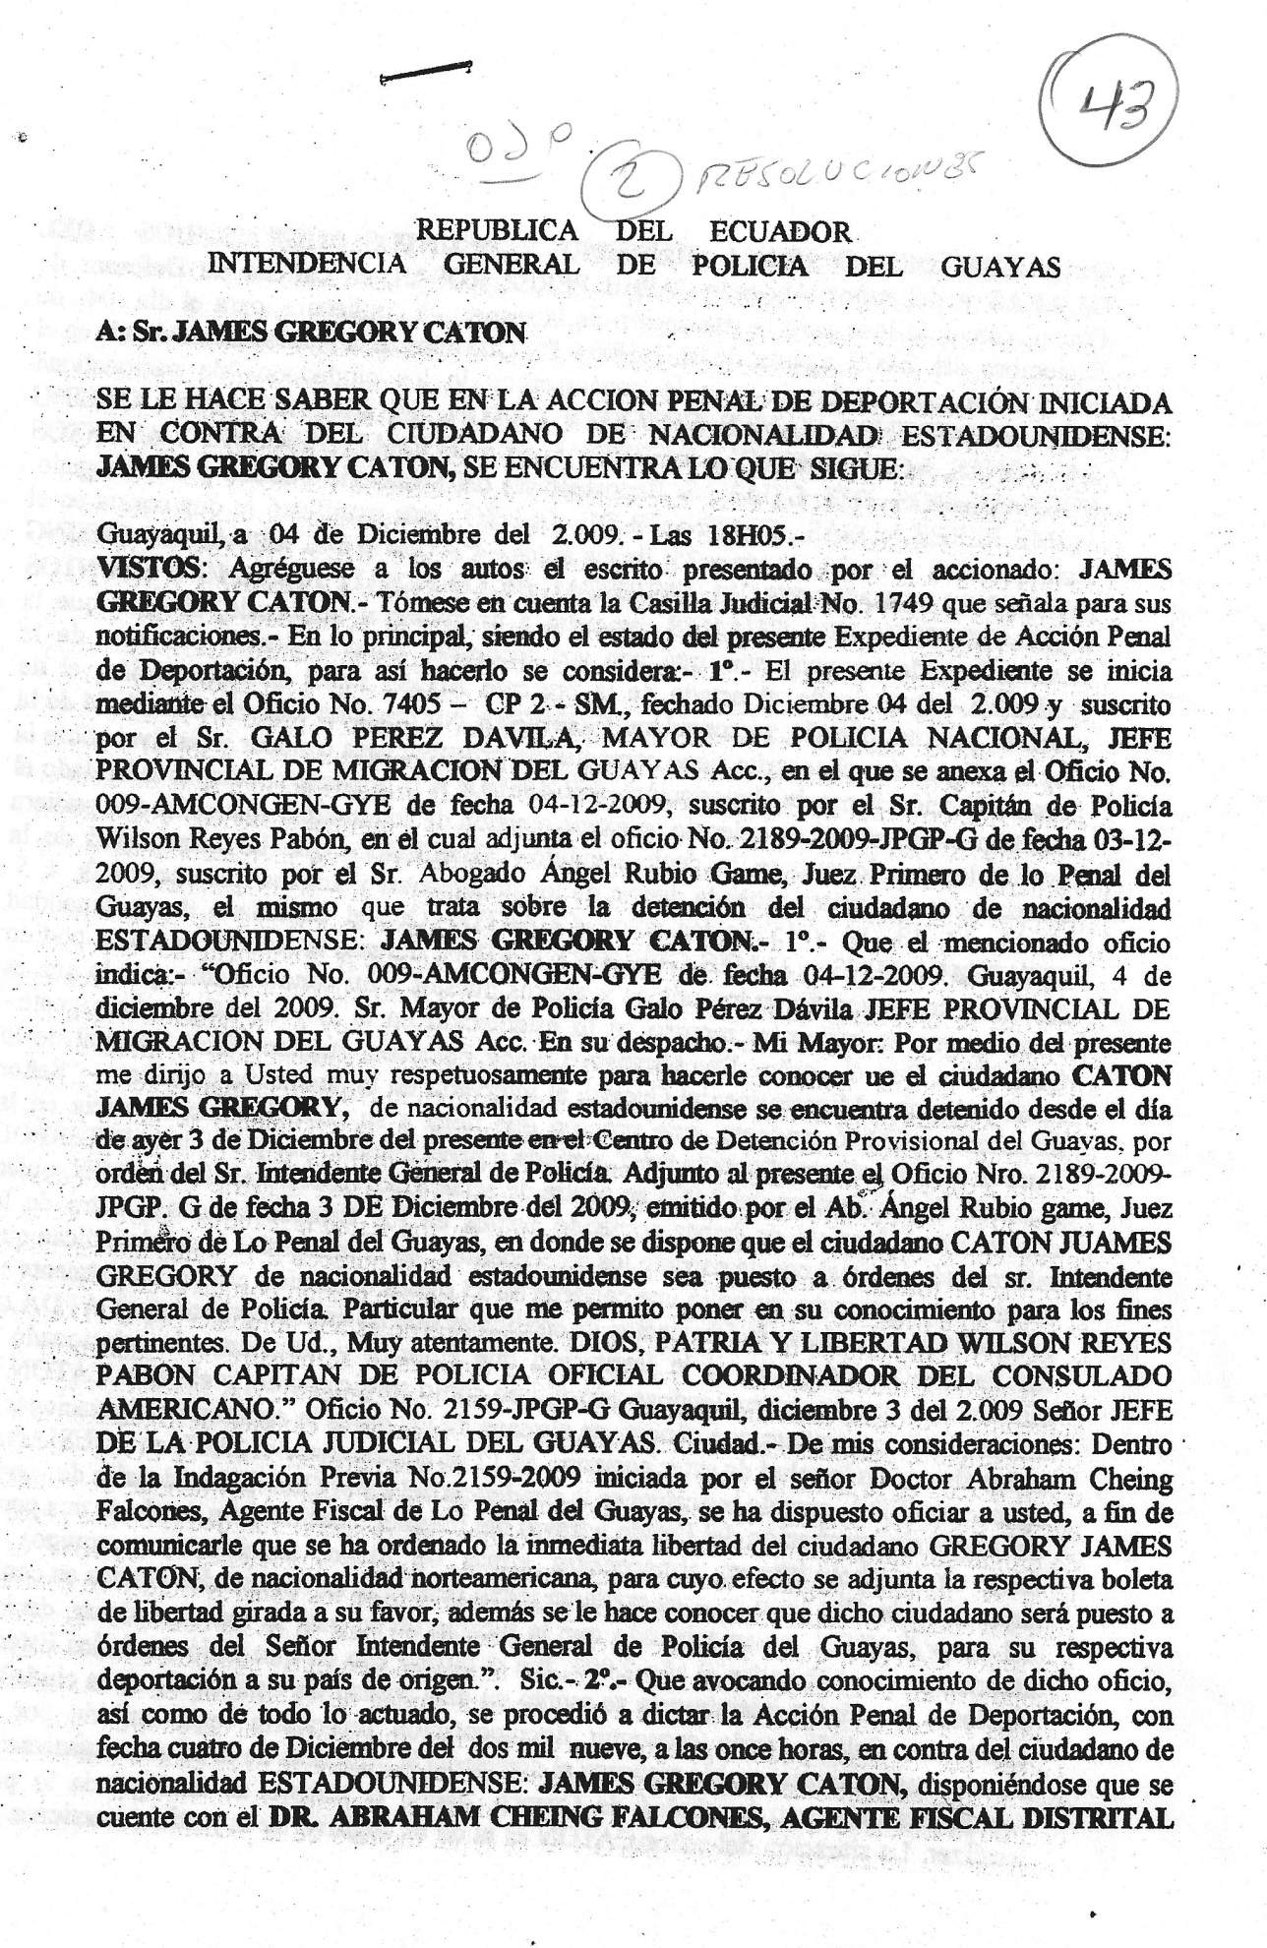
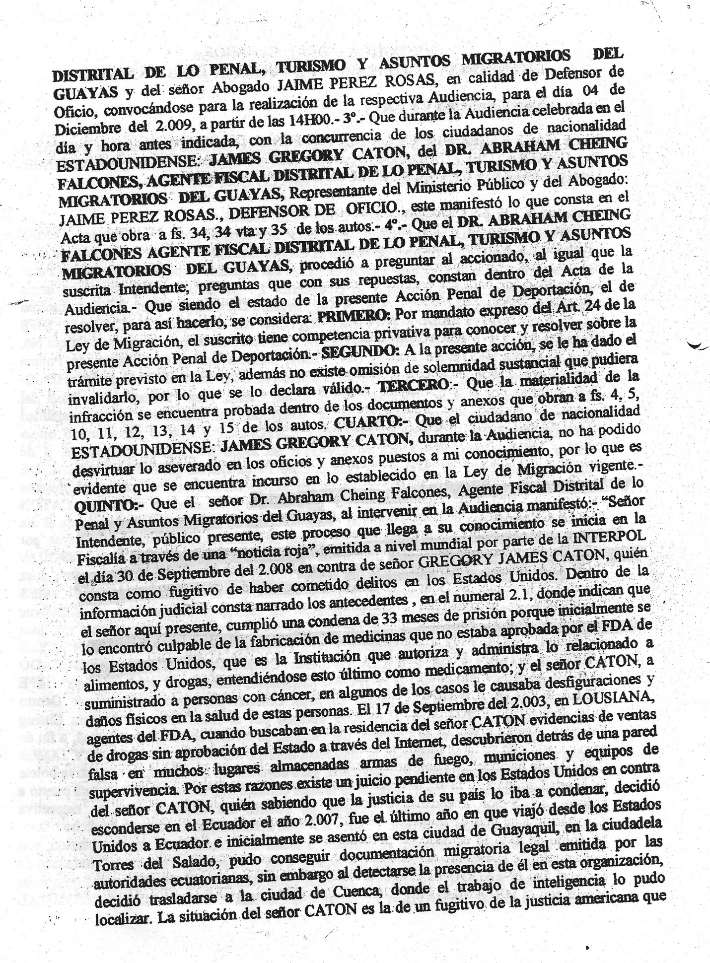
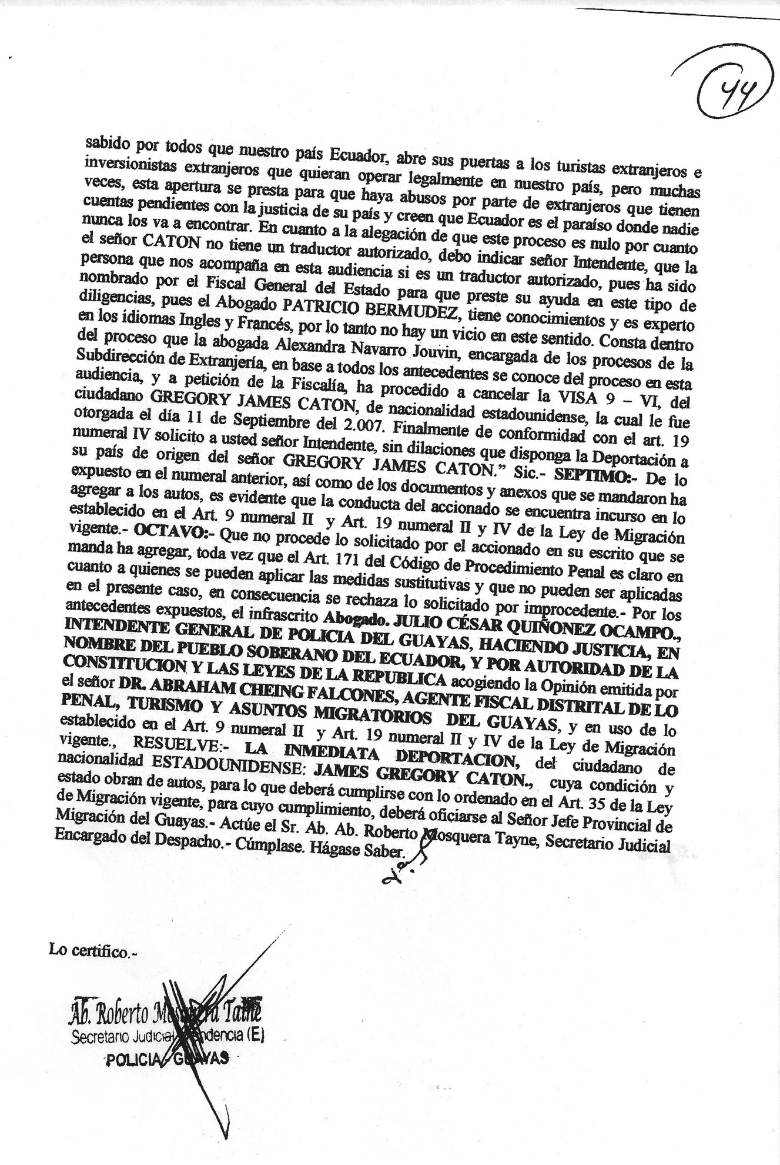

REPUBLIC OF ECUADOR
GENERAL MAYOR’S OFFICE OF THE POLICE DEPARTMENT OF GUAYAS

TO: MR. JAMES GREGORY CATON

IT IS MADE KNOWN THAT THE PROCEEDINGS OF DEPORTATION INITIATED AGAINST THE NORTH AMERICAN CITIZEN JAMES GREGORY CATON IS AS IT FOLLOWS:

Guayaquil, December 4, 2009 at 18H05
SEEN: Please add to the rulings the report presented by the defendant: JAMES GREGORY CATON. Take into consideration the Judicial Box No. 1749 that he states for his notifications. Main matter, being the present Expedient a Criminal Prosecution of Deportation, to be that way, it is considered: 1. - The present Expedient begins with Official Action number 7405-CP 2 –SM, of December 04, 2009 and issued by Mr. GALO PEREZ DAVILA, CHIEF OF THE NATIONAL POLICE, PROVINCIAL HEAD OF IMMIGRATION OF GUAYAS with the annexed Official Action number 009-AMCONGEN-GYE of 04-12-2009 issued by the Captain of Police Wilson Reyes Pabon. This last Official Action was annexed to Official Action number 2189-2009-JPGP-G OF 03-12-2009, issued by Atty. Angel Rubio Game, First Criminal Judge of Guayas; this is about the arrest of the NORTH AMERICAN citizen: JAMES GREGORY CATON. 1. - That the mentioned official action states: “Official Action number 009-AMCONGEN-GYE of 04-12-2009. Guayaquil, December 4, 2009. Chief of Police Galo Perez Davila PROVINCIAL HEAD OF IMMIGRATION OF GUAYAS- Hand delivered. Chief, hereby, I inform you that the citizen CATON JAMES GREGORY, of North American nationality, is arrested at the Provisional Detention Center of Guayas since yesterday, December 3rd by order of the General Mayor of Police. Annexed to this document is Official Action number 2189-2009-JPGP-G of December 3, 2009 issued by Atty. Angel Rubio Game, First Criminal Judge of Guayas, where it is stipulated that the citizen CATON JAMES GREGORY of North American nationality be put under orders of the General Mayor of Police. This is what you are here being notified for all legal purposes. Sincerely God, Fatherland and Liberty- WILSON REYES PABON, CAPTAIN OF POLICE, COORDINATOR OF THE AMERICAN CONSULATE”. “Official Action number 2159-JPGP-G Guayaquil, December 3, 2009. HEAD OF THE JUDICIAL POLICE OF GUAYAS- City– To whom it may concern- In the Prior Investigation No.2159-2009 initiated by Doctor Abraham Cheing Falcones, Prosecutor of Guayas, it is ordered to notify with the purpose of informing you that the immediate release of the North American citizen GREGORY JAMES CATON has been ordered. For that effect, the respective release order is annexed. Also, we inform you that such citizen will be put under orders of the General Mayor of the Police Department of Guayas for the respective deportation to his country of origin.” Sic 2. – That advocating knowledge of such official action as well as all of the acted, the Criminal Prosecution of Deportation was ordered with date of December four, two thousand nine, at eleven hours, against the North American citizen JAMES GREGORY CATON, ordering to account with the presence of DR. ABRAHAM CHEING FALCONES, DISTRICT PROSECUTOR OF CRIMINAL, TOURISM AND IMMIGRATION AFFAIRS OF GUAYAS and the Atty. JAIME PEREZ ROSAS, in his capacity as a public defender, summoning them for the respective Hearing on December 4, 2009 at 14H00.- 3.- That during the Hearing celebrated on the aforesaid day and hour with the attendance of the North American citizen JAMES GREGORY CATON, DR. ABRAHAM CHEING FALCONES, DISTRICT PROSECUTOR OF CRIMINAL, TOURISM AND IMMIGRATION AFFAIRS OF GUAYAS representing the Public Ministry and the Attorney JAIME PEREZ ROSAS as a public defender. This stated what the Act consists of on pages 34, 34 and reverse side 35 of the rulings. - 4.- That DR. ABRAHAM CHEING FALCONES, DISTRICT PROSECUTOR OF CRIMINAL, TOURISM AND IMMIGRATION AFFAIRS OF GUAYAS asked the defendant as well as the Mayor questions that are included with their answers in the Record of Hearing.- That being present the Criminal Prosecution of Deportation made to resolve, the following is considered: FIRST: As expressly mandated on Article 24 of the Immigration Law, the undersigned has privative competence to know and resolve about the present Criminal Prosecution of Deportation.- SECOND: The present action has the procedure provided by Law, also there is no defect in substantial formality which could invalidate proceedings, for which it is declared valid. – THIRD: That the materiality of the offense is proved in the documents and annexes that are found in pages 4, 5, 10, 11, 12, 13, 14 and 15 of the rulings. FOURTH: That the North American citizen JAMES GREGORY CATON, during the Hearing, could not detract the stated in the official actions and annexed documents known by me, therefore it is evident that it is deemed in what is established in the current Immigration Law. FIFTH: - That Dr. Abraham Cheing Falcones, DISTRICT PROSECUTOR OF CRIMINAL, TOURISM AND IMMIGRATION AFFAIRS OF GUAYAS, participating in the Hearing stated: - “Mayor, present public, this process that is brought to your knowledge starts at the Prosecutor’s Office with a “red notice” issued worldwide by the INTERPOL on September 30, 2008 against GREGORY JAMES CATON who is considered as a fugitive who had committed crimes/offenses in the United States. The precedents are related in numeral 2.1 of the judicial information where it is stated that the gentleman present here complied with a sentence of 33 months because, initially, he was found guilty for the manufacture of medicine that was not approved by the FDA of the United States which is the institution that authorizes and administrates what is related to food and drugs. This last one is also considered as medicine; and Mr. CATON has administered these to people with cancer and in some cases caused disfigurations and physical damage in the health of these people. On September 17, 2003, in LOUISIANA, agents of the FDA, when they were at his residence looking for evidence of Internet sales of drugs without the approval of the State, discovered behind a false wall, in many places, firearms, ammunitions and survival kits. For these reasons, there is a judgment pending in the United States against Mr. CATON who knew that the justice of his country was going to condemn him, decided to hide in Ecuador in 2007. It was the last year that he travelled from the United States to Ecuador and initially settled in this city of Guayaquil, in Ciudadela Torres del Salado. He was able to obtain legal immigration documents issued by Ecuadorian authorities. However, when this organization detected his presence, he decided to move to the city of Cuenca where intelligence was able to find him. Mr. CATON’S situation is the one of a fugitive of the American justice. And it is known by all of us that our country Ecuador opens its doors to foreign tourists and investors that want to legally operate here. But many times this opening causes abuse by the foreigners that have pending accounts with the justice of their country and therefore think that Ecuador is the paradise where nobody will ever find them. About the claim that this process is void because Mr. CATON does not have an authorized translator, I should indicate, Mayor, that the person who is here in this Hearing is an authorized translator since he has been assigned by the General Mayor of State to help us in this type of procedures since Atty. PATRICIO BERMUDEZ has knowledge and is an expert in the languages of English and French. Therefore, there is no defect in this sense. It is also included in this process that Atty. Alexandra Navarro Jouvin, clerk of proceedings of the Sub-directorate of Immigration, based on all the precedents and by petition of the Prosecutor’s Office, has proceeded to cancel the 9-VI VISA of the citizen GREGORY JAMES CATON, with North American nationality that was issued on September 11, 2007. Finally, in compliance with Article 19, numeral IV, I request you, Mayor, without delays, to order the Deportation of GREGORY JAMES CATON to his country of origin.” Sic. – SEVENTH:- Of the stated in the last numeral as well as the documents and annexes sent to add to the rulings, it is evident that the defendant’s behavior is deemed on Article 9, numeral II and Article 19, numeral II and IV of the current Immigration Law. – EIGHTH: - That the defendant’s request does not proceed, since Article 171 of the Criminal Procedure Code is clear about the cases that apply under the alternative measures and these cannot be applied in the present case. Consequently, the request is rejected for being wrongful. For the stated precedents, the undersigned Atty. JULIO CESAR QUINONEZ OCAMPO, GENERAL MAYOR OF THE POLICE DEPARTMENT OF GUAYAS, DOING JUSTICE, IN THE NAME OF THE SOVEREIGN PEOPLE OF ECUADOR, AND BY THE AUTHORITY OF THE CONSTITUTION AND THE LAWS OF THE REPUBLIC invoking the Opinion issued by DR. ABRAHAM CHEING FALCONES, DISTRICT PROSECUTOR OF CRIMINAL, TOURISM AND IMMIGRATION AFFAIRS OF GUAYAS, and using the established on Article 9, numeral II and Article 19, numeral II and IV of the current Immigration Law, RESOLVES: THE IMMEDIATE DEPORTATION of the North American citizen JAMES GREGORY CATON, whose condition is as stated filed on file, therefore what has been ordered on Article 35 of the current Immigration Law must be complied with. For such compliance, the Provincial Head of Immigration of Guayas must be notified. – Atty. Roberto Mosquera Tayne, Judicial clerk in charge of the Court. It is ordered that this be fulfilled and that notice be given.

I hereby certify.

(Illegible signature)
Atty. Roberto Mosquera Tayne
Judicial clerk
GUAYAS POLICE

