Summary Notes
Concerning the kidnapping of cancer researcher, Gregory James Caton

Below are a series of summaries , which take into account the information in more than 100 pages of legal documents, including court transcripts, filings, private email and other correspondence, relating to the illegal kidnapping and deportation of Gregory James Caton from Ecuador in December, 2009.

December 27, 2011

This document contains the following four items. In each case the Spanish original is followed by its English translation.
- “Human Rights Violations of Citizen, Gregory James Caton” -- A quick 10-point summary of the high points of the extraordinary details of the case. This is a “high-points-at-a-glance” executive summary written by Caton’s legal counsel.
- Summary of the Case of the Rights Violation(s) and Illegal Deportation of the Foreign Citizen, Gregory James Caton. This 4-page paper is a more detailed summary of the kidnapping, legal proceedings, and the aftermath, covering the crucial time frame of December 2 – 14, 2009.
- “Kidnapped, Imprisoned and Deported: A Bitter Christmas for a North American Family.” This article was written by the famous Ecuadorean journalist, Edgar Cardenas (then 54), in late December, 2009, and was re-published in El Mercurio, the largest general readership newspaper in Cuenca, Ecuador. It is reproduced here as it details the highlights of the case as seen through an independent Ecuadorean journalist. It is a summary from a journalist’s perspective.
- “Constitutional & Legal Principles That Were Violated in the Detention (of Gregory James Caton).” Self-explanatory, this was written as a legal opinion by an Ecuadorean constitutional lawyer in Quito, Dr. Roberto Moreno, following the kidnapping and deportation. It is a summary seen through the ideas of a constitutional lawyer.

”Human Rights Violations of Citizen, Gregory James Caton”
Note that each of the ten points below constitute one or more violations of Ecuadorean law – per point. The Spanish original appears first below.

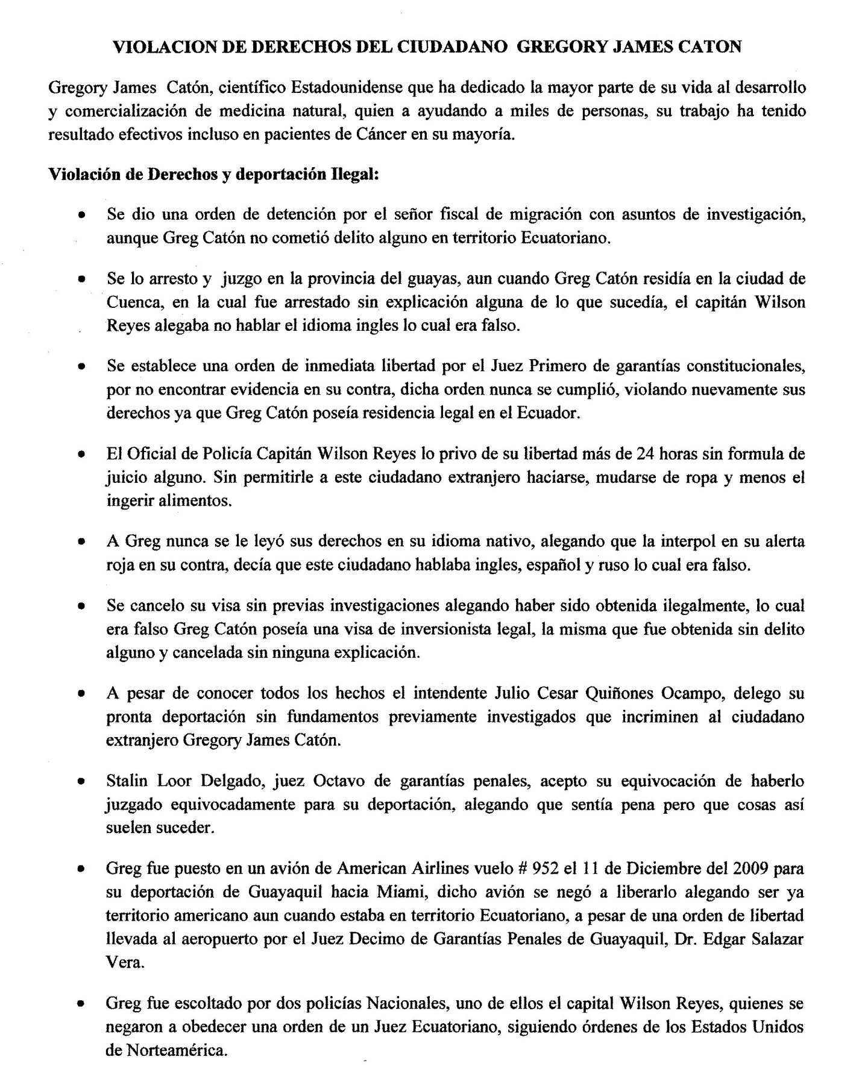

RIGHTS VIOLATIONS OF THE CITIZEN GREGORY JAMES CATON
Gregory James Caton, an American scientist who has given the majority of his adult life to the development and marketing of natural medicines, who has helped thousands of people, and whose work has been effective even with a majority of cancer patients served, has had his rights violated in the following ways:

Rights violations and illegal deportation:

- There was a warrant by a “Fiscal” (i.e. prosecutor) of Migration with investigative matters, even though Greg Caton did not commit any crime in Ecuadorian territory.

- He was arrested and tried in the Province of Guayas, even though Greg Caton resided in the city of Cuenca (Province of Azuay), where he was arrested without any explanation of what was happening. Captain Wilson Reyes claimed, in court, that he did not speak any English, which is not true.

- Judge Angel Rubio, the presiding judge, after reviewing the facts of the case, issued an immediate release order in Caton’s case. In other words, the result of the extradiction hearing was that Judge Rubio did not find any evidence against him. There was no evidence presented that Mr. Caton had done anything that would warrant his extradition. This order was never fulfilled, again violating Caton’s rights, as a legal permanent resident of the country of Ecuador.

- The police officer, Captain Wilson Reyes of the Ecuadorean National Police, deprived Caton of his freedom for more than 24 hours without the benefit of trial, imprisoning him for a period of time that exceeds the time allotted by Ecuadorean law, before the benefit of his extradition hearing. He did not allow Caton any change of clothes, or access to food.

- No one read Caton his rights in his native language, as required by Ecuadorean law. Instead, Reyes relied upon information from an Interpol alert that stated that Caton was fluent in English, Spanish, and Russian – none of which is true. Caton’s only language of fluency is his native one: English.

- Caton’s Ecuadorean Visa allowing him permanent residency was canceled without prior investigation. Reyes claimed that Caton obtained his Visa illegally, which is not true. Greg Caton had a legal “investor’s visa,” identical to that of his wife, Cathryn, whose legal status has never been questioned. Caton’s Visa was obtained without any violation of law and cancelled without any explanation.

- Despite knowing the facts of Caton’s case, intendente Julio Cesar Quinonez Ocampo of Guayaquil, who has an impressive history of committing corrupt acts while in an official capacity, requested that Caton be deported from Ecuador without any legal foundation. Not only did Ocampo not provide any legal basis for Caton’s deportation, but there existed no investigation which would have been requisite for such a finding in the first place.

- Loor Stalin Delgado, “Eighth judge of criminal guarantees,” with whom Caton had a scheduled hearing which was aborted by Caton’s illegal deportation, stated after the deportation that this illegal act was a “mistake” and that he felt sorry about it, but that “things like this happen sometimes.”

- Greg Caton was put on an American Airlines plane -- Flight # 952 on Friday, December 11, 2009 – thereby illegally deporting him. When Caton asked Reyes where they were going, after being taken from the prison in Guayaquil, Reyes stated in clear, understandable English that he was being taken to see the judge for his hearing. Instead of taking Caton to his hearing, Reyes took Caton immediately to Guayaquil International Airport. He was deported on a non-stop flight from Guayaquil to Miami. About an hour before the flight, Caton was able to get ahold of a cell phone and notify his wife of what was transpiring. Calls were made to Caton’s legal team which resulted in none other than the Tenth Judge of Criminal Guarantees, Dr. Edgar Salazar Vera, who presided over a second hearing which caused the hearing with Dr. Delgado to be scheduled, wherein Dr. Vera requested that Caton – who by that time was on the tarmac – be immediately released. The plane’s pilot refused to release him, claiming to be on American territory, even though the plane was clearly sitting in Ecuador. Thus, an American Airlines pilot refused to honor the orders of an Ecuadorean judge on Ecuadorean territory.

- Greg was escorted by two Ecuadorian policemen, one of whom was Capitan Wilson Reyes, who himself refused to obey the order from an Ecuadorian judge. Thus, Reyes committed treason by opting to follow orders by the U.S. State Dept. over those of an Ecuadorean federal judge.

Summary of the Case of the Rights Violation(s) and Illegal Deportation of the Foreign Citizen, Gregory James Caton.
The original document was composed in Spanish and appears immediately below. It is followed by its English translation.

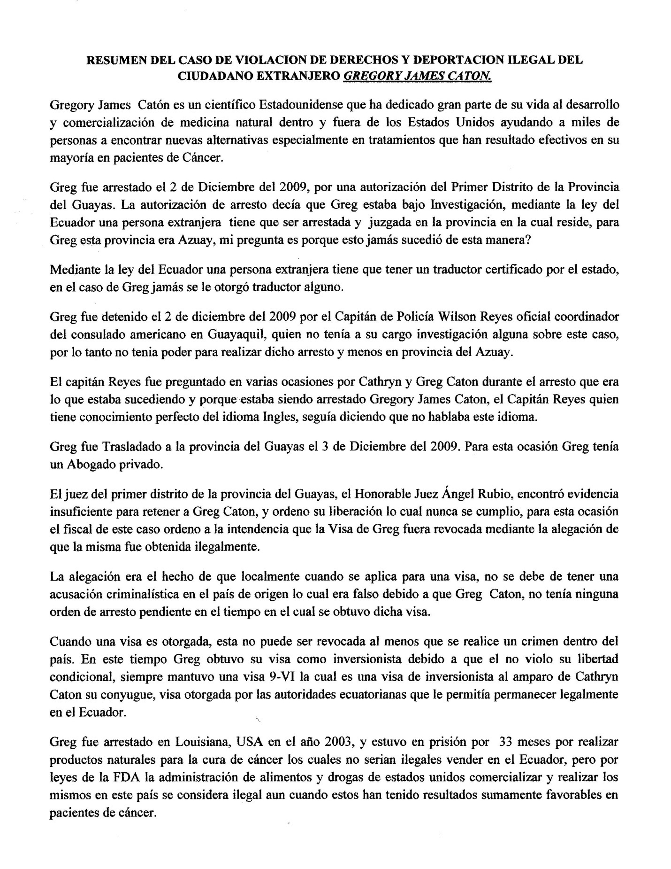

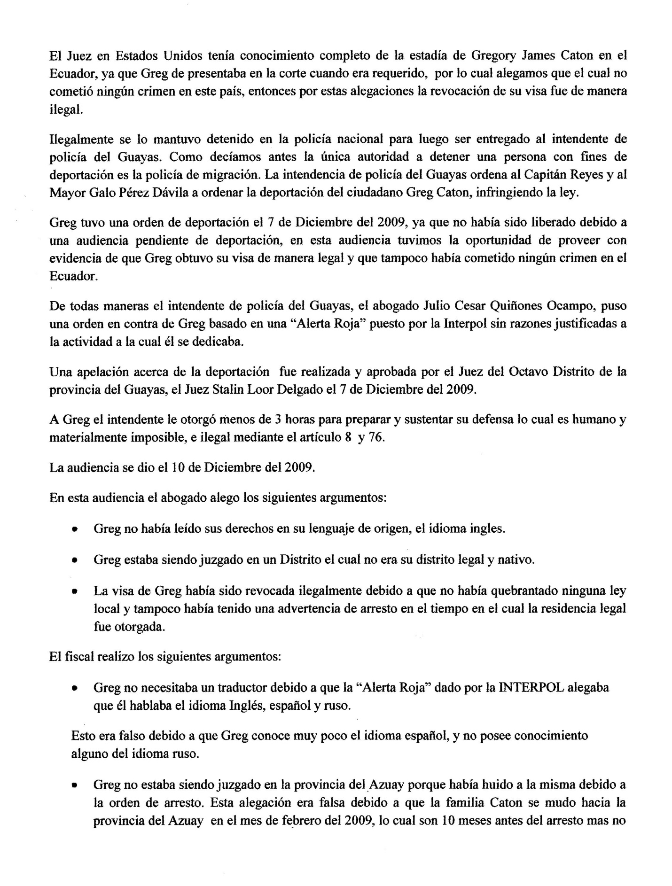

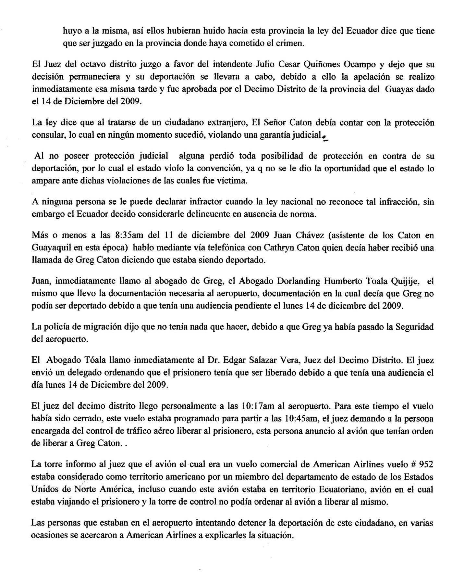
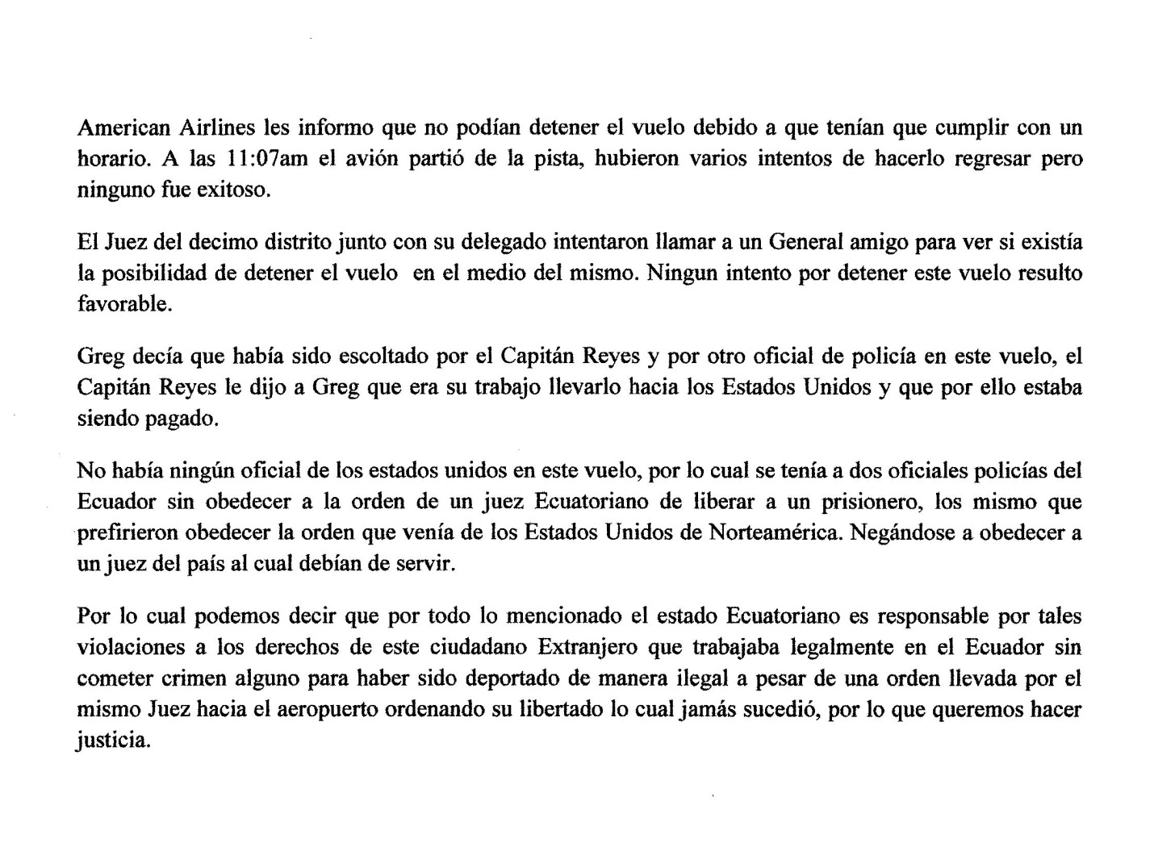
English translation:
SUMMARY OF PARTICULARS INVOLVING THE CASE OF RIGHTS VIOLATIONS
AND ILLEGAL DEPORTATION OF THE FOREIGN CITIZEN GREGORY JAMES CATON

Gregory James Caton is an American scientist who has devoted much of his life to the development and marketing of natural medicinal products, both inside and outside the United States. He has helped thousands of people find effective alternatives, especially with cancer remedies that have a long, time-tested history of effective use.
(Editor’s Note: see Chapter 1 of Meditopia: http://www.meditopia.org/chap1.htm).

Greg was arrested on December 2, 2009, as a result of an illegal order issued from the First District of the Province of Guayas. The arrest warrant said that Greg was under investigation under Ecuadorean law – which subsequently was shown to be untrue. Under Ecuadorean law, a foreign person must be arrested and tried in the province in which he resides. In Caton’s case, this was the Province of Azuay, not Guayas. Knowledgeable Ecuadorean attorneys consulted on this matter have indicated that this alone is unprecedented.

Under Ecuadorean law, a foreign person must have a state-certified translator; in Greg case, no attempt was made to assign him a translator, though at every step, it was apparent that Caton could not understand what was occurring.
Greg was arrested on December 2, 2009 by Captain Wilson Reyes, an official with the Ecuadorean National Police, acting on orders from the U.S. Consulate in Guayaquil. At no point was Reyes in charge of any investigation into this case, because there never was one. Therefore, he had no power to make that arrest, and even less so, commissioning a crime on Azuay territory.
Captain Reyes was asked on several occasions by Cathryn and Greg Caton during the arrest what was going on and why was Gregory James Caton been arrested , the Capitan Reyes who spoke perfect English, keep saying that he didn’t know English, which is untrue.

Greg was moved transferred from the Province of Azuay to Guayas on the evening of December 2, 2009. Even at this stage, Caton was never read his rights or told what law(s) he had violated. He was not granted access to his attorney.
The judge of the First District of Guayas Province, the honorable Judge Angel Rubio, found insufficient evidence to hold Greg Caton, and ordered his release. This court-ordered release was never fulfilled. The position of the prosecutor in this extradiction hearing was that Caton’s visa was obtained illegally. Again, not only was Greg Caton’s Ecuadorean Visa not obtained illegally, but it was obtained in the very same manner, using the same attorney, that was used to obtain the Visa of Cathryn Caton (Greg’s wife), which has never been questioned – then or now.
The allegation against Caton was that when he applied locally for a Visa, he should not have any criminal charge in his country of origin, which was false because Greg Caton did not have any outstanding arrest warrants from any jurisdiction worldwide at the time he obtained his Ecuadorean visa.
When a Visa is issued in Ecuador, it cannot be legally revoked unless that person commits a crime in Ecuador, under Ecuadorean law. At the time, Greg was granted a Visa as a “9-VI investor.” This Visa was obtained under Cathryn Caton, his spouse, which allowed him to remain legally in Ecuador.

Greg was arrested in Louisiana, USA in September, 2003, for marketing products “not approved by the U.S. Food and Drug Administration.” He served a 33 month sentence for making natural products which would not be illegal to sell in Ecuador – only under the laws of the U.S. FDA.
Nor was Greg Caton residing illegally in Ecuador, even under U.S. law. U.S. Federal Judge Tucker Melancon, his sentencing judge, granted permission for Caton to travel back and forth to the U.S. to conduct business. (It was only after Caton obtained his Ecuadorean Visa that he discovered a conspiracy involving the U.S. prosecutor’s office in Lafayette, Louisiana, which became the basis for his non-return to the U.S. Even so, this does not violate Ecuadorean law. The particulars on this part of Caton’s case is argued extensively in Chapter 3 of Meditopia: http://www.meditopia.org/chap3-1.htm).
So, again, under Ecuadorean law, his deportation was legal, according to all Ecuadorean attorneys that the Caton’s have consulted.

Returning to the pre-deportation events in Guayaquil, Caton was illegally held by the National Police before being handed over to the Chief of Police in Guayas. As stated previously, the only governing authority in Ecuador that has the legal right to detain a person for deportation purposes is the immigration police. The Chief of Police in Guayas ordered Captain Reyes and “Mayor” (a titled position higher than Captain) Galo Reyes Perez Davila to deport Caton, thereby breaking Ecuadorean law.
An order to deport Caton was issued on December 7, 2009. This was done even though there was an appellate hearing pending with Judge Salazar Vera, during which time it would have been shown that any claim that Caton had obtained his visa illegally was without truthful basis, and that, furthermore, any claim that Caton had violated an Ecuadorean law was meritless.
Anyway, the Chief of Police in Guayas, Julio Cesar Quinones Ocampo, placed an order against Caton based on an “Interpol – Red Alert” posting, which itself contained substantial and deliberate false information – which even if it had been true, would not justify extradition under Ecuadorean law.

An court appeal regarding the proposed deportation was made ​​and approved by the Judge of the Eighth District of Guayas Province, Judge Delgado Stalin Loor, on December 7, 2009.

For this second of three hearings – the third of which would never transpire – Caton was given less than 3 hours by the Mayor to prepare and support his defense, which is humanly impossible, and illegal under Article 8 and 76 of the Ecuadorean Constitution.

This second hearing took place on December 10, 2009.
At this hearing Caton’s attorney argued the following points:

- Greg had not been read his rights in his original language (English), as required by law.
- Greg was being judged in a province that was not his current jurisdiction.
- Greg's visa had been revoked illegally because he had not broken any Ecuadorean law, nor was there any legitimate arrest warrant at the time he was granted his legal residency.

The “Fiscal” (i.e. Prosecutor) made the following arguments:

- Greg did not need a translator because his “Interpol – Red Alert” posting said he spoke the Spanish, English and Russian languages.

This was not true because Caton’s knowledge of Spanish was then and is now rudimentary. He possesses no functional knowledge of the Russian tongue and at no time could speak no more than a handful of words in that language.

The Fiscal claimed that Caton was not being tried in the Province of Azuay, because he had fled to it, because of the arrest warrant. This allegation was patently false because the Caton family moved to the Azuay province in February of 2009, fully 10 months before the arrest. The Caton family could not possibly have run away from an arrest warrant which would not be issued for another 10 months after their move.

Worse still, Ecuadorean law indicates that a violation must be tried in the province where the crime was committed. This is yet another law that was deliberately ignored in his proceedings.

The Eighth Judge of the District, Dr. Stalin Loor Delgado, in Caton’s second hearing on December 10, 2009, gave in to the pressure from the Intendente, Mayor Julio Cesar Quinones Ocampo, as well as a U.S. State Dept. official, who was present at all of Caton’s hearings in Guayaquil. This set the stage for an appellate hearing, which was filed by Caton’s counsel that same afternoon. This appellate request was approved by the Tenth District of Guayas and a hearing date was set for December 14, 2009.

Although Caton had consular protection from his “native country” (the U.S.), as demanded by Ecuadorean law, during his hearings, such assistance had no bearing. This is because his abduction and deportation, which amounted to little more than an “extraordinary rendition,” were planned and executed by the U.S. Government itself. Thus, he lost any chance of protection against the rendition that followed.
No person in Ecuador – citizen or legal resident – can be declared a national offender of the law, if he does capable of acknowledging such a violation. In this case, there were none.

At about 8:35 am on December 11, 2009 Juan Chavez (Caton’s assistant at that time), spoke by telephone with Cathryn Caton who claimed to have received a call from Greg Caton saying that he was at Guayaquil airport and that he knew he was in the process of being deported, since Reyes had lied about his intentions throughout that morning.
Juan immediately called Greg's lawyer, Dorlanding Humberto Toala Quijije, the same attorney who took the necessary documentation to the airport, stating that Caton could not be deported because he had a pending hearing on Monday, December 14 2009.

The immigration police said that they had nothing to do with the matter, because Greg had already passed through the airport security.
Dr. Toala Quijije immediately called Dr. Edgar Salazar Vera, Judge of the Tenth District. The judge then immediately sent a court officer to the airport, giving the order that the prisoner had to be released because he had a hearing on Monday, December 14, 2009.
The Tenth District Judge personally arrived at 10:17 am at the airport. By this time the plane was already on the tarmac. This flight was scheduled for 10:45 am, and the judge demanded the person responsible for air traffic control free the prisoner. Air traffic personnel relayed this order to the plane’s pilot, who then refused to honor the order.
The tower informed the judge that the plane which was an American Airlines Flight #952 was considered U.S. territory by a member of the U.S. State Department, even when the plane was on Ecuadorian territory.
The members of the Ecuadorean court who were then at the airport trying to stop the deporta-tion of this citizen, repeatedly came to American Airlines to explain the situation.

American Airlines reported that they could not stop the flight because they had to follow a schedule. At 11:07 a.m. The plane left the runway, there were several attempts to get him back but none was successful.
The Judge of the Tenth District, along with his officer, tried to call a general friend to see if there was any possibility to stop the flight while cruising over Ecuadorean territory. No attempt to stop the flight was successful.
Caton was escorted by Captain Reyes and another officer on this flight. Capt. Reyes told Greg in unmistakable English that it was “his job” was to take him to the U.S.
There was no U.S. official on this flight – only two Ecuadorian police officers, disobeying the order of a Ecuadorian judge to release a prisoner, while taking direct orders from the U.S. State Dept.

“Kidnapped, Imprisoned and Deported: A Bitter Christmas for a North American Family.”

A scan of the original (Spanish) draft of this article appears below, immediately followed by its English translation. Note that the article takes the form of a letter to the Editor. Interestingly, the author of this article, Edgar “Patricio” Cardenas of Cuenca, a long respected journalist in Ecuador, well-known for his frontline coverage of Ecuador’s war with Peru in 1996, died in late 2011. The article was subsequently published in Cuenca’s daily, “El Mercurio,” after the kidnapping in December, 2009.

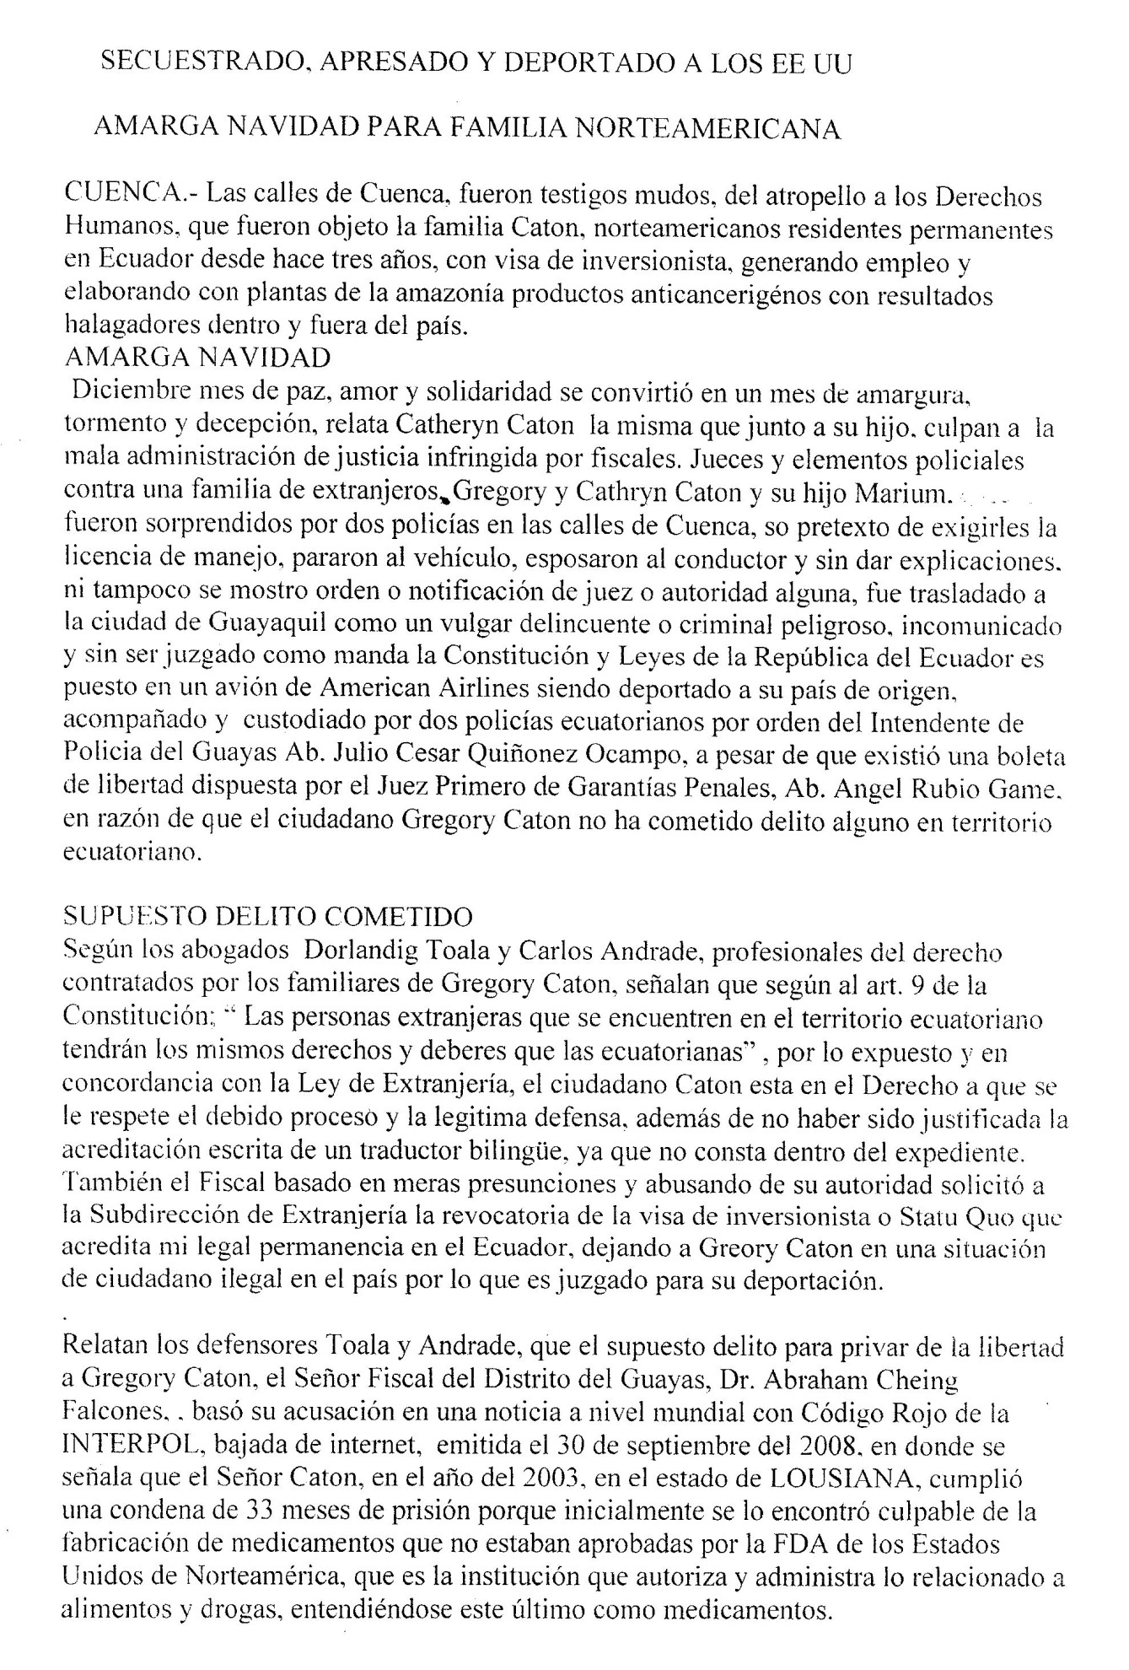
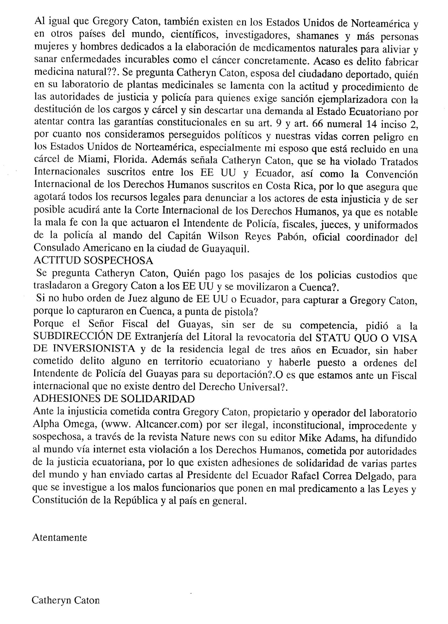
English translation :

“Kidnapped, Imprisoned and Deported: A Bitter Christmas for a North American Family.”
CUENCA. - The streets of Cuenca were speechless witnesses of the violation of the Human Rights that the Caton family was subject of, North American permanent residents of Ecuador for the past three years, with investors’ visa, generating employment and producing cancer remedies with plants of the Amazon with good results in and out of the country.
A BITTER CHRISTMAS
December, a month of peace, love and solidarity became a month of bitterness, torment and deception, affirms Cathryn Caton, who with her son blame the bad administration of an infringed justice by prosecutors, judges, and police officers against a foreign family. Gregory and Cathryn Caton and their son Myron were surprised by two police officers in the streets of Cuenca with the excuse of requiring the driver’s license. They stopped the vehicle, handcuffed the driver and without giving explanations nor showing any order from a judge or an authority, Gregory Caton was taken to the city of Guayaquil like a vulgar delinquent or a dangerous criminal, without the right to communicate and without being judged by the Constitution and Laws of the Republic of Ecuador. He was placed in an American Airlines airplane and deported to his country of origin accompanied and guarded by two Ecuadorian policemen under orders of the Mayor of Police of Guayas, Attorney Julio Cesar Quiñonez Ocampo, in spite of a release order issued by the First Judge of Criminal Guarantees, Lawyer Angel Rubio Game, in reason that the citizen Gregory Caton had not committed any crime in Ecuadorian territory.
THE ALLEGED CRIME COMMITTED
According to the lawyers Dorlandig Toala and Carlos Andrade -- attorneys hired by Gregory Caton’s family -- according to Article 9 of the Constitution: “Foreign persons in Ecuadorian territory shall have the same rights and duties as those of Ecuadorians.” Considering the aforesaid and in agreement with the Immigration Law, the citizen Caton has the right to have his process respected and be given a legitimate defense. Moreover, there is no justification for the fact that there was no written translation since it is not included in the file. Also, the Prosecutor based his decisions on simple presumptions and abused his official position, requested the Sub-directorate of Immigration to revoke the investment visa or Status Quo that justifies his legal presence in Ecuador, leaving Gregory Caton in an illegal position in the country for the reason that he is tried for his deportation.
The attorneys Toala and Andrade state that the alleged crime to imprison Gregory Caton, the Prosecutor of the District of Guayas, Atty. Abraham Cheing Falcones, based his accusation on a worldwide INTERPOL notice with Red Code issued on September 30, 2008, where it affirms that Mr. Caton was sentenced to 33 months of imprisonment in Louisiana in 2003 because he was initially found guilty for the production of medicine that was not approved by the FDA of the United States of America, that is the institution that authorizes and administrates all that is related to foods and drugs.
In the United States as well as in other countries of the world there are scientists, researchers, shamans and other people like Gregory Caton that are dedicated to the development of natural medicine to relief and cure illnesses such as cancer. Is it a crime to develop natural medicine? That is what Gregory’s wife, Cathryn Caton asks herself in her laboratory of natural medicine. She feels disappointed to see the attitude and procedures of authorities of justice and police here for whom she demands a severe sanction with the removal from their offices and imprisonment without discarding a demand against the Ecuadorian State for attempting against the Constitutional Guarantees in the Articles 9 and 66, numeral 14, subsection 2. She states “This is why we feel that we are politically pursued and our lives are in danger in the United States, especially my husband who is imprisoned in Miami, Florida”. Cathryn Caton also indicates that the International Treaties agreed between the United States and Ecuador, as well as the Human Rights International Convention held in Costa Rica were violated. Therefore, she indicates that she will exhaust all the legal resources in order to denounce the perpetrators of this injustice and if it is possible, she will turn to the International Court of Human Rights since it is evident there was bad faith on the part of the Police Mayor, judges and the policemen under Captain Wilson Reyes Pabon’s (coordinator of the U.S. Consulate in Guayaquil) upon whose orders they were acting
SUSPICIOUS ATTITUDE
Cathryn Caton asks herself: Who paid the flight tickets of the Ecuadorean police officers that guarded Gregory Caton to the USA and also went to Cuenca?
If there was no order of any judge in either USA or Ecuador to capture Gregory Caton (without proper jurisdiction), then why was he captured in Cuenca, at gun point?
Why did the Prosecutor of Guayas, acting outside his professional jurisdiction, ask the Sub directorate of Immigration of the Littoral to revoke the “Statu Quo” or Investors Visa and the legal residence of three years in Ecuador from Gregory Caton without committing any crime in Ecuadorian territory? Why did he accept orders from the Police Mayor of Guayas for the deportation of Gregory Caton? Or, are we before an international mayor that does not exist in Universal Law?
SOLIDARITY ADHESIONS
Before the injustice committed against Gregory Caton, owner and operator of Alpha Omega Laboratory (www.Altcancer.com), Mike Adams -- editor of Natural News online magazine -- spread to the world the violation of human rights committed by the Ecuadorian authorities of justice. Therefore, there are solidarity adhesions from many parts of the world that have also sent letters to the President of Ecuador, Rafael Correa Delgado asking to investigate the bad authorities that give bad reputation to the Laws and Constitution of Ecuador.
Sincerely,

Cathryn Caton
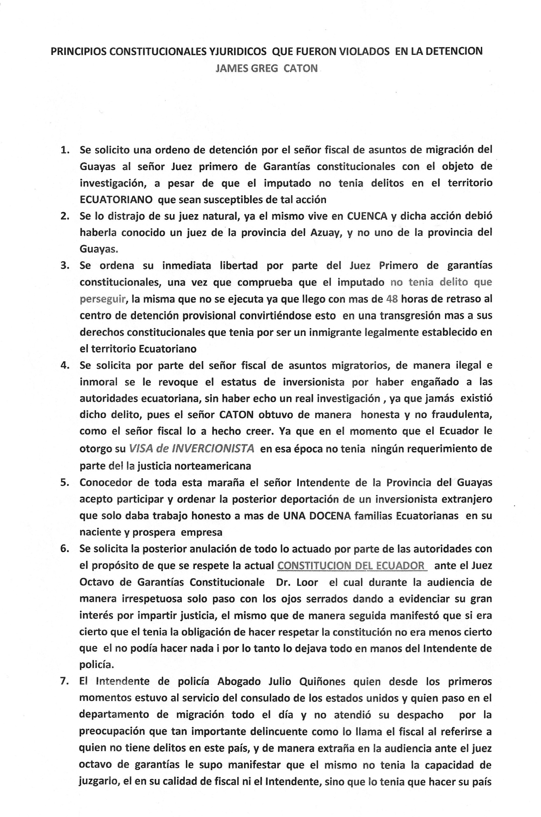
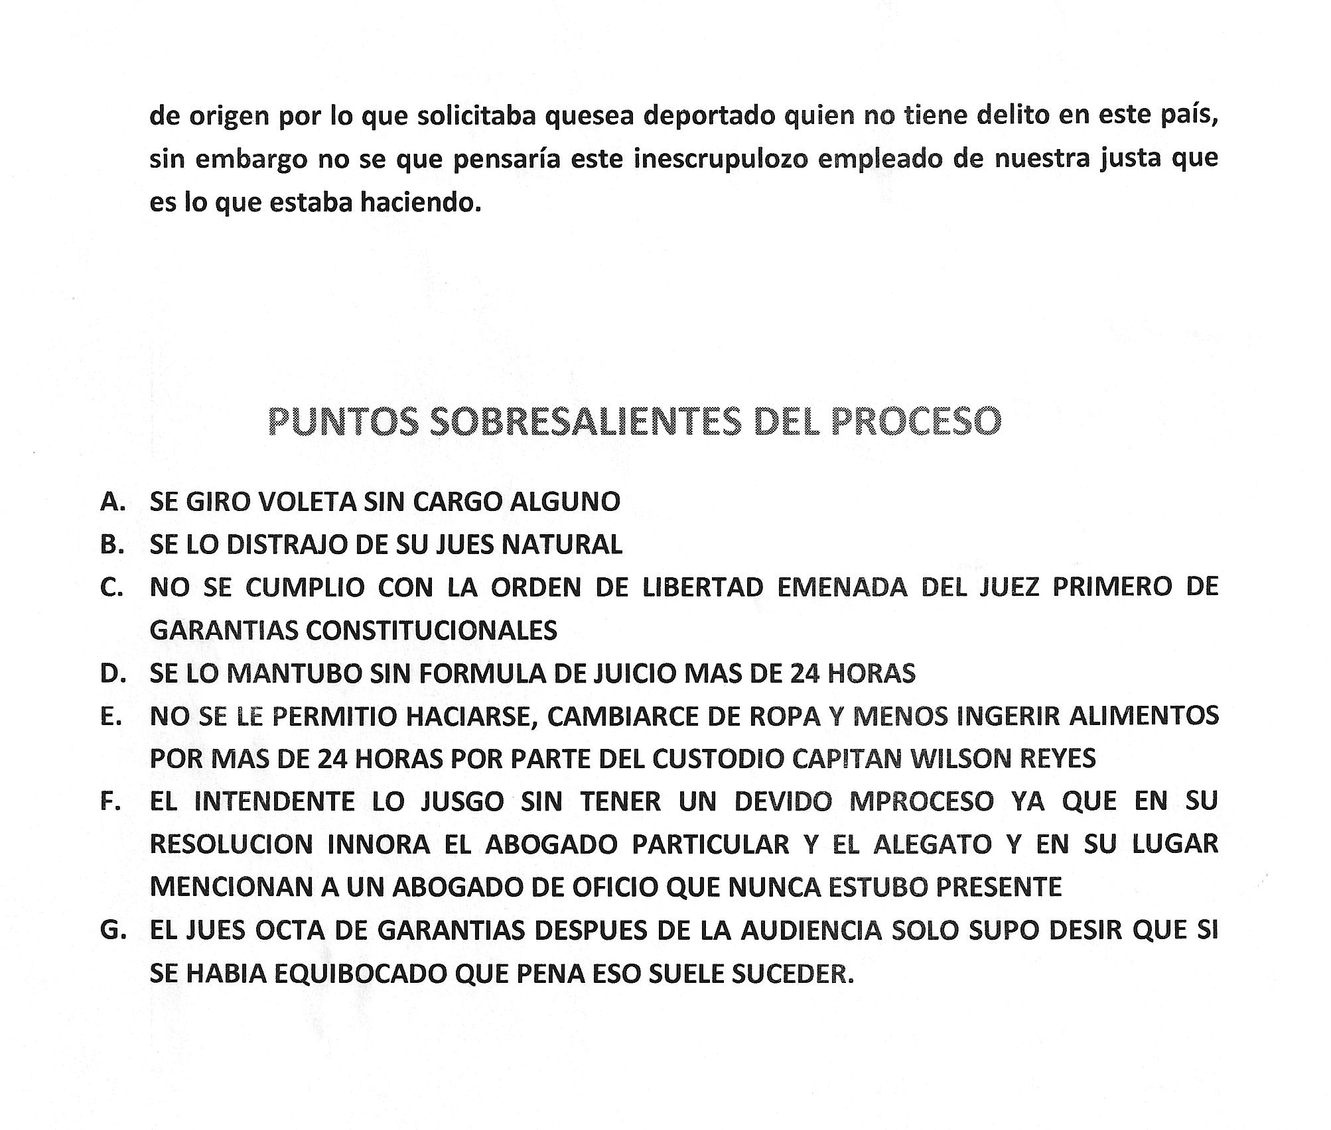
The English translation now follows:

CONSTITUTIONAL AND LEGAL PRINCIPLES THAT WERE VIOLATED IN THE ARREST OF
JAMES GREG CATON

- There was an arrest order requested by the immigration prosecutor of Guayas to the First Judge of Constitutional Guarantees with the object of an investigation, even though no crime had ever been committed in Ecuadorian territory by the Defendant that would justify such a thing.
- This case was re-directed away from the natural judge of proper jurisdiction who lives in Cuenca to authorities in Guayaquil. Such action should have been known by a judge of the province of Azuay and not by one in the province of Guayas.
- The First Judge of Constitutional Guarantees issues an immediate order of freedom once it had been shown that the accused had committed no crime. Such order was deliberately disobeyed and did not arrive for over 48 hours of delay in the provisional detention center. This becomes another violation committed against the constitutional rights that the accused had for being a legal immigrant in Ecuadorian territory.
- There was a request by the immigration prosecutor to illegally and immorally revoke the status of investor from the accused, wherein the representation was made that the accused obtained his visa with deceit. Such representation is made despite the complete absence of a real investigation since such crime never existed. Mr. Caton obtained his visa in an honest and not fraudulent way, which contradicts what the prosecutor wants to be believed. At the moment that Mr. Caton was issued his investor’s visa, there were no charges from North American authorities.
- Being aware of all these facts, the Mayor of the province of Guayas, nonetheless, accepted to participate and later ordered the deportation of a foreign investor who employed more than a dozen Ecuadorian families in his nascent and prosperous company.
- The subsequent annulment of all the authorities’ actions was requested in order to respect the current Constitution of Ecuador before the Eighth Judge of Constitutional Guarantees, Dr. Loor. During the hearing, in a disrespectful way, he acted with his eyes closed. Subsequently, he indicated that it was true that he had the obligation to enforce respect for the Constitution and it was not true that he could not do anything and that he left everything in the hands of the Mayor of Police.
- The Police Mayor, Atty. Julio Quiñones, who was at the service of the American Consulate from the beginning and who spent the entire day in his office and did not handle anything for being preoccupied with such an “important criminal” (as the prosecutor refers to a person who has no crimes in this country), and in a strange way during the hearing before the Eighth Judge of Guarantees, was able to manifest that he was not capable of judging the accused in his quality of prosecutor nor mayor and that he had to be judged by his country of origin. Therefore, the deportation of a person with no crimes in this country was requested. However, I do not know what this unscrupulous employee of our justice was thinking of when he was doing this.

SIGNIFICANT POINTS OF THE PROCESS

- AN ORDER WAS ISSUED WITHOUT ANY CHARGE
- THE CASE WAS MISASSIGNED AWAY FROM THE PROPER JUDGE IN AZUAY WHO SHOULD HAVE HEARD THE CASE AND ASSIGNED TO A JUDGE IN GUAYAQUIL, IN VIOLATION OF PROPER JURISDICTION.
- THE ORDER TO RELEASE THE DEFENDANT, ISSUED BY THE FIRST JUDGE OF CONSTITUTIONAL GUARANTEES, WAS NOT FOLLOWED.
- THIS CASE WAS NOT CONSIDERED AS A TRIAL FOR MORE THAN 24 HOURS
- CAPTAIN WILSON REYES DID NOT ALLOW THE ACCUSED TO CLEAN OR CHANGE CLOTHES. NOR WAS HE ALLOWED TO EAT ANYTHING FOR MORE THAN 24 HOURS
- THE MAYOR JUDGED THE ACCUSED WITHOUT HAVING THE DUE PROCESS AND IN HIS RESOLUTION, HE IGNORED THE PRIVATE LAWYER AND THE ALLEGATION AND INSTEAD MENTIONS A LAWYER THAT WAS NEVER PRESENT
- AFTER THE HEARING, THE EIGHTH JUDGE OF GUARANTEES ONLY SAID THAT HE MADE A MISTAKE AND THAT IT USUALLY HAPPENS. [Editor note: Astonishingly, the Eighth Judge actually said that – that such things “usually” happen, not rarely, not sometimes, but usually!]

