Judge Vera’s Ruling: Dec. 10, 2009

Background: After filing the “Action of Protection” on behalf of Gregory James Caton on December 10, 2009, the judge reviewing the matter immediately set a hearing for Monday, December 14, 2009.
The U.S. Consulate in Guayaquil, in complete disregard for both international and Ecuadorian law, had Caton illegally deported the following day, Friday, December 11, 2009.
What follows is the Judge’s letter announcing the ruling to the Chief of Police in Guayaquil – who ignored it -- followed by its English translation.

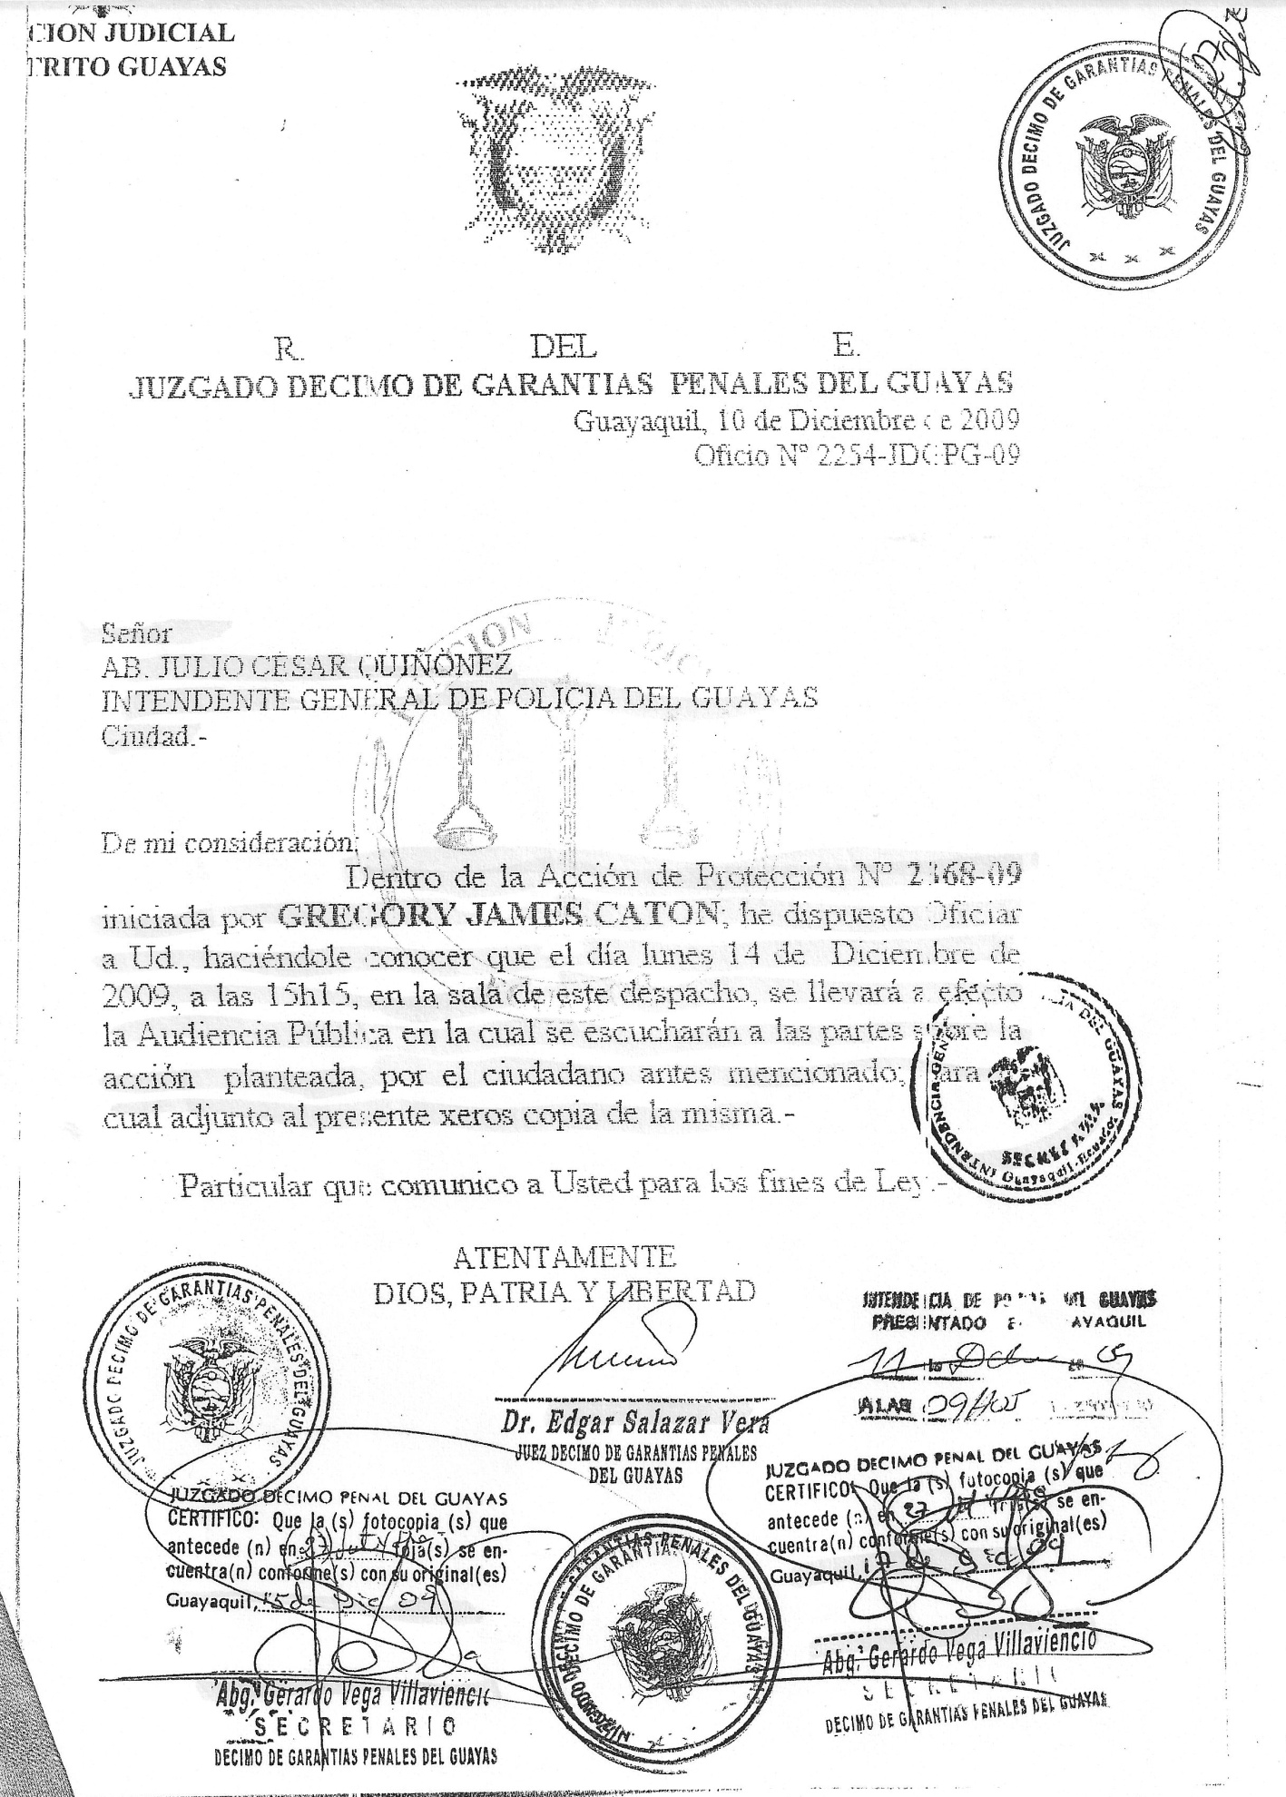
R. OF E.
TENTH COURT OF CRIMINAL GUARANTEES OF GUAYAS
Guayaquil, December 10, 2009
Official Action number 2254-JDGPG-09

ATTY. JULIO CESAR QUINONEZ
GENERAL MAYOR OF THE POLICE OF GUAYAS
City.-

To whom it may concern:
In the Petition of Protection No. 2368-09 started by GREGORY JAMES CATON, I am notifying you that there will be a Public Hearing on Monday, December 14, 2009 at 15H15 in the judge’s chambers where the parties involved will be heard about the established petition by the aforesaid citizen. I annex copies.
Information that I hereby notify you for all legal purposes,
Sincerely,
God, Fatherland and Liberty
(Illegible signature)
Dr. Edgar Salazar Vera
TENTH JUDGE OF CRIMINAL GUARANTEES
OF GUAYAS

